# General

Hotkeys affect the focused window, so make sure your mouse cursor is over the area you need to work in, first!

Ctrl + Mouse Wheel – When over a drop-down, will allow you to scroll through misc items; really handy for things like the Film settings on the Scene / Color Management Tabs.

When you have a color picker available (say the texture paint window), you can use it quickly with the “S” key.

You can access entries in a popup menu by pressing the appropriate number key. If you to W and then 1, you will select subdivide without touching the mouse at all. Alt + number adds ten, so Alt + 7 = 17, which is useful for long menus like "specials."

Pull down the top menu bar to reveal the python commands for everything you're doing.

Gestures are gone in 2.5+. The VBO option for speedups when drawing multires/subsurf models is now enabled by default as of 2.77+.

Under the object menu are "quick effects", which are shortcuts for common FX techniques: adding fur, explosions, etc.

Notice a lot of stuff on the toolbar missing (like the layer buttons?) You’re probably in local mode, just hit ‘/’ on the numpad to get back.

Space - brings up command search.

# File Dialogs

F1 – Load

F2 – Save

Ctrl + Q - Quit Blender

Ctrl + W - Quick Save

Ctrl + O - Open

Ctrl + Shift + O - Open Recent

Ctrl + S - Save

Ctrl + Alt + S - Save As Copy

Ctrl + Shift + S - Save As

Shift + F1 - Link / Append Window

In File Dialog:

P – Parent window

If NumLock is on, the following will work with the numpad:

* + will advance the numeric part of the filename by 1 every time it's pressed
* - will revert (subtract) the numeric part of the filename by 1 every time it's pressed

# Windows

Pie Menus:

Tab: Edit Modes

Ctrl+Shift+Tab: Snap Mode

Z: Shade Mode

. – Pivot Point

Ctrl + Space: Manipulator

Q: Viewport (Top/Left/Front/Etc)

F5 – Flip a menu from the bottom to the top (and vice-versa)

Shift+Z – Jump to rendered view. Hit it again to return to the previous mode.

Object in your way? Fly mode works for perspective view as well, and works better than zoom for getting past objects.

You can also dolly the view by doing a Ctrl+Shift+MMB, which will actually move your viewpont, not just zoom in/out (apparently, the way blender is written, the viewpoint center is fixed, and you can zoom in and out from there, but only to an extent, which is why (sometimes) you can’t zoom any farther. Dolly or fly to get around this.

Drag the dividers in the lower-left and upper-right to split and recombine windows. It's a huge pain to actually get this to work right (for joining.) When it's time to join, just right click-the dividing area and select "join areas"

Shift + Drag on those dividers to get a new pop-up window. You can then position this on another monitor.

You can drag toolbars and menus closed. You'll get a plus sign to "restore" it where the menu used to be.

Ctrl+Clicking on a panel’s header opens it and closes all others! You can click + drag on the triangle to mass open / close areas in the panel. If you start with a bunch of open areas, you’ll close them as you drag. If you start with closed tabs, you open them as you drag.

You set viewport background image is under the "N' menu on the right (under the "background image" selection.)

Ctrl + <- or Ctrl + -> (Note: those are the arrow keys, not greater/less) = switch workspace. UV editing, in particular, appears to have a handy setup.

Window clipping (Alt+B) is actually awesome; you can remove anything you're not interested in; quicker than hiding everything you're not using. Alt+B again to cancel.

Similarly, Ctrl+B is a render border; Ctrl+Alt+B clears this.

Shift + B - Zoom to box / border; Note: this actually zooms to an item **in** the border. If the border doesn’t enclose any object, this will fail.

Shift + C – Put cursor at 0,0,0 and view all. (Handy! For just “view all”, hit “home”)

Shift + F - Fly Mode View Movement. MMB to move/in out, just move cursor to redirect.

Ctrl + Alt + Q - Toggle Quad View (or View/Toggle Quad View); will toggle back to whichever view the mouse cursor is over at the time of the switch.

T - Toggles the tool shelf (to the left of the viewport) on and off.

N - Called the properties panel, or sometimes the transform sidebar (technically, the item/transform/view toolbar).

Shift+F2 – Set window to BGE Logic Editor

Shift+F3 - Set window to nodes

Shift+F4 - Set window to Python Interactive Console

Shift+F5 - Set window to 3d viewport

Shift+F6 - Set window to animation tracks

Shift+F7 - Set window to context / tabs / buttons (right-hand side)

Shift+F8 - Set window to tracks

Shift+F9 - Set window to outliner

Shift+F10 - Set window to image view

Shift+F11 - Text Editor

Shift+F12 - Dope Sheet

F11 - Toggle Render View, Get Back to 3D From Render

Alt + F11 - Toggle Blender Fullscreen

F12 - Render

Home – Zoom Out to See All Objects (similar to Shift + C, although *that* shortcut also sets the 3D cursor to the origin.)

Alt + Home (period) - Focus the view on the cursor

Num 0 – Camera View

Ctrl + Num 0 – “See” out of currently selected object. Good for positioning Cameras.

Num 1 – Front

Ctrl + Num 1 – Back

Num 2 – Rotate View Left

Num 3 – Right

Ctrl + Num 3 – Left

Num 4 – Rotate View Right

Num 5 – Toggle between perspective (default) and orthonormal (same-size, regardless of distance) modes

Num 7 – Top

Ctrl + Num 7 – Bottom

Using Shift + Any of the above will align the view to a selection (be it an object or face); the most useful is Shift + Num 7 which will look at the face dead-on; Shift+Num 1 / 3 will merely look at the face/object from the side.

Num . (Period) – Center view on selection.

Shift Num . – Lock view to selected

Alt Num . – Clear lock

Also available on the “N” menu, which will let you *pick* an object by name. view / lock to object.

Ctrl + Num . (Period) – Center the view on the 3D cursor

Ctrl + Up or Down, Shift+Space - Toggle Fullscreen on Current Window

Ctrl + Left/Right - Toggle Window Sets (e.g., Switch from modeling -> animation)

Num + - Zoom in

Num - - Zoom Out

Num / (divide) - Zoom in on selected, hide all others (called local view, do again to cancel)

Shift + Space – Maximize current window (Also Ctrl +Up)

# Input & Manipulation

Hold down **LMB** and move your mouse to the left or right while hovering the mouse cursor over the number to change values quickly.

Numeric boxes can accept simple expressions, so 4 /2 = 2; If something is set to .10, you can type .10 * 60 to make it 60 times bigger. Use a decimal if you want a floating-point result, otherwise 3/2 = 1.

Press E with the mouse cursor over an Object Selection Field to activate an Object Picker.

When hovering the mouse over any value, colour or text field, just hit **Ctrl+C** to copy the value and then **Ctrl+V** when hovering over another field to paste it there.

Hold down MMB while dragging to constrain to the closest (global) axis.

Hitting an axis key (x,y,z) after selecting move/rotate/scale allows you move only that axis.

Hitting Shift+x,y,z, LOCKS that axis, constraining you to the other two.

By default, when you double-tap an axis to lock to it when using global coordinates, you'll move in local coordinates instead. However, if you've used Alt+Space to pick another axis, you can use *that* instead of local coords. So Alt+Space, pick Normal, then G Z Z will now move along the normal of the selection.

Alt + Spacebar - Select Orientation for manipualtion (local / global / etc), 2.5+

Ctrl + Alt + Space - Create Orientation

Ctrl - Snaps when held down (5 deg on rotation, .1 in on size, new coords to whole nums).

Shift - Fine-tuned movement.

Ctrl + Shift - Snap, but use a finer scale.

Shift + Tab – Toggle Snap

Ctrl + Shift + Tab – Select snap type

As of 2.76, Blender will now let you choose between absolute grid snapping (lines up perfectly with the on-screen grid) or incremental snapping, which was the default/previous behavior.

After selecting rotate, move, scale, etc, you can punch in a number. E.g., S 2 will double the size of the object.

G G – goes to slide mode instead of move!

R – Rotate

R R – (Hit ‘r’ twice) Rotate Object in Trackball Mode ((Note the MMB trick to constrain to an axis works here, as well as regular rotate)

Shift + Click on a manipulator, then drag to constrain operations to the axes orthogonal to the selected one.

Shift + S – Snap Menu

Shift + Tab - Toggle Snap

Ctrl + Shift + Tab - Snap Type MENU

Create orientation really is really handy for mesh precision work: if you wanted to create an orientation aligned with, say, a character line on a car this would work for you. Remember to use G XX / YY / ZZ to move relative to the selected axis. Custom orientations can be managed in bottom of the properties (N) pane.

You can define custom transform orientations, using object or mesh elements. Custom transform orientations defined from objects use the local orientation of the object whereas those defined from selected mesh elements (vertices, edges, faces) use the normal orientation of the selection.

The default name for these orientations comes from whatever you have selected. If an edge, it will be titled, "Edge," if an object, it will take that object's name, etc. The Toolshelf (T in the 3D View) allows you to rename the custom orientation after you hit CtrlAltSpace.

# Outliner

If you drag one item’s icon onto another, it will set up a parent/child relationship between the two. To undo the relationship, drag the child out to an empty spot in the window. This works even if you have multiple instances of the outliner open: you can drag and drop between them.

You can duplicate an object by dragging it from the outliner to the 3d viewport. If you drag one object’s material (from the outliner) onto another object in the 3d viewport, it will assign that material to the object.

Clicking on the mesh data icon in the outliner will put that item into edit mode. Click again to toggle back to object mode.

If you Ctrl+Drag over any of the render / selectable / viewport attributes in the outliner, it will toggle them for you. Note that the Click+Drag has to start as a regular click on something; then, hold down Ctrl and start dragging.

# General Editing

Scale only in edit mode! Having a non-uniform object scale can mess up your animations, your particle systems, your displacement maps, etc, if you scale in object mode. If you *have* to scale or rotate in object mode, make sure to apply the scale and rotation before animating.

Z – Toggle Between Wireframe and Solid Shading

F3 – Repeat (History List)

Ctrl+Tab will go into either Pose mode (for armatures) or Weight paint (for other objects). Hitting again will toggle back to whatever you were in previously (edit, object, sculpt, etc)

Ctrl + Space - Manipulators On / Off. (Also buttons under the main window next to the 'global' box)

Ctrl + , (comma) - Set median point as pivot

Ctrl + . (period) - Set individual origins as pivot

, - Set bounding box center as pivot

. - Set pivot to 3D cursor / Pivot Pie Menu (if Pie Menus are on.)

Alt+Z - Toggles the viewport shading type

Alt + Space – Change orientation (Global/Local/Normal/Etc) – This is actually great, as it lets us quickly switch to normal mode, then use the S Z Z 0 trick to flatten things out.

Alt + , - Manipulate object centers only.

This takes a bit of explanation: This is only useful for multiple selections in object mode: it essentially locks scale and rotate on the selected objects. When this is active and you scale objects, they'll *move farther away (or closer)* without resizing the objects themselves. When you rotate objects, the common axis between your selection will rotate (which takes the object's origin point with it), but the individual objects themselves do not rotate. This will also respect the origin mode: if you have 3d cursor set, your multiple objects will move around the cursor instead of their common origin point.

F3 - Repeat History

F6 - Brings up a review window to tweak the parameters on the last action

1 – Select Layer One, 2 – selects layer 2, all the way to 10

Alt + 1 – Select Layer 11, Alt + 2 – Select Layer 12, etc…

Shift + 1 - Add Layer 1 to "active" list.

` - backtick - Toggle all layers on.

Shift + A - Add item to scene

Ctrl + Alt + Shift + C - Set Origin Menu

Alt+C - Convert selected from one type of object to another

Shift + D – Duplicate (Warning: the new item shares materials with the old one)

Alt + D – Linked Duplicate; creates a new object with **all** of its data linked to the original object.

H – Hides selected vertices, faces, etc. (also works in the UV editor)

Shift + H – Hide everything not selected.

Alt + H - Reveal all.

Ctrl + J – Join objects together (must be of same type); the new center is obtained from the previously active object.

Ctrl + L - Make Links between objects (if you want to share materials, for example.)

M - Layer Menu (Move Selected Object to Different Layer)

Ctrl + M - Mirror Tools (Modeling Mode, Hit Ctrl + M, then the axis you wish to mirror across.)

Alt + O – Clear Origin: this only applies to children of a parent object: it essential snaps the child back onto the parent.

Ctrl + P – Parent: first selected is child, second is parent.

Alt+P - Unparent.

You can parent an object to a either one or three verticies in another object. First, select the child, then the parent. Next, go to edit mode, and select either one or three parent vertices. **Then** hit Ctrl+P: this is called "Make Vertex Parent"

Shift + R - Redo last action (2.5+ Only)

Ctrl + T – Track

(good for cameras and lights; if you camera doesn’t line up, you might have applied a manual rotation to it, so you’ll want to Alt+R the camera to remove your rotation)

Alt + T – Clear a Track Constraint

U – Make Single User Menu (Object Mode)

W – Specials Menu (Subdivision, Merge, Hide, Reveal, Smooth, Bevel, Etc.)

Also polygon tools, etc. [Edit Mode]

In object mode, has Restrict Render Unselected / Clear Restrict Render

X – Delete Selected

Ctrl + Z - Undo

Ctrl + Shift + Z - Redo

Ctrl + Alt + Z – Bring up the Undo History menu , so you can jump to a history state.

Ctrl + A - (Apply) Scale / Rotation / Location to the object data - Makes the current scale / rotation = the default.

Alt + G – Clear all translations

Alt + R – Remove all rotation from object

Alt + S – Clear all resizings. (Object Mode)

Meta balls (and tubes, planes, etc) are implicit surfaces (not explicitly defined) that are actually just computer procedures. The balls will join if brought close enough to each other.

Modifiers applied to linked duplicates (Alt+D) don't affect the original; you can add lattices to linked dupes to create different versions of an object that share geometry.

Randomize Transform (Only available via space bar) appears to be the easiest way to randomly perturb some locations and rotations.

O - Toggle proportional edit mode (Both edit and object modes.)

Alt+O – Proportional edit (Connected) (Edit Mode only)

Alt + O – Clear the object’s origin (Object mode only)

Shift + O - Cycle through the proportional falloff options.

MMwheel - change the size of the influence area.

- There’s a neat trick you can do with this; if you clear a child’s origin in a parent / child relationship, the child will move to the parent.

# Selection

The *last* selected (when selecting multiples) item is the “active object.”

In 2.68+, you can you box *deselect* as well. Just drag-select with the box, when hold SHIFT as you let go and you’ll deselect the region.

As of ~2.75, you can’t do edge selects with “emulate 3 button mouse” enabled and LMB-select enabled. As of now, even selecting LMB-select grays out emulate 3 button mouse (although depressing “emulate 3 button mouse” WILL have an effect. Seems easier to just use MMB/Shift+MMB/MMB-scroll for viewport navigation and leave “emulate 3 button mouse” off.

As of 2.78, you can select a vertex/edge/face, then Ctrl+Shift+LeftClick (or Rightclick if you use the conventional mouse selection) to select the whole region between those two items.

If you have a slew of objects selected, only one will be the *active* object. If you make any changes (such as displaying wireframe, x-ray, etc), only the active object will be affected. If you want ALL the highlighted objects to change, Alt+Click the option instead!

Ctrl + Click a vertex to extend your selection to that vertex. This is GREAT because – instead of selecting an edge loop and getting too much or too little, you can manually pick where you want the selection to stop. Also handy

Groups are simple logical groups of items that don’t share any other attributes. They’re merely for organization. They don’t appear indented in the regular outliner view, but if you switch to the “groups” tab in outliner you can choose between them.

Shift + Alt + G – Remove from group

Ctrl+Shift+Alt + G – Remove from all groups.

As of 2.6 (ish), if you have multiple items under the cursor, just keep clicking. Blender will cycle through all the objects under the cursor.

Don't forget about the "select" menu at the bottom of the 3d window; It'll let you select all items by type, plus a few other such as doing a random select of objects or selecting by name.

Alt + Select - Select menu, shows you everyting under the cursor. (This’d be Alt+LMB with our setup)

Ctrl + Numpad + / - - Grow / Shrink selection (dumb)

Ctrl + Shift + Numpad - Grow / shrink selection (smart) – it’ll try and continue in the line that you’re making, and if you’re picking every other vertex, it’ll continue the pattern. It also works with vertices, edges, AND faces! It’ll also continue along diagonals, which means you can easily create spirals!

Ctrl + Select – Selects the shortest path between your first selected vertex / face / edge and the one you are clicking on.

Ctrl + LBM drag - lasso select. Kind of dumb, as RMB is select most of the time.

Shift + RMB – Add to selection

Alt + RMB on an edge or face - face or edge loop selection, depending on what mode you're in.

Ctrl + Alt + RMB - edge ring selection. Like edge select, but selects faces instead of edges.

Shift + Alt + RMB - add loop to selection; will select faces if you select two adjacent edge loops. Also works with edge ring selection

A – Deselect / Select All

B - Box select

B - Box Select + MMB = Box Unselect

C - Circle Select

C + MMB = Unselect

MMB scroll - makes the circle bigger or smaller

Shift+G in object mode brings up the select grouped menu, which lets you select children of an object, parents, objects of the same type, color, etc.

Shift+G in edit mode brings up select similar, where you can select similar by area, texture, normal, image, etc ... (In edit mode, this is called select similar)

Ctrl + G - Group objects

Ctrl + I - Select Inverse

L – Linked select (selects edge, face, etc. closest to cursor, as well as all other faces, edges, etc. linked to it.)

Shift + L – Select all objects containing a link of some sort in object mode.(IPO / Data / Material / Texture)

Shift + L - Deselected linked vertices. (Edit Mode)

Ctrl + L – Select Linked All (Edit Mode) (This respects seams in edit mode as well)

Note that in edit mode, L and shift L will work on whatever the cursor is hovering over. You don't even have to press a mouse button. Just move your cursor over some something, and hit L, and the verticies will be added to your selection.

O – Proportional Edit Mode (Like dragging mountains out of a grid)

Shift + O – Changes the falloff mode, which you’ll notice on the header of the 3d viewport

Neat trick for moving one item to another: select the first, do Shift+S, cursor to selection, then select the second object and do Shift+S selection to cursor.

By selecting multiple objects, you can hit Ctrl+L and force them to share the same material. Likewise, you can also Ctrl +L and link modifiers, which essentially "copies" the modifier stack across objects!

Using the outliner, you can Ctrl + LMB on the glyph for a node to select all its kids (for meshes, this would be the upside down triangle thing.)

# Mesh Editing

Numpad Slash: Toggle between global view and local view. Local view shows only the currently selected object.

Under the Mesh menu is an option for “automerge editing.” When you drop a vertex on top of another it will automatically merge them. Not on by default, but sure is handy.,.

Shift + Tab – Snap

When snapping to verticies, you can mark verticies by hitting “A” while you’re over them. The vertex you’re trying to move will snap to the average of all the vertices that you’ve tagged!

If you're using a background image for editing in Blender, and you want the object to appear translucent: open background images in N/properties, and click the "Front" Button, which will draw the object on top of things in a semiopaque fashion. It is located on individual background image’s pane.

G G – Vertex Slide, Curiously also available with (Shift+V); Note that the slide goes *towards* where the cursor is, so if you want to use this to shrink something make sure that your mouse pointer is “inside” your selected vertices.

Alt + Shift + S – Transform to sphere; the amount you drag afterwards determines how spherical your selection becomes. Also respects the the current pivot center.

Ctrl + F - Face specials has a neat "inset faces" tool that's very similar to extruding a face by zero then scaling inwards (but in one step!)

F - Make face

Alt+F – Fill face – Unlike “Make face” above, fill face will as many faces as it needs to fill the currently selected hole.

I – inset faces – Like an extrude followed by a scale; the scaling happens on the normal axis.

Don't underestimate the value of a good Numpad period – it zooms and focuses on the currently-selected item.

Ctrl + L – select linked all; appears to respect seams if you're in face select mode (but not vertex or edge); Note that unliked "regular" L, you can control the seam limit in F6 afterwards.

L – select linked; also respect seams even if you're in face select, so have no idea how this differs from the above. Doesn't give you the option to enable/disable seam tracking, but you can hit this while hovered over the object, while ctrl+l needs a fae.

Alt + R - Spin verticies (in edit mode); Appears to always spin them relative to the view plane.

Shift + V - Vertex Slide

Ctrl + 1 ... 5 in object mode, adds a subsurf modifier to the object, and sets all geometry to smooth mode. The number changes the subdivision level in the viewport, not the render.

You can also adjust the mean crease (as well as the bevel weight) for selected vertices by going to N/Transform. Under the usual X/Y/Z entries are vertex and edge entries (in edit mode, anyway.)

On creasing vs extra edge loops: creases are limited in how much they can do for you. They can't be exported to other applications, they don't work well with deformation, and other modelers claim they just look worse in any situation. Hence, the community's preference for extra loops.

Meshes have the concept of “manifold”; a non-manifold mesh is a mesh for which an “out” cannot be computed, or where there are edges belonging to more than two faces. Non-manifold meshes can cause problems when subsurfing, and are not available for decimation, so it’s a good idea to avoid them as much as possible.

You can select verticies and do “smooth vertex” which will relax just the area around the selected verticies. Great if you’re trying to fix a rather “severe” edit that you just made.

Two hints will tell you if your mesh is non-manifold:

Normal recalculation leaves black lines somewhere

The decimator refuses to work, stating that there is no manifold.

The old Scale-Z along the normal trick isn’t necessary as of 2.76, as there’s now a dedicated “make planar faces” option. Select the faces, run this, then pick the number of itrations.

Ctrl+Shift+R – when a loop is selected, will create a similar loop on each side that you can then slide in and out. (2.76+)

While selecting a **face** will cause blender to also allow you to select that face’s normal as an axis, selecting an edge loop will *not*. Create a face, perform your operation, then delete the face as a workaround.

Also as of 2.76, hitting “v” while beveling will let you control whether or not you want to bevel both edges AND vertices or just vertices.

As of 2.78 Hitting “P” will change the *profile* of the bevel, so it can be curved in, curved out, square, or something in-between. Hitting “S” will let you set the # of bevel segments by typing in an exact number (instead of scrolling with MMB.)

Avoid tris for good topology. For instance, a UVsphere will show awful triangular distortion, even when smoothed/subsurfed, at the "cap" where all the vetices merge together when specular highlights are on the triangles. Avoid this by subdividing the affected area until the triangles are as small as possible.

The best way to do this is to pick the radial edges at the cap and do a subdivide smooth. If you're in the wrong mode (vertex/face) or have the wrong stuff selected, Blender won't give you a nice smooth ring of geometry; instead you'll get a lot of useless crap and more triangles.

Ctrl+F brings up the “faces” special menu. Instead of just hitting “F” to cap off a cylinder, you can do Ctrl+F and “grid fill” to get something a LOT more pleasing. You can play around with the span & offset to tweak the results:

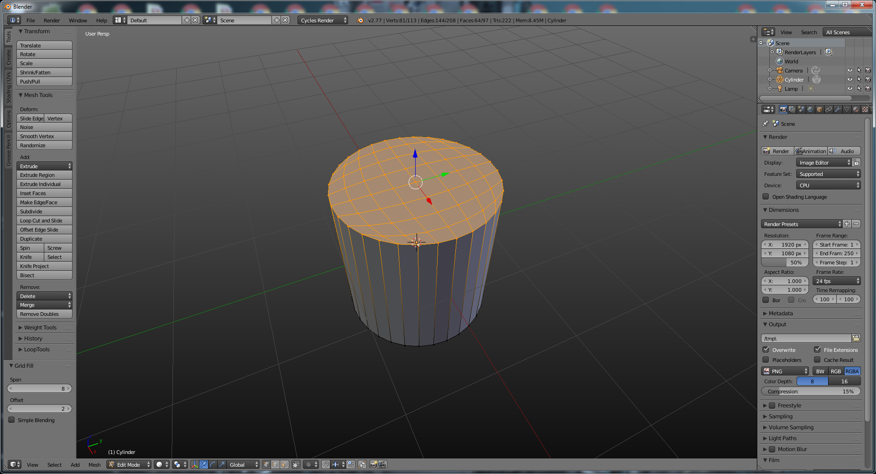

A neat trick to get rid of extra geometry that you don't need. If you have an extraneous edge loop, you can select it, then when you hit "X" to delete, you can select "edge loop", and Blender will only delete the loop, but not the faces "underneath" it.

If you have a piece of geometry you need to fill in, you can duplicate it with Shift+D, then hold down Ctrl (which will cause snapping behavior). As long as the magnet is on in the toolbar, you can drop the new geometry in any other existing holes of the same size.

Select vertices you want to align; then hit scale, an axis, then 0, and they'll all line up.

If you’re trying to make a crease at an E-pole (extrude), and the results don’t look right, first reduce the crease, then make a loop cut and move it down towards the crease. You’ll get the same effect without the weirdness.

If you’re modeling and you have weird indentations (or splits), that means there are likely veticies sharing the same spot in 3D space (especially if you’ve spun an object.) To fix this, select all the verticies, then go to W Key > Remove Doubles. When removing doubles, you don’t need to select the exact vertices; it’s usually easier to just select the model wholesale, then do an edit->remove doubles

If you want to do a terrain heightmap, you have a bunch of choices: adding a disp map to the texture, applying a texture that maps to nothing, then using the "noise" button under mesh tools (which appears to use the first texture for displacement.) The most effective way is to use the displace modifier, which does all the above, but is more flexible since you can apply it / turn it off, etc.

Ctrl + B (Bevel Edge / Face) - If you're in 2.6+ anyways

Ctrl + Shift + B (Bevel Selected Vertices) - If you're in 2.66+; scroll the mouse wheel to increase / decrease the amount of beveling.

As of 2.66, thanks to vertex bevel, it's really easy to make a circular hole inside an object: bevel a vertex to get a diamond, then delete the face and run "to sphere" on the selected ring around the face you just deleted. Instant circle!

Ctrl + 1 – 5 – Applies a subsurf and changes the (View) Subsurf Level in edit mode.

PgUp / PgDown - Change Multires / Subsurf Level for Viewport (Also Works w/SubdivSurfs)

E – Extrude (note, just ctrl+click (LMB on default blender, or RMB with our current setup) on open space with an active selection in edit mode will do this as well, regardless of vetex/edge/face mod)

Note that hitting S or R after E will immediately switch to scaling the extruded face or rotating it (without displacement), and it is considered one operation by blender’s history menu. This isn’t *terribly* useful, but can shave off one keystroke from those times you’d normally use extrude to make an indenation (you’d normally have to hit <enter> then s for scale).

Shift + E - Crease

If the shift+drag crease method isn't doing it for you, you can always select the edge(s), then hit N for transform properties, and edit the crease numerically.

Ctrl + E - Edge Specials (Crease Edge; Loop Slide, Mark Seam, Etc)

Alt+E - In 2.5+, the default is to extrude your select as one big piece. If you want individual faces, do Alt+E, then pick individual faces.

In Edge specials, you can mark sharp, which will be used by the edge split modifier.

F – Create Line from 2 Vetices, Create Face from 3 or 4 Vertices (blender likes 3 better, though.) Seems to default to smoothed, though, for some reason.

Ctrl + F - Face Specials

As of 2.6X: If you have just a single edge selected but it's "obvious" where the next face should go (like below), you can just hit F with the edge selected and it'll make a face for you. You can just keep hitting F to keep filling things in. Also works on a single vetex selection (but in that case, makes a tri instead of a quad)

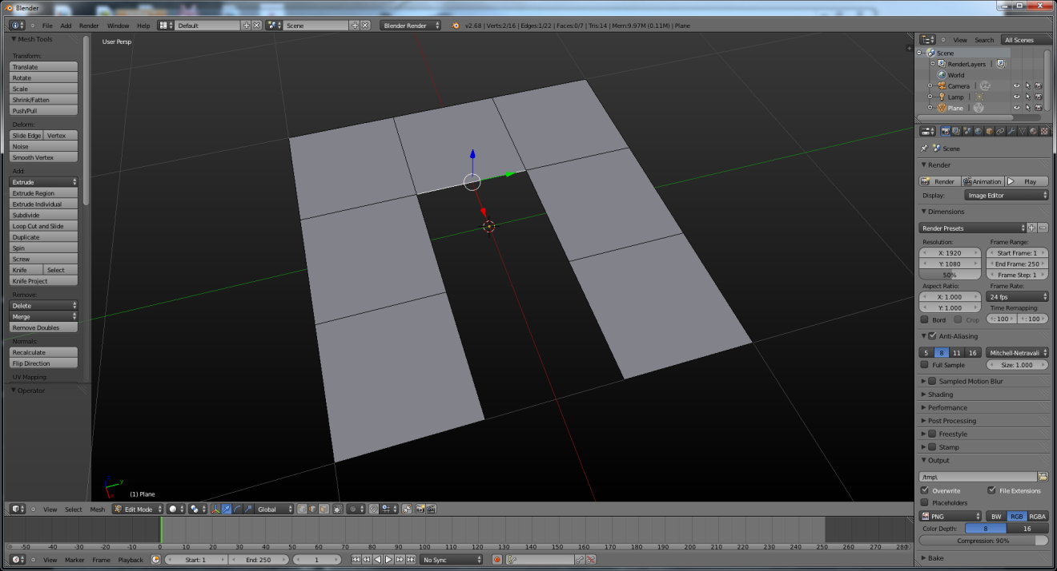

As of 2.66: Tap G once, it's a move, Tap G twice, it's an edge / vertex slide.

Alt + J - Convert (Merge) Tris to Quad

K – Kut, click on lines, then hit enter to cut.

Alt + M – Merge Menu / Merge At Center/Cursor/Collapse.

Collapse - Collapse works like merge at center, but works individually on multiple selected areas.

Ctrl + M - Mirror tool; different from the mirror modifier in that it doesn't make a copy, it just mirrors across an axis (albeit with a couple extra options we can’t make heads or tails of)

Shift + Ctrl + Alt + M - Selects all non-manifold edges/vertices in a mesh, including holes. Ctrl + F will then fill these using beauty fill. Note this selects holes as well as edges with three faces, etc. (Seems to only work in vertex select mode.)

Ctrl + N – Make normals consistent.

P - Lets you separate off pieces of a mesh. These become a new object.

Y lets you separate pieces of a mesh, but these will remain part of the mesh.

Ctrl+R - Create Rings (Loop Cut)

When doing a loop cut with Ctrl+R, you can hit the numpad + and – key to increase or decrease the number of cuts. Also, the middle mouse will increase the number of cuts. Hit RMB to force the loop cut to be exactly in the center.

When you pick the number of loop cuts and you’re in placement mode, you can hit “e” to use edge mode. Instead of the “blended” loops, you’ll get a loop that exactly matches one side or the other. Use “F” to flip which edge you match, and C to toggle clamping options.

Ctrl + Alt + Shift + S - Shear

Alt + Shift + S - To sphere (edit mode); Blender 2.5 gives you a nice preview.

Alt + S – Scale Verticies in the direction of normals (shrink-flatten) (Edit Mode); will change the volume of a shape without changing the entire form.

Alt + R - Spin Verticies, use F6 or T to change properties aftwards.

Ctrl + T - Convert Selected Quad to Triangles

Shift + W – Warp Tool - Causes your mesh to warp in a circle around the cursor. Good for putting, say, circular text around a globe.

Y – Split faces off from selected mesh (edit mode), keeps those faces in same object.

Note that in 2.69+ we now have access to the Bisect tool. This acts (somewhat) like the knife, except that it only works as a plane. Afterwards, you can choose to keep one side of the cut (or the other), or fill the resulting hole that you made. (hit F6 for this – there’s no way to do it ahead of time.)

Autosmooth works on faces you have already selected as smooth. Any angle between faces that is higher than the degree listed in the autosmooth window will appear creased. Anything less is smoothed. Autosmooth is now in object data (the pane with three vertices.)

The mirror modifier sometimes makes it harder to use shape keys and weight paint. In the toolbar pane (left) of Blender 2.5, click x-axis mirror, which will mirror your moves, rotates, and scales - beware, it doesn't work for extrudes, so it's bet used for, say, shape keying.

Subdivide Modifer: You can use the “fractal” setting in the options panel/F6 to add displacement noise to the object while you’re editing it.

You don't always have to use a mirror modifier right away; if you leave the whole mesh intact, it allows you to proportionally edit around the x-axis a lot easier; if you have mirror on, bounding box center won't be where you think it will.

In the scene pane, you can now just click "imperial" units to set everything to inches/feet automatically.

There’s a LOT of different ways to crease something that’s been subsurfed:

1. Add a crease to some edges
2. Extra edge loops near the desired crease
3. Mark Sharp + Edge Split

1 & 2 produce similar results (the left torus), while mark sharp + edge split is the only way to get the object on the right: an object that retains its curved shape yet still has creases.

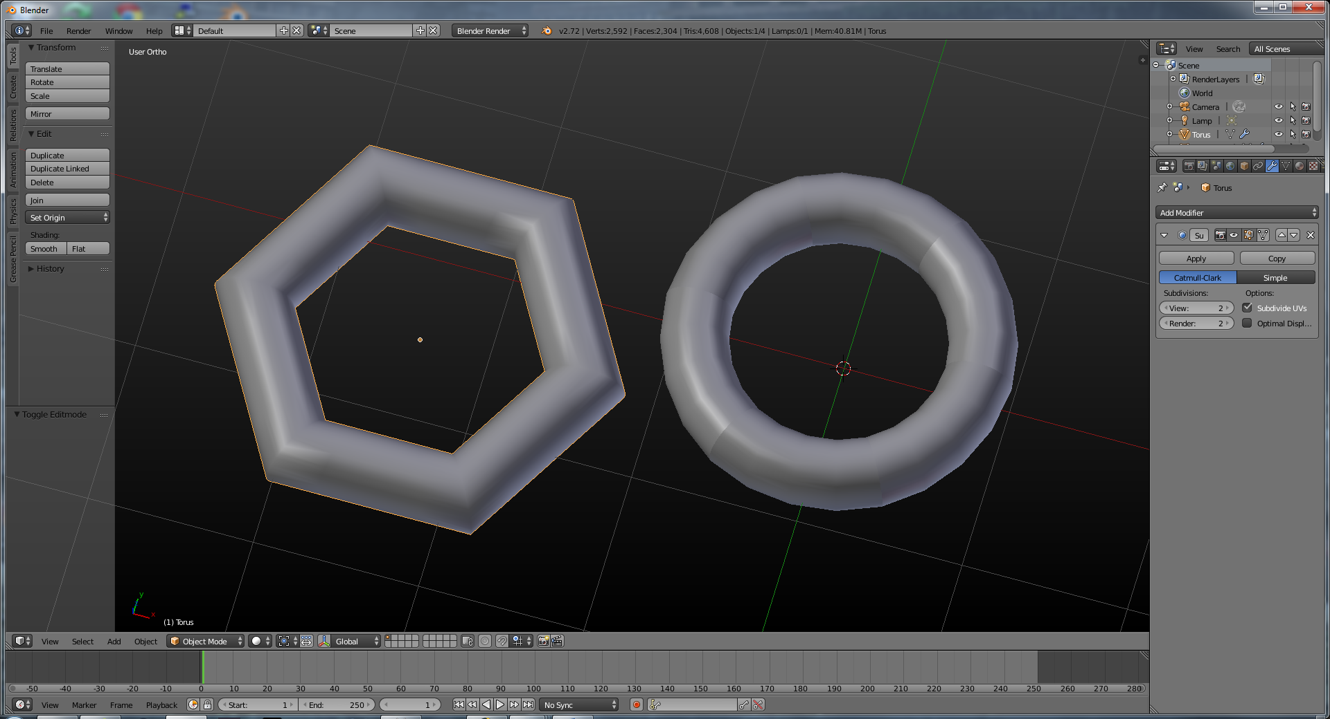

Note that you can also have blender pick which faces are set to shade smooth *for you*. Under an object’s Object Data tab, pick “auto smooth.” Edge split also has the same option (split based on angle).

Want to make a set of faces the same size? You *might* be able to do this with looptools / space on the surrounding edge loops, but that might not be possible. Fear not, while it’s kind of a pain in the ass, it **is** possible:

With the *face select* mode enabled select the face and press Shift+Num 7 to allign it to view. Then snap the cursor to it (Shift+S-->*Cursor to Selected*) and add a *plane*. Check the ***Allign to View*** box in a *Tool Shelf* (T) and scale it (S) to the desired size.  
[](https://i.stack.imgur.com/x5r4P.gif)

Enable the *snapping tool* (click the magnet icon), change *snap element* type to ***Vertex***. Snap the vertices of your object to the newly added plane, then select the whole mesh (A) and *remove doubles* (W-->*Remove Doubles*). [](https://i.stack.imgur.com/7kVl2.gif)

Repeat the process with the other faces. [](https://i.stack.imgur.com/dAdH1.gif)

## Non-Destructive Modeling

You can use shape keys to simulate non-destructive modeling (see Kent Trammell's video at http://cgcookie.com/blender/2013/03/22/non-destructive-modeling-with-shape-keys-in-blender/) (If you change the topology, though, you'll likely scramble the shape key results.)

Shape keys don’t work well when you change the topology.

# Topology

Detached geometry is a good shortcut for hard-surface models, but won’t bevel properly (as the detached geometry just intersects instead of attaches.) Freestyle won’t generate edge lines properly, either. Transparent/translucent materials will also look wonky.

It also can make UV mapping harder.

Edge loops are *everything* in topology. If you get your topology right, your models will animate better. Good topology is essential if you want fast framerates (realtime) and good deformation (both realtime and pre-rendered). For realtime rendering, bad topology can also create rendering problems

Here’s a good example of how an all-tri mesh subdivides in an ugly manner:

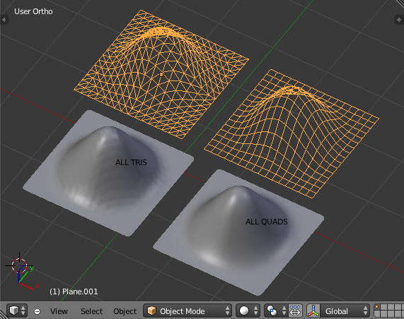

Also try to make every face roughly the same size with an even distribution and proportional to the faces around them. Tri’s aren’t awful when you have a flat model that doesn’t need to deform.

1. **Edge loops should be around defining features and edges**. For example, if you have a hole in your mesh, there should be a loop around it. It makes the shape easier to change and makes creasing the mesh with more edge loops much simpler.
2. **Try to keep a quad based mesh**. If you are forced to use a triangle or n-gon, try to hide it away on a flat surface, or a hidden part of the mesh, where, when it messes with the subsurface modifier, the distortion will not be as noticeable.
3. **Try to keep quads even sized and square**. Otherwise you'll have weird stretching issues.

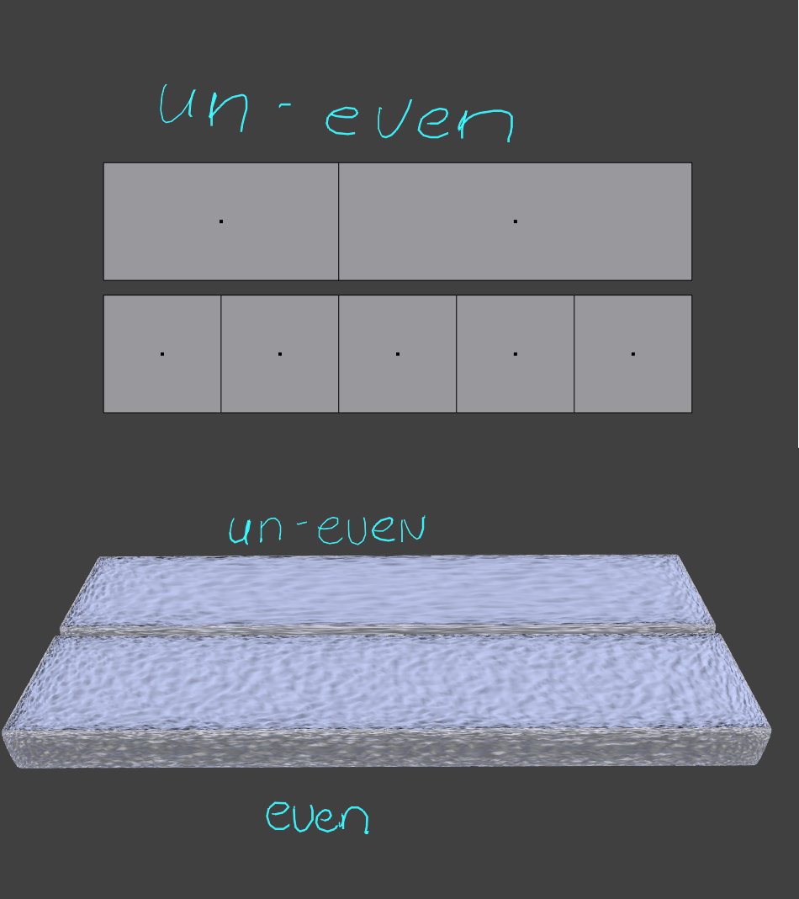

Try to keep polys about the same size, which will prevent mapping problems. If you have tris or poles, hide them in a part of the model that doesn’t deform.

All-quad junctions will look like the following:

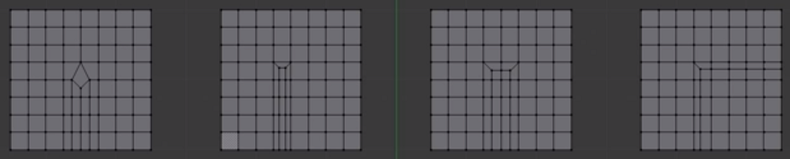

Options 2,3, and 4 can be accomplished by selecting the appropriate faces, then hitting “I” for inset. For option 4, uncheck “boundary” in the F6 menu (or options) to remove the inset faces from the edge of the poly.

For option 1, select the edge that will be split into the new geometry, then Ctrl+B to bevel it. Next, run a Ctrl+R on the middle of the newly created polys to add the center row back in.

See this page for animated gifs:

<http://blender.stackexchange.com/questions/3004/what-are-the-most-efficient-workflows-to-create-all-quad-junctions>

You can repeat technique #2 and #3 from the image above to split down into a LOT of detail where needed:

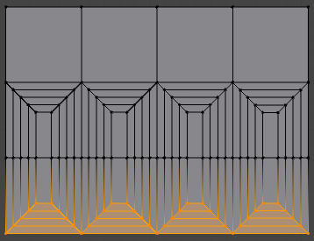

By removing the highlighted faces and making the vertices flush:

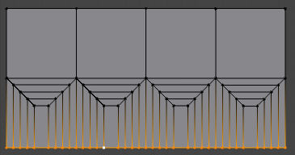

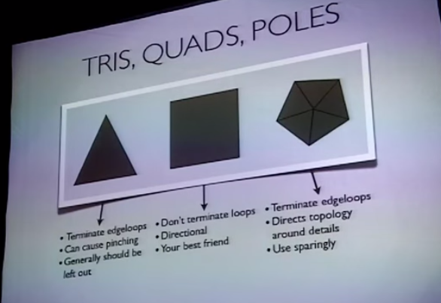

Use quads if at all possible. Using triangles in rounded areas of a mush cause artifacts. Tri should only be used on flat areas of your mesh if they cannot be avoided. Some modelers have a philosophy of “no triangles at all”, but sometimes you can’t escape them (so don’t feel bad if you’re stuck.) They do add pinching to models with subdivision surfaces on, so it’s more important to remove them in that case. If you’re making a low-poly model for a game (where the model won’t be subsurfed), feel free to use triangles in moderation. Tri usually only cause *severe* (pinching) problems in animation.

Ngons are great – if you’re working on a “hard surface” model like a robot or archviz wall, etc. Generally:

|  |  |
| --- | --- |
| 5down voteaccepted | I think that there is not an absolute "Best" way to make it. It depends on what's you goal.   * If you are want to **render only** this simple geometry, **ngons** are ok while they keep being planar. * If this is only the starting point from a more complex geometry, maybe is better to mantain a**quad**-only topology to **help future modeling**...or maybe not,... it depends! What's sure is that quads are the only way to take advance of the edgeloops, which usually makes the model easier to handle. * If you are going to add a **subdivision surface** modifier to smooth the surface, you definetely nedd a **quad-only** mesh to have easily user-predictable results * If you are making a **game asset** you'll probably will look for the lesser amount of polygons, so some quads may should be switch to **tris**... * If you want to **deform** an object for an animation, you'll probably need a **high density quad** base topology for the interested parts in order to avoid streching   and so on...  At the end, the topology strategy strictly depends on what you are developing meshes for and how. |

Note that when developing games, you can’t really escape tri’s, so it’s less important to fret about them in this domain:

**In games however**, There is a stage in the process where *triangulation is often unavoidable* and should be carefully embraced.

There is a point in the video game workflow where your game model should be completely triangulated, because most game engines will robotically do this for you if you don't, with often undesired results. Some concave surfaces will become convex and vise versa, while some unwanted/useless loops form from the resulting triangulation. You'll want to triangulate it before you export, and DEFINITELY before you bake normals. Here are two big things that can go wrong if you don't.

**surface/color baking**, especially normal baking, where you transfer details from Hi-res objects onto low res objects are very dependent on how a model has been triangulated. Rays cast from the high res surface to the low, virtually filling in low res gaps with information. So that if you export a model and it's map out to a different program, the triangles may be automatically cut differently to how they were in the other program, resulting in unwanted artifacts.

**Surprising deformations/shape**, The way that you animated/modeled the object may appear different because of the engine's method of triangulation, 'what you see is what you get' should be the aim. (this may need a better explanation.)

Don’t feel bad if you’re stuck.) They do add pinching to models with subdivision surfaces on, so it’s

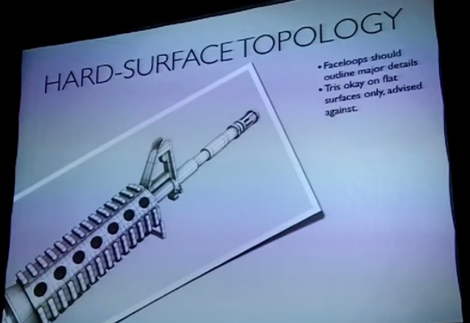

Hint:

Follow the features of your model with your face loops:

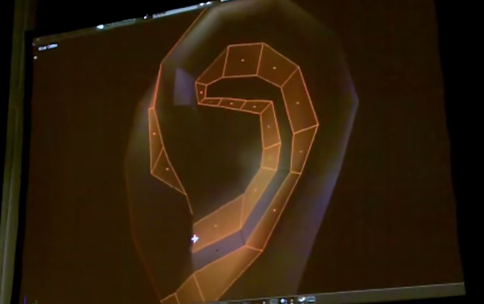

Jonathan Williamson prefers to model edge by edge instead of doing box modeling.

If you have to add a tri or a pole to a mesh that’ll be deformed, use it in an area that won’t be deformed/animated.

One way to remove a triangle? See the triangle in the picture below (it’s under the cursor.)

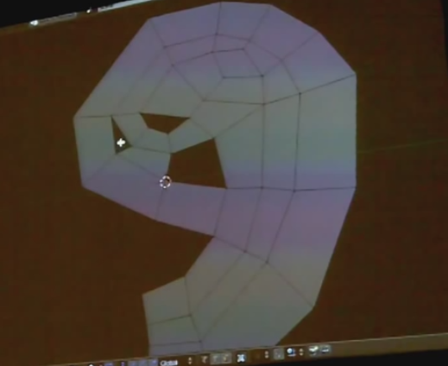

One way to remove that triangle is to select the edge loop at its point, the rip (V) the edge loop and fill in the faces between. The point will now be two vertices, giving you a quad instead of a tri:

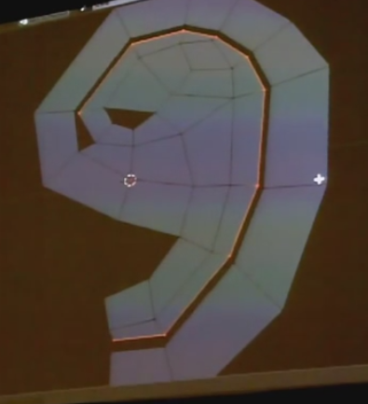

You can use this to remove loops en masse:

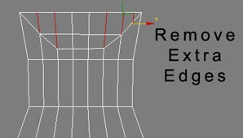

Using a diamond to add extra detail on a hand:

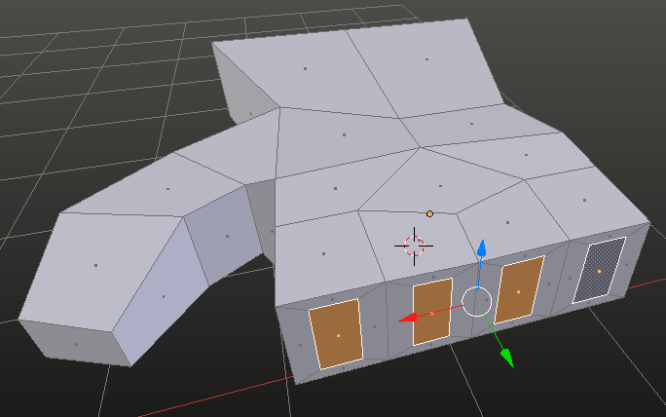

# Grease Pencil

To start, you have to add a new grease pencil from the N / right sidebar. Drawing settings: surface means you will only draw on the surface of your meshes.

Use the D key while dragging to draw with your grease pencil; (you could also click "draw" in the tools menu for this, but ... yeecch.)

D+RMB erases grease pencil marks.

Ctrl + D + LMB - Draw a straight line

Ctrl + D + RMB - Draw polys

View - stays in place with the view

Cursor - stays at the depth of the 3D cursor

Stroke - Aligns to the depth of any strokes already in the view; will move the stroke in and out (in terms of depth) to align with them, unless you ahve "only endpoints" selected.

Surface

The "Onion Skin" options will ghost out previous grease pencil marks (mostly used for animation.)

In the tools menu, you can select between freeform (draw) line / poly / and the eraser.

In the "N" properties menu, you can convert to curves, or select what you're drawing on (viewport, object surfaces, free, etc)

2.77 added stroke sculpting, where you can go to the “edit strokes” mode, then smooth/pinch/pull/etc. The options can be selected from the Tool menu under “Grease Pencil”, or:

E+LMB – hold to drag and sculpt

E+Ctrl+LMB – same, but inverteded (only for reversible brushes like thicken)

MMB scroll – decrease or increase brush strength

D+E – display stroke sculpting pie menu (weird, eh?)

Shift + F – set brush strength.

Ctrl + F – set brush size.

Tools from 3d modeling now work in grease pencil:

Shift +G (Select Grouped) – selects all points on the current layer.

M – move to different layer.

Alt+C – Convert to geometry.

Shift+W – Bend tool. Bends the grease pencil drawing around the cursor.

As of 2.78, Grease pencil also does a lot of animation:

When you draw, the stroke is drawn in the plane of the 3d cursor.

If you know you’re going to be drawing for a bit, hit the “continuous drawing” option in the toolbar on the left. It’ll free you from having to hold down “D” all the time. You can also turn it on implicity by releasing the “D” key while drawing.

The easiest way to erase is to hold down the RMB.

Animating the individual grease pencil strokes is done by going to the Dope Sheet, then putting it in Grease Pencil mode. From there, any changes you make in time will automatically generate keyframes.

You can parent grease pencil strokes to bones to make then animatable. This is done in the properties panel under the “Grease Pencil Layers” section:

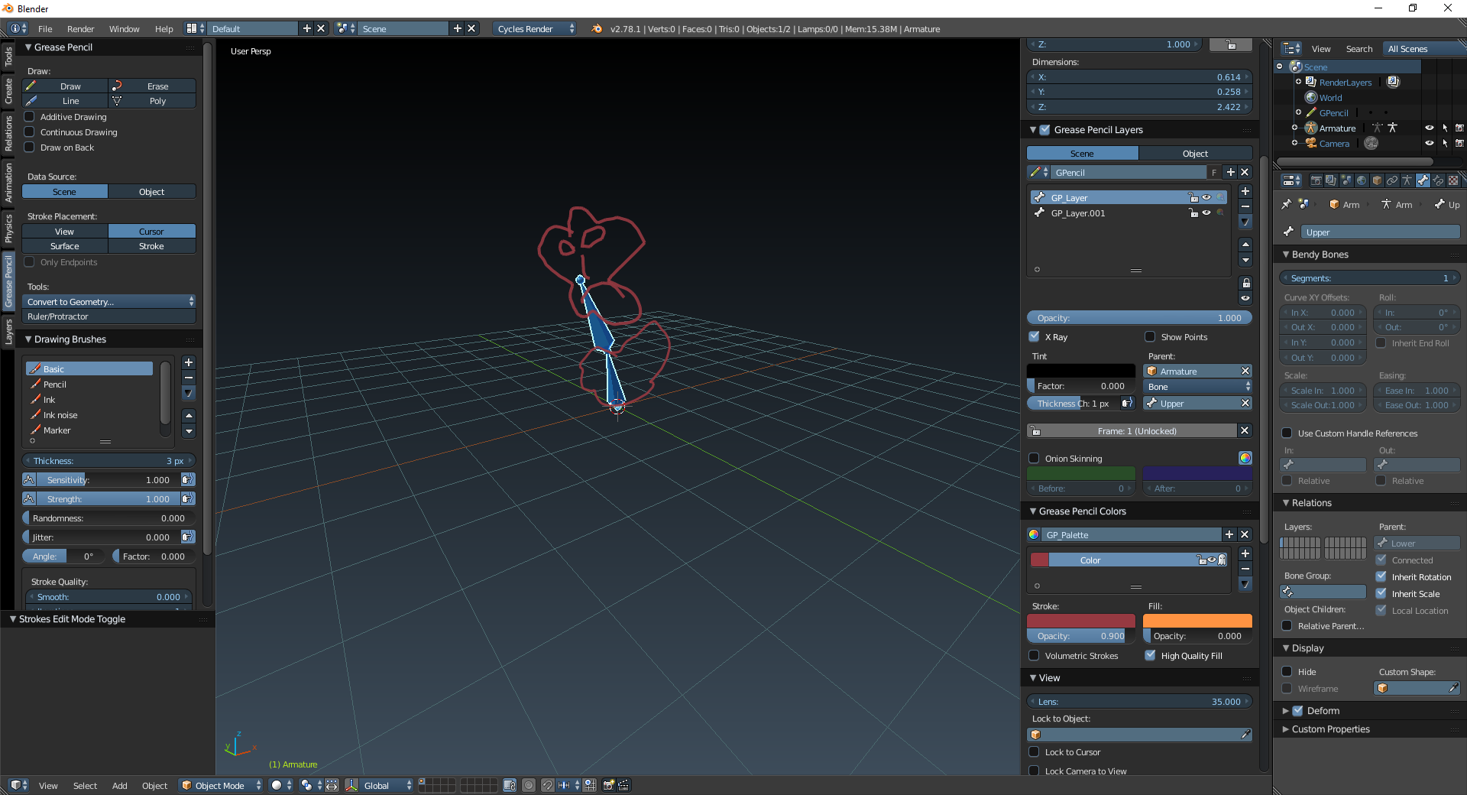

There does NOT appear to be a good way to get grease pencil strokes to tween. Right now you literally have to animate frame-by-frame or use bones. Unless we’re wrong. Which is possible. This is for Blender 2.78, BTW.

# Retopo

Retopo is used to make low-poly out of a high poly-model, or just to re-build topology. In 2.5 it is no longer a separate tool, just a specific mode. When snap is on (see the magnet in the bar at the bottom of the viewport), click the "use snap projction" button (plane in front of sphere) From here, you can either build something *on top of* what you're looking at, or you can then join the new geometry to the old and rebuild.

You can also use retopo to project shapes, or make a "cast" of something if you retopo a grid of verticies back onto an object.

Go into the object display options and turn on X-Ray to make things easier.

Also: you can start with a mesh square, get into a good starting spot, and then extrude individual edges / vertices to make your retopo'ed model.

Baking high-res surfaces onto your retopo'ed model after is pretty simple, see:

http://blenderartists.org/forum/showthread.php?236706-How-to-bake-normals&p=1988182&viewfull=1#post1988182

Using BSurfaces (the new name for Surface Sketchnd) makes retopo easy:

1) Create a plane and delete all the vertices; this will be the object to hold our retopo'd model.

2) Add a new grease pencil in the righthand pane / properties / N tool bar; Set the grease pencil to "surface".

3) Draw strokes with the grease pencil by holding down the 'D' key and dragging with the mouse. Assuming BSurfaces is loaded, you'll have an option in the lefthand toolbar to "add surface"

4) If you're having a problem with the new surface being below the surface of the original, then add a shrinkwrap modifier to the retopo'd mesh. You can change the offset to push the new vertices even farther out.

Note: for bsurfaces, loops on strokes will give you only cross loops where you've drawn a stroke. With this deselected, bsurfaces will draw any number of stokes, averaged and spread out evenly.

If you're using grease pencil with bsurfaces, the direction of the drawings matter.

If you’re trying to snap a whole bunch of vertices to a surface at once and it’s not working, look for a button called “project individual elements” in snap settings.

# Duplication

## Duplication Along a Curve (Dupliframes)

Note: this isn't intuitive at all.

Create your path, and under the curve options turn on "path animation" and click the "follow" button. Set frames to the number of copies you want.

Select your object to be duplicated, and under its object settings click Duplication / Frames, then disable speed.

Next, your object first, then the path. Then Ctrl+P to parent the object to the curve (you don't need to pick any of the "complicated" parenting options: just vanilla parent.) From here, hit Alt + O to reset the origin on the child, otherwise the cloned objects will just sit at the center of the scene.

Use Ctrl+Shift+A to make them real objects afterwards (at which point you can always Ctrl+J to join them.) They'll all be linked, so you may want to hit "make single user copy." The Speed option is used when the parent-child relationship is set to Follow Path (see below). In this example, the monkey will then travel along the circle over 16 frames. (As long as you go to the curve properties and set path animation / frames to 16).

## Dupliverts

If you duplication / verts on a parent object, all child objects will be duplicated on the vertices of the parent.

This one's easy: parent a child to a another object, then hit Duplication / Verts under the parent's Object / Duplication tab. Note that while the original child and the arrangement object are shown in view, neither will be rendered.

If you have "rotation" selected, the objects will face out on the vertex normals.

This is a good trick for duplicating lights for fake global illumination. Remember to reverse the normals if you're using a sphere as the mesh parent, as otherwise the lights fill face outwards.

Don't worry about hiding the duplivert/face clone original; it'll be hidden for you.

Ctrl + Shift + A – Makes Duplivert Objects Real

# Text

You can add text using the add menu. To actually change what the text says, go to edit mode with Tab, then type whatever you want.

# Bezier Curves

They’re easy to work with: after positioning the control points from the initial curve, you can add points to a curve by picking an endpoint and clicking CTRL LMB on a new spot to add a point. After you’re done, do A for all, then V, then set trangent type to automatic (the equivalent of the old pre-2.5 Shift+H/smooth handles) to smooth out all the tangents, which will save you from having to re-align them manually.

You can also use W/subdivide to create more points on the curve between existing verticies.

Blender will automatically make holes for you if you embed once curve in another.

You can manually control the thickness of a portion of curve by selecting it and then hitting Alt+S to scale. You won't notice this unless you add a bevel object to the curve. BevelObj is not a setting on the curve pane of Blender 2.5

You can also Shift+D to duplicate a point on a curve if you want to "branch off" of it. This is helpful if, for instance, you were making a tree out of curve shapes and wanted to make a branch.

You can draw them in 3d and have them “thickened” if you change (under the curve options pane) Fill to “full” and then change Bevel.

As of 2.78, there’s a new freehand draw curve option. To use it, you have to create a Bezier first, then go into edit mode, and under “Create” on the left hand tools pane use “Draw Curve.” Under options (also on the left), you can project to surface which will result in curves drawn on a surface. If you want to draw lines coming off of the surface (like hair), under options there’s a strangely-named option called “only first”, which means “only use the first surface normal to determine the orientation of the curve.)

Shift+RMB (in curve edit mode) – freehand draw curve.

Alt + C – Closes the loop on your curves, only works if you have the endpoints selected. (Seems to always give the same result as F) (Called "Toggle Cyclic") Alt + C will work if you have *any* point on the curve, though, where the "F" trick needs the endpoints selected.

F – Adds a segment between two verticies; also can join a curve.

V – Handle type menu

W - Specials (let you subdivide)

On the curve panel, the Bevel Object gives the object is profile.

On the curve panel, you can set taper and bevel curves under the "geometry" section.

When parenting a mesh to a curve, you will be presented with a menu that will allow you to do a curve deformation.

When you’re done, you can convert a curve to a mesh with Alt+C

*gotcha* You can spin a curve only after converting it to a mesh. This is part of the mesh mode tools menu in 2.5+.

After you’re done, you might end up with a “kink” where the start of your curve is. Select all the verticies, hit “w” to bring up the specials menu, and then “remove doubles.”

# BSurfaces

You have to make sure this add-on is enabled before you do anything with it.

The edit strokes option in the toolbar turns your grease pencil drawings into bezier curves.

Bsurfaces will create surfaces using grease pencil strokes or bezier curves.

1. Grease pencil curves can be drawn and being used while being in mesh edit mode.
2. Bézier curves have to be drawn first as a curve object. You have to select the curve object, select the target mesh container, switch into mesh edit mode and select the desired edges to perform the loft command to.
3. It is possible to switch into the curve edit mode to fine tune the crease pencil curves. However as with bézier curves, you have to select the curve container first, then the mesh container, switch into mesh edit mode to perform any BSurfaces operation.

Surfaces will be drawn through your created curves.

Selected mesh edges can have curves drawn between them to make a bridge.

If the tips of a stroke are near eachother, they surface will close auotmatically.

Swapping the first / last points in a curve can make twisted surfaces.

If you make a "crosshatch" style surface, make sure to leave "tails" at the end ... if you try to make a perfect square at the ends bsurfaces will likely vomit on you. Eg, make them like this:

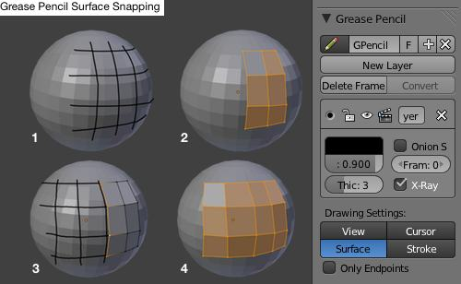

To *extend* a surface, you have to have the vertices that you’d like to extend **from** selected before you draw anything. Also note that new curves are drawn at the “depth” of the cursor, so make sure to set that in the right spot before drawing anything.

A “first vertex” is a vertex de-selected from an edgeloop. This lets you control twisting when doing briding.

Want to make a surface from Bezier curves?

Draw the curves, join them into one object (if necessary), then add a mesh object. With the mesh and the curves selected, go into edit mode of the mesh object, and bsurfaces will let you create the surface.

# Modifers

In 2.76+, the subsurf modifier now supports opensubdiv (from Pixar), which will speed rendering GREATLY.

You don't need parenting for a lattice to work, just enter the name of the lattice after adding a lattice modifier to an object. You can also add the lattice modifier by parenting the object to the lattice (Ctrl + P): Note: a lattice is a separate type of object from a mesh, and must be created using Shift+A / Lattice. You can't subdivide it: you can only control its # of x/y/z subdivisions through a special lattice tab in the tab stack.

You can Ctrl +L to link modifiers, which essentially "copies" the modifier stack across multiple selected objects!

Mirror mirrors meshes across an axis for you. The mirror happens around the center of the object, so you may have to manually place the center for this to work properly.

The curve modifer lets you deform a model with a curve. Had we known about this when we did our flowers, we would have used this instead of armatures for the petals, etc. (Although they're not as easily animated.) An easy way to overcome this is by adding hooks to control the bezier curve points. Click on each control point and choose "hook to new object" from Ctrl+h (hooks) menu. Now the spline will follow the hook, and the hook can be animated.

Verts can be assigned to different hooks from the Ctrl+H menu as well.

Tip: You can just parent a mesh to a curve to get a curve modifier automatically applied to your mesh.

Gotcha: When you’re creating a curve as a modifier for an object, make sure to place the curve directly on top of the object. If you leave it off to the side for editing purposes, the deformation on your object will not look right.

Gotcha: If you want the deformed object to match the length of the curve, you actually change this in the Curve’s object data panel under Shape / Path/Curve Deformed: stretch / bounds clamp (this is actually two boxes). Then if you select this curve as the basis of a curve modifier, the mesh will stretch to fit.

If you want to make copies of something (think array) but make the copies rotate, then use the array modifier with an empty for an object offset. From there, twist the empty and watch as the duplicates are created in a circle around the empty.

Protip: Want to control the size of a texture (say, applied to a displace modifier) interactively? Create an empty, then go the modifier, set the texture coordinates to “object”, then pick the empty. When you resize the empty, you’ll see the texture change in size; rotate will also change the orientation of the texture, etc. This can be useful, as it’s a bit more interactive than just changing numbers in a box.

Protip: Using an empty’s object space to control texture is also good if you’d like to duplicate an object and have the effects of the modifiers look different on each instance.

If you’re going to use displacement, make sure you apply the scale with Ctrl+A > Scale first, as displacement won’t turn out right otherwise.

# Materials

For flat, billboard-style textures that are applied to planes, you can use

Shift+T – Move texture space

Shfit+Alt+T – Resize texture space

To change the generated texture space coordiantes to your liking, which might be easier than creating UVs, etc.

To see materials in the viewport, tick "textured solid" on an object under the right-hand properties window (N) under Display/Shadi8ng.

L – Select Linked UVs (UV Editor)

Alt + L – Unlink Selection (UV Editor)

P – Pin Vertex (UV Edit Mode)

Alt + P – Unpin Vertex

U - Unwraps selection in edit mode.

W – Weld tool (UV Editor)

What’s the difference between the bump and displacement nodes? In practice, not much, aside from more exaggerated shadows on extreme bumps, with bump on the left. Some people seem to like the way that looks (but we think it looks … wrong.)

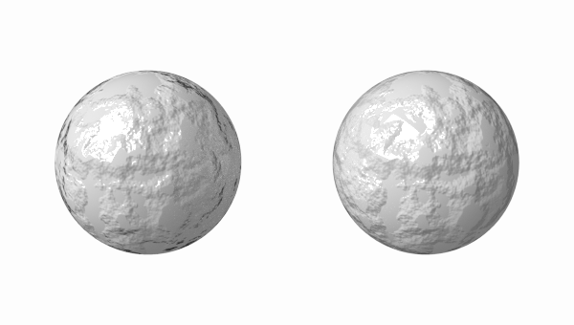

The other difference is that the displacement node (right) can actually *displace* geometry if enabled in the experimental feature set (as of 2.77)

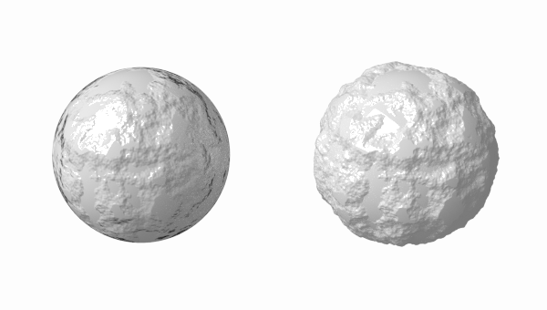

In general, light is far more likely to be reflected at grazing angles than dead-on, so use Fresnel reflection to fix this. Fresnel and layer weight nodes are similar, but Fresnel lets you choose the IOR, whereas layer weight is more for … “manual” tuning between 0 and 1.

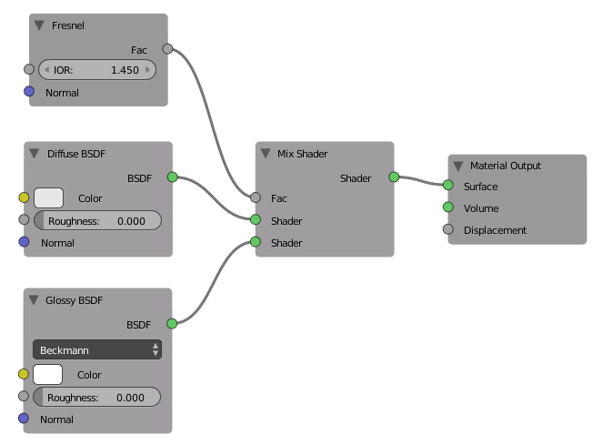

Gotcha: Absolutely make sure to apply the scale to the object before we UV unwrap it; the UV unwrapping will be flawed, otherwise

Gotcha: For cycles specular / bump / etc textures, make sure to set these to “non-color data” in the node editor.

Protip: try to unwrap so that seams are hidden out of view, or in less obvious parts of the model.

In cycles, use Beckman reflection is good for metals, GGX for anything else. Ashikhmin-shirley is something of a middle ground.

Refraction is a weirdo shader that is basically glass but without the reflection component. Think black holes or heat distortion.

Translucent is a shader that lets light through; meant for thin stuff like grass or paper. Use with other shaders for extra realism; also make sure light bounces are turned up, otherwise the materially will be un-naturally dark.

If you're trying to texture paint and Blender won't let you, check to make sure that you created an image over in the UV window to draw on.

One tutorial guy had good luck with "follow active quads" in the UV unwrap menu when working on difficult geometry.

Unwrap vs Follow Active Quads: As near as we can tell, unwrap will try to unwrap and fit everything in the window as cleanly as it can, takes seams into account, and will likely result in a “scrunched” shape. Follow active quads follows face loops, and does a better job of keeping things rectilinear. It is also dependent on the active face’s current UV orientation in some way we cannot fathom ATM.

If you get stray Uvs after unwrapping, click the “keep UV and blender selection in Sync” button in the toolbar. From there, you can pick the stray Uvs and delete them in the 3D editor window.

When you have a color map with alpha, you should apply it to color, alpha, **and** spec so that the tranparent parts don't reflect specular highlights. Also hit "premultiply" (premultiplies alpha) on the image pane so that your edges don't look all janky. If you have a B&W image that's *just* an alpha, you should probably hit "RGB to Intensity" under influence.

Blender lets you do displacement maps as a modifier and as a texture. The modifier seems to have a few extra options.

Vertex paint mode lets you paint on vertices; cycles puts this in an attribute called “Col” by default, although you can change this under the Object Data / Vertex Colors tab.

Raytrace is fancy transparency; depth is how many bounces: you typically need one for every entrance or exit from a surface + 1. The IOR is the index of refraction, which for glass 1.51714.

In reflection: What’s Fresnel? What this means is the color of the material will be strong because the light source is taken into consideration. If the Fresnel wasn't used, the object would appear dark because the light source isn't directly calculated in the mirror.

When light strikes a surface and is re-irradiated in all directions isotropically, this is diffusion. This means the camera will see the same amount of light from that point no matter what the incident viewing angle is.

Specular reflection, on the other hand, is viewpoint-dependent. The basis of this is Snell’s law. Diffusion is dominant on surfaces with large amounts of small-scale roughness (which scatters light), while specular reflection dominates on a smooth surface.

If you mark a group of faces with a seam, then select a face and hit “L” (for Link), Blender will select the rest of the faces in that seam in UV Edit Mode.

In the internal renderer, you can pick from a bunch of items (such as Halo) that render based on a per-vertex basis, not per-face. Halo is now on the top of the pane. Halo cause vertices to render as points of light. Cycles can’t do this (as of 2.72), so you have to composite this to get that effect.

The 'Add' slider controls how much the halo is 'added' to whatever is behind it - this is more used for textures to control how much of the texture you want to appear on the objects. An easy way to think of the 'Add' slider is as a transparency for all of the halos.

Environment maps allow you to kludge true environmental reflections into your scene. Displacement maps only really work on meatballs and meshes. You should convert NURBS surfaces and other surfaces to meshes before displacing them.

Tip: If you have islands in your unwrapped UVs, you can select one vertex, then hit L to select all the linked vertices, then G to move that island out of the way (or whatever.)

The W (Weld) menu also gives options to align selected vertices in either X or Y axes.

To actually paint in texture paint mode, you have to go into Image / Texture Paint. It also helps if you go to View / View Paint Tool, which will let you select colors, etc.

If you want to mark a seam as creased, one way to do it is to change the value for “Mean Create” in the transform menu. (The one under ‘n’, near the top by the x/y/z values. Only available in edit mode.)

If you assign UV maps to an object for coloring that already has a texture on it, you need to make the texture opaque so you can “see” underneath it to the UV map image. (This can be done with the Col(or) slider in “Map To” in the Material Buttons.)

Mist can also be turned on in the environment settings. If you want to see the range, go to your camera, and hit "display mist" under Display.

Clay can benefit from Sub-surface scattering. use the "cream" preset for good results.

If you Ctrl+LMB in a ramp selector, you add a new ramp point

This is the right way to hook up a normal map in Cycles: make sure to set you texture to non-color data, put it on a normal map node, then map THAT into the normal node input:

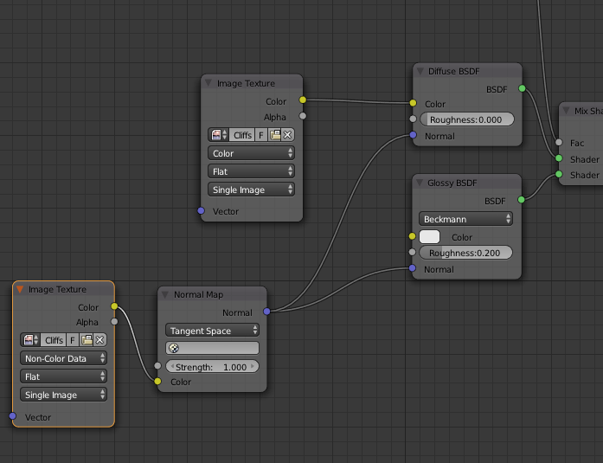

## Glossy Variations

Sharp glossy is for perfectly reflective materials; it’s basically a perfect mirror. You can get the same result with the other distributions by setting roughness to zero, but they won’t be as fast as “Sharp.”

Beckmann and GGX are two different algorithms for simulating 'microfacets' or micro scratches in dielectrics (typically things with reflection that arent metal) and conductors (metal). These are usually called 'microfacet distribution' and simulate the effect of very small imperfections in a surface - resulting in what appears to be a different falloff.

From left to right, the roughness or glossiness parameter is increasing from 0 to 1 in increments of 0.1. From top to bottom, they are vanilla Beckmann, vanilla Ashikhmin-Shirley, vanilla GGX:

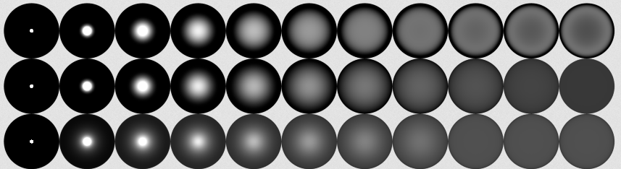

Beckmann acts particularly oddly at higher roughnesses (>.6) so if you're going to use it I would stay away from making your materials rougher than that.

More opinion from the web:

* **Sharp**: It creates perfect reflections and doesn't use the roughness paramenter. It is equal to Beckmann or Ashikhmin-Shirley distributions with a roughness value of 0.0, but Sharp is faster in rendering in this case.
* **Beckmann**: It is better for materials which reflect much light or are very shining or glossy, that is, whose roughness is lower than 0.2.
* **GGX**: It is better for materials which reflect little light or are little shining, that is, whose roughness is higher than 0.2.
* **Ashikhmin-Shirley**: This distribution was introduced in cycles after Beckmann. It is said that it is more perfect and real than Beckmann, but probably a bit slowly in rendering. Differences can be appreciated when reflecting dark colors (Ashikhmin-Shirley is better).

The Blender Cycles Lighting and Rendering Cookbook states that GGX is better for organic surfaces, while Beckman is better for inorganic surfaces.

As for the others’, here’s a good overview:

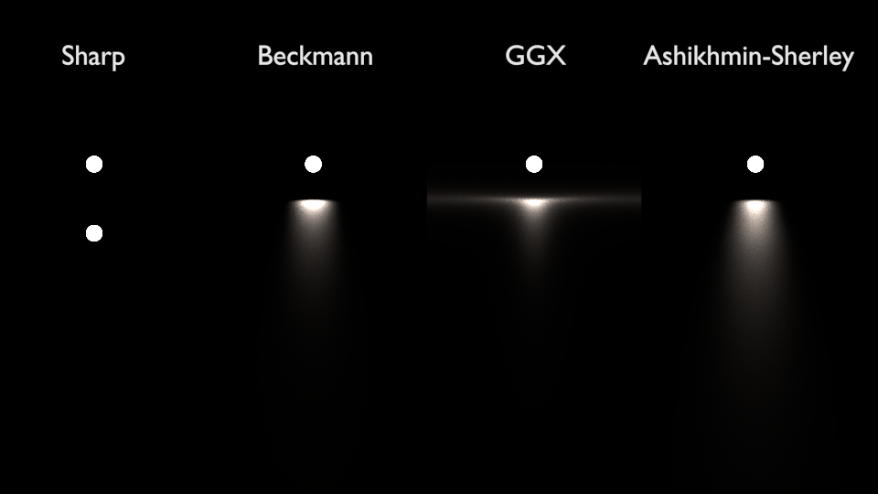

From Stack Overflow:

tl;dr: Always use GGX, set your roughness map to Non-color Data and square it with a math node before plugging it into the Glossy BSDF.

Different microfacet distributions will have differently shaped specular highlights. Beckmann and Ashikhmin-Shirley are both similar to a Blinn-Phong specular highlight that you might find in a game engine or Blender Internal, although they're normalized so that tighter highlights are brighter and duller highlights are less bright.

If you are just rendering for yourself I'd recommend sticking with GGX unless you've got a really, really good reason not to. The longer tail on the highlight makes the microfacet distribution more believable. Generally people remap the roughness map to make it more perceptually linear, so that if something is 30% glossy (for example) a specular highlight will have a radius of 30% of the radius of the hemisphere.

AS:

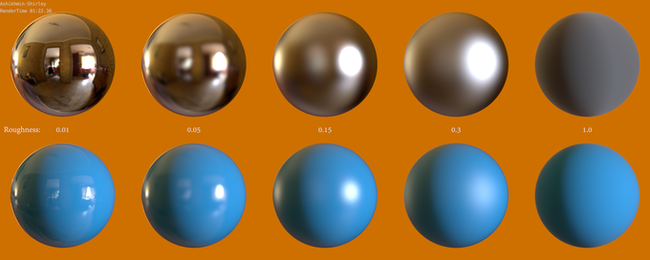

Beckmann:

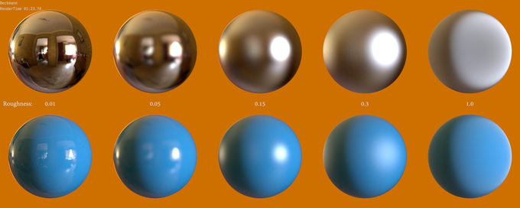

GCX: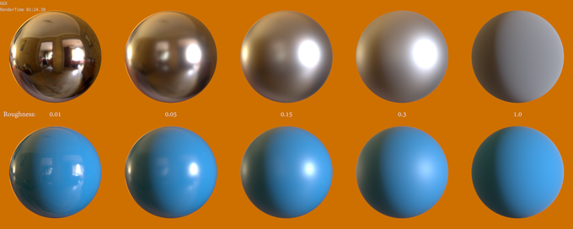

## Adding Variation To Your Colors

Use the random output of the object info node as the input to a ColorRamp with as many variations as you’d like. From here, feed that color into a MixRGB with your primary color, or set the Node to “screen” and use the ColorRamp as the 2nd input.

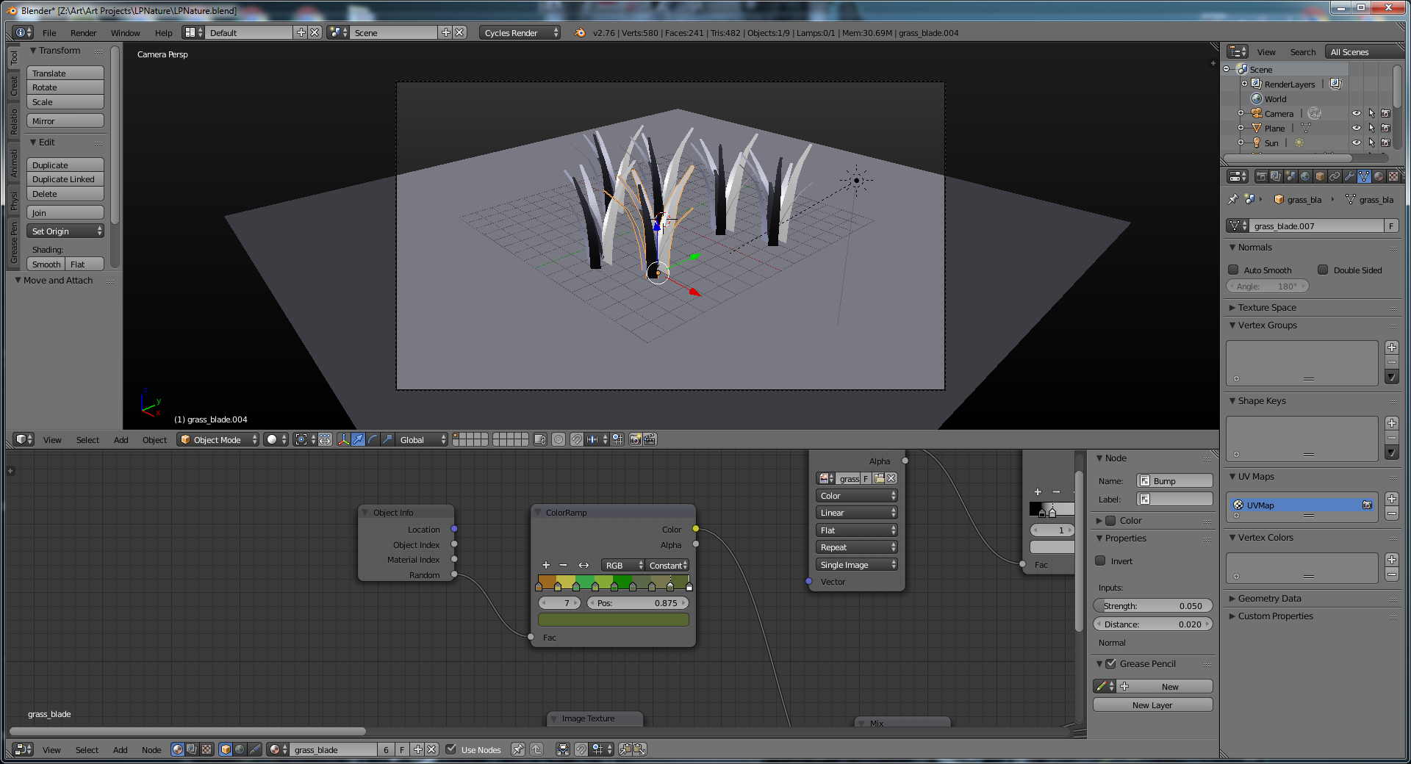

## Matcaps

Matcaps (short for material capture) are materials with all the lighting and reflections for a scene baked in already. The main purpose seems to be for sculpting: you can get an accurate representation of what the material will look like in the scene without having the expense of a real material.

matcap stands for "material capture" -- it is a complete material **including lighting and reflections** so you can add it to an object and not have any need for, well, lighting and reflections. It is most commonly used for sculpting, as it gives quick and useful feedback on how an objects shape is changing.  
  
The key to using a matcap texture is that is is mapped to the object's *normals* (which exist in relation to the camera), and your material is set to *shadeless* (because you don't need lights to have any influence, as they are a part of the matcap texture):

So as the camera moves around the object, the reflections and highlights move around your object (as if the object were moving and not the camera). In other words, if your object were a sphere, no matter how you looked at it, it would look like the matcap sphere (reflections always in the same place, e.g.). But as your object takes non-spherical shapes, thus changing the normals, the material responds as if it were made of the complex material (in this example I'm using the zbrush jade matcap):

You can set up a matcap – a material that’s entirely dependent on a material’s tangent space like follows. The matcap itself is a spherical image. The matcap is in the lower left; using this material will cause objects to always show their light source to the upper left.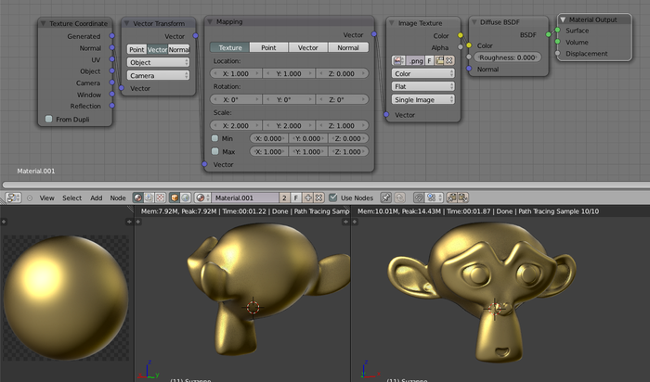

Note that to truly make this a shaderless material, you should use an emission output with a low strength, and use a light path node to only “present” the material for camera rays. This trick is also good for NPR materials.

NOTE: As of Blender 2.7X, you can easily get a matcap in the viewport for any object by going to Properties (the N bar on the right), Shading > Matcap.

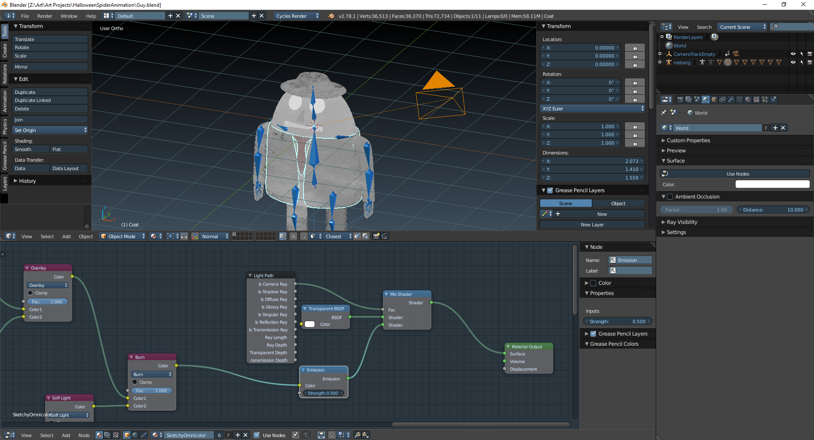

# Nodes Editor

2.67+ will adjust your nodes for you when you stick something in the middle. By default, everything will be moved *right¸* but you can hold “t” while doing the insert to move the nodes on the left instead.

X – will delete a node, but CTRL+X will delete a node and reroute the old connections, which is handy for removing a node from a chain.

Ctrl+X just seems to vaporize the nodes instead of cutting. Either use Ctrl+C / Ctrl+V, or just use the “copy to clipboard” and “copy from clipboard” icons on the lower toolbar.

You can set labels for every node in your scene. The node box is in the properties panel:

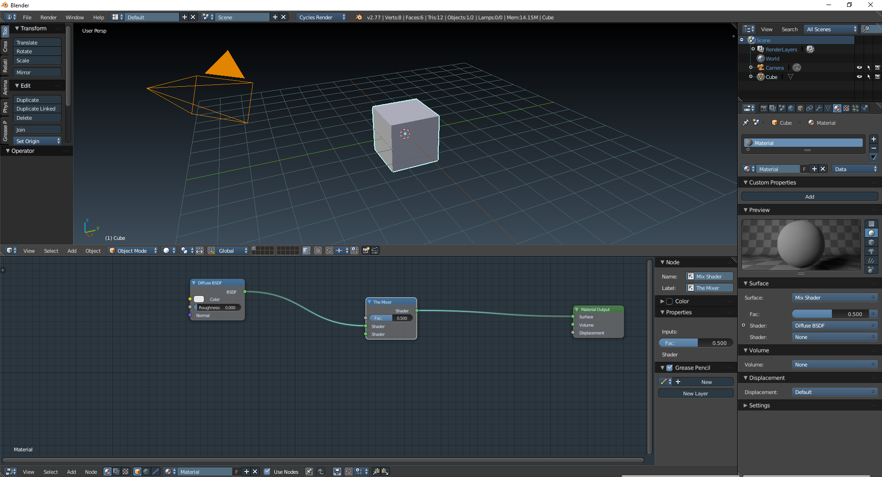 and when set, will change the text on the node in the viewport:



Ctrl + H – Hide the unused input / output sockets of a node.

F – Automatically links nodes together. It appears to work by finding the rightmost node of the expected type and linking it. It can only link one input at a time, so don’t expect it to plug both inputs of a Mix Shader.

Ctrl+F – Opens the find box, finds a node in your setup by name (which is also another reason to use labels).

Alt + Drag (on a node) – Move a node around, but preserve links. Blender will attempt to reroute the links after movement (ala Ctrl+X)

A "golden rule" of sorts is: match colors with colors.

Generated Coordinates – Uses the bounding box of the object to generate axes from 0-1, with the 0,0,0 point being in the lower lefthand down corner. Generated coordinates have a problem in that if one axis gets stretched, the UVs get stretched in that direction as well; now your procedural textures will be elongated in that direction.

Object Coordinates – Uses the center of the object as the origin. Uses local axes, and units don’t depend on object’s shape. It’s always 1 blender unit along each axis. Because it uses the object center as its 0,0,0 point, it will have trouble with non-tileable textures. This isn’t the case with procedural textures, which is what object coordinates are normally used with.

Ctrl+Shift+Click on a node to add a viewer to it.

When you rotate the coordinate system with a vector transformation, the texture is rotated around the origin for the coordiantes: object center for “object”, lld corner for “generated.”

It appears that if you have a node that won’t let you enter negative values (such as a color node’s r/g/b fields), you can actually force it by feeding a value node into the target node instead of entering a number directly into the target node.

You can’t animate UV coordinates with the regular mapping node, but you can fake it by making your own scale / translate / rotate nodes. Note that in Vector/Point mode, rotations are done Z Y X, while in Texture mode, the rotations are done X Y Z.

A custom translate can be done using the ColorRGB Add (blender will treat colors and vectors the same), so just set the RGB values like you would XYZ.

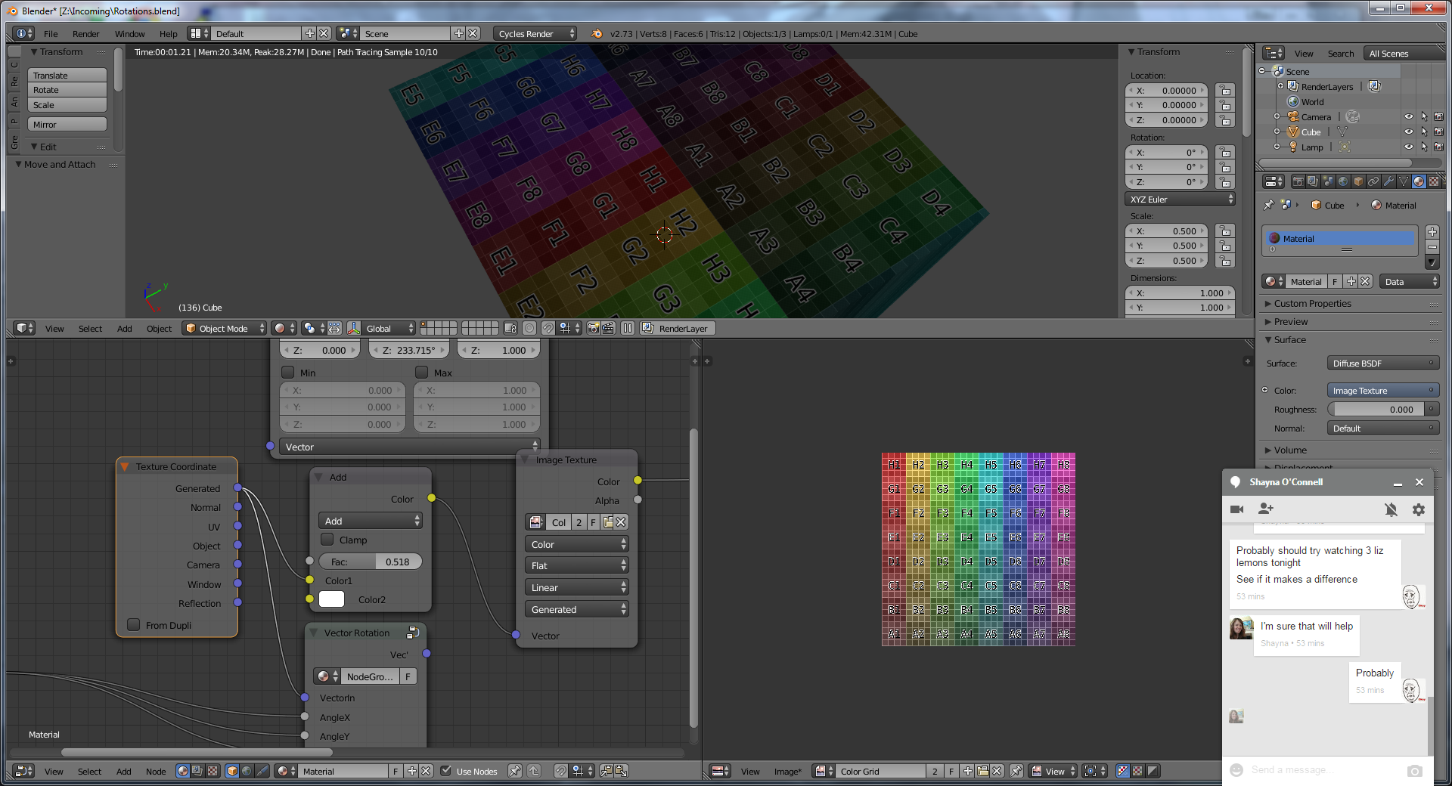

Want a negative shift? If you have a node that won’t let you enter negative values (such as the color node’s r/g/b fields), you can actually force it by feeding a value node into the target node instead of entering a number directly into the target node.

Shift + Drag over a group of lines: will create a “reroute” node for them, essentially cleaning them up: (2.64+)

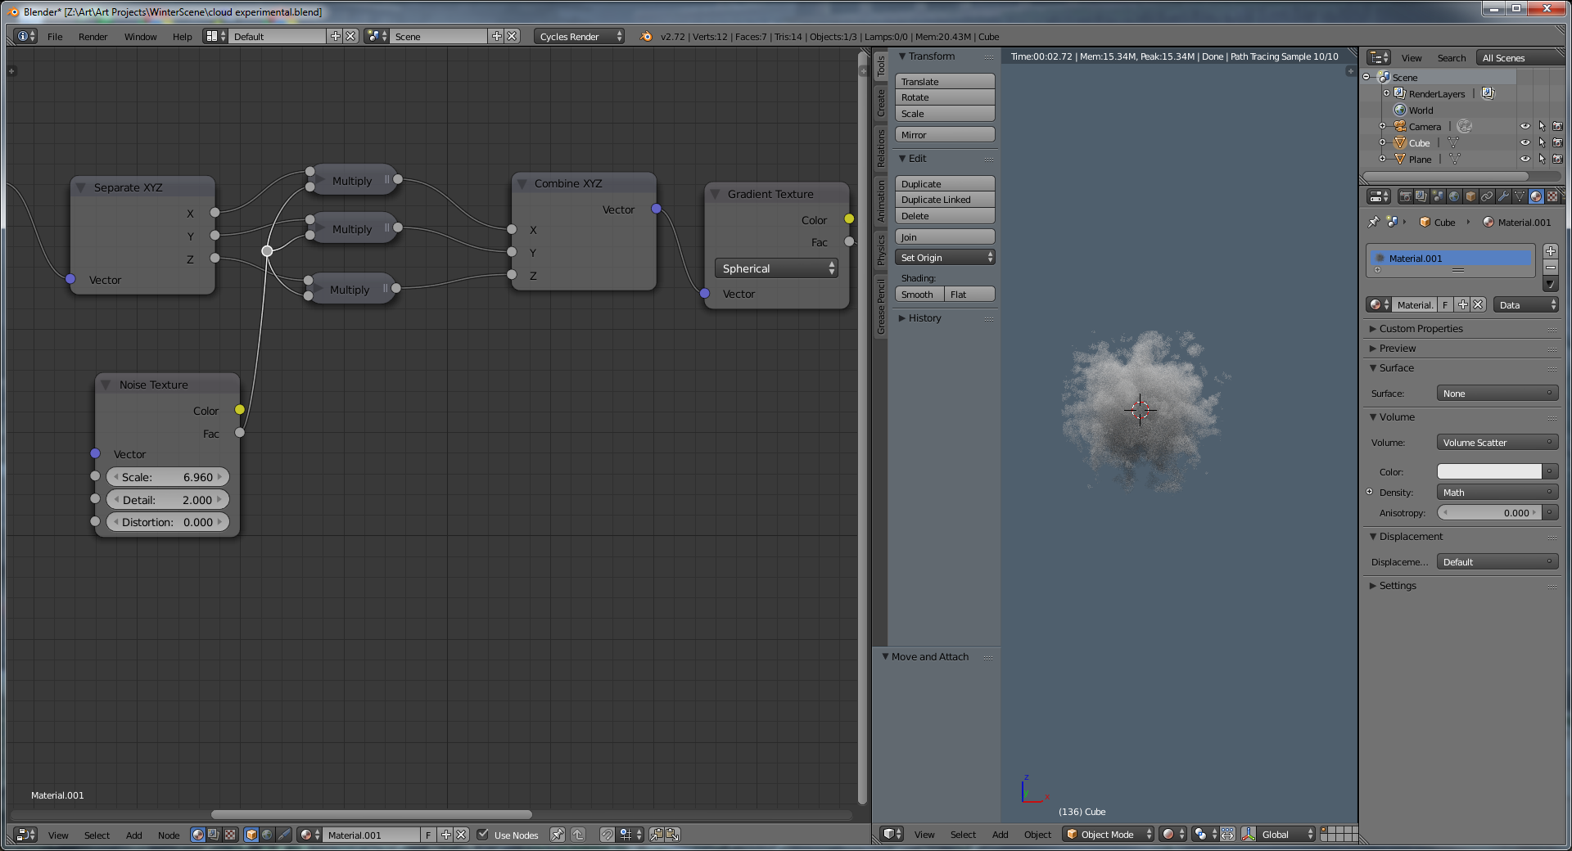

If you want to connect up a bunch of nodes, box select them (B), then hit F to connect their ports by type.

Two steps to doing a material in node editor:

1. Click on the object, then switch to node editor
2. Click on "use nodes" on the bottom toolbar.

If you've made a group, hit "tab" to open it up and edit it.

Ctrl + X on a material node: deletes the node without breaking your link (replaces your node with a link from the node to its left to the node to its right.)

Ctrl + LMB drag - makes a knife, lets you cut existing node connections.

Ctrl + G - Make a group – if something is selected, it’s added to the group automatically.

If you'd prefer something a little less "black-box" than a group, use a frame node, which lets you color and label node sets for your shader.

Cycles nodes have a “Random” output under “Object Info” (!?) you can use this to add a little randomness to your material. Note that the random value is *PER OBJECT*, not per fragment. This can be used for random colors in particle systems, or to select random textures for object instances, etc.

You feed the random node output into the “Hue” terminal of a Color/HSV node, then send that to your diffuse. Note that this won’t work if you leave the default color of the HSV’s “Color” node as white; in this case, there’s no hue to change!

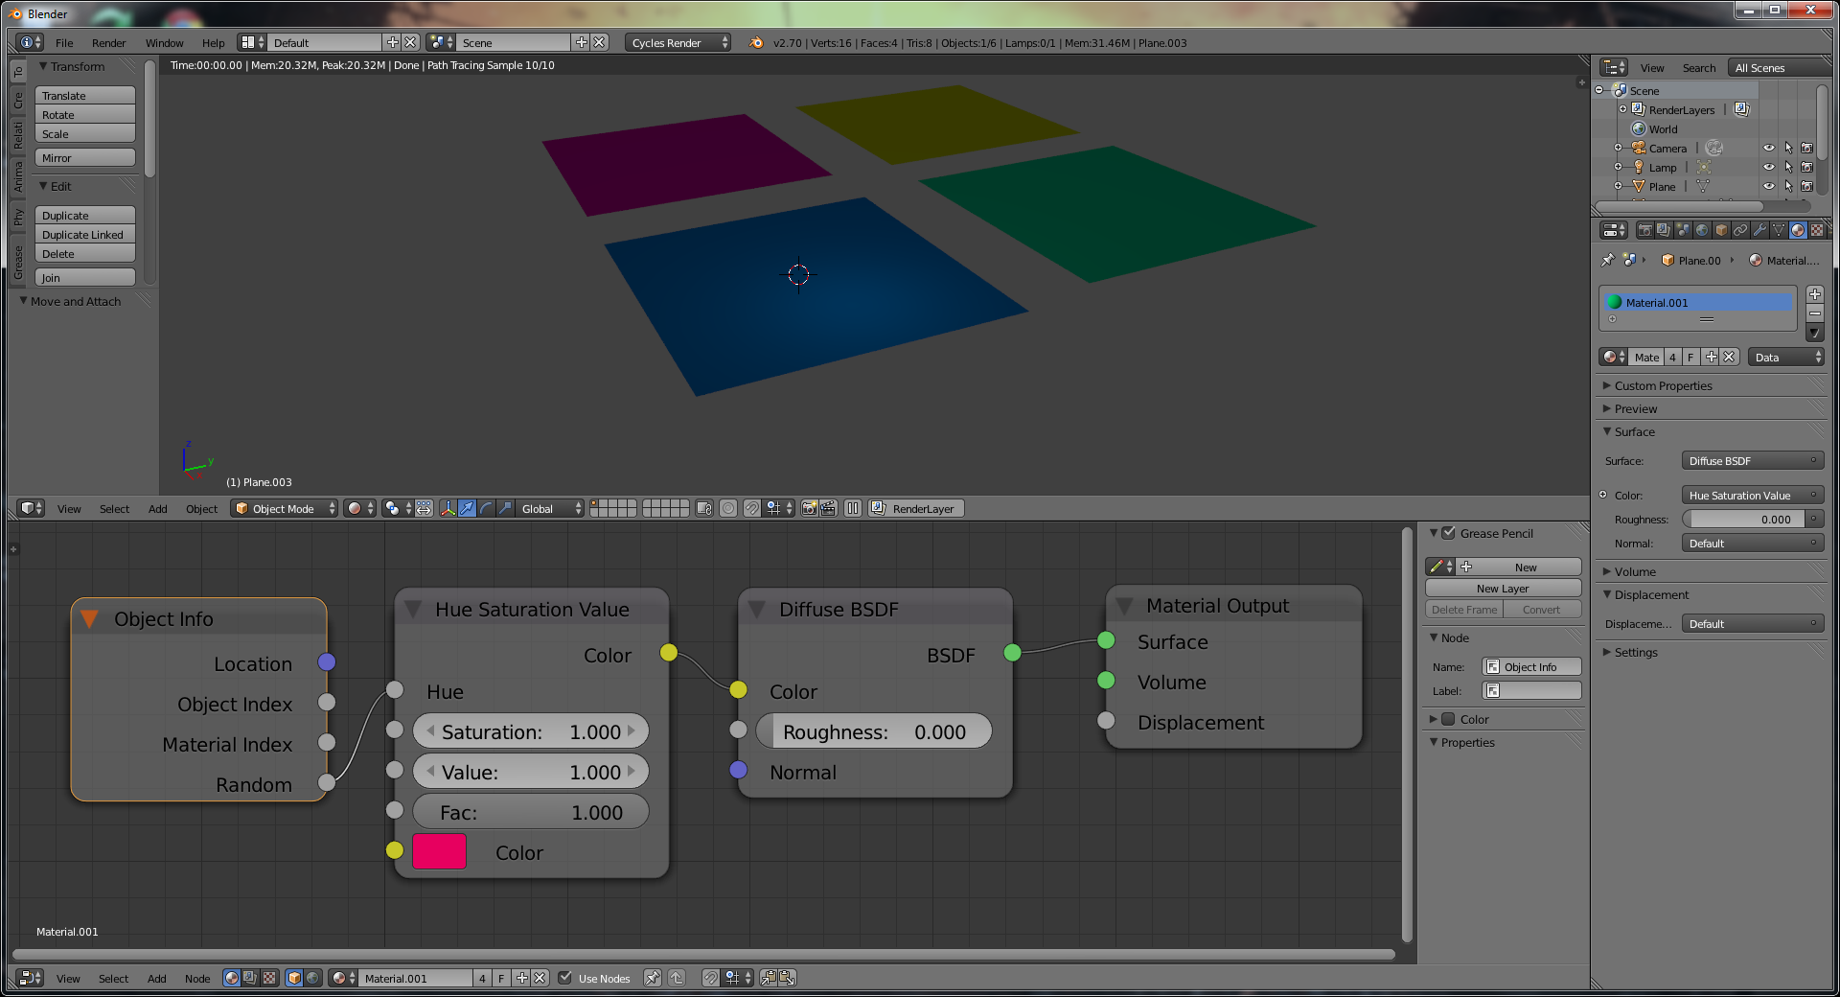

Want to pick between textures? Feed the random to a Math/Converter set to round (for force the random value to Int 0 or 1), then input *that* value to the Fac of a Mix node:

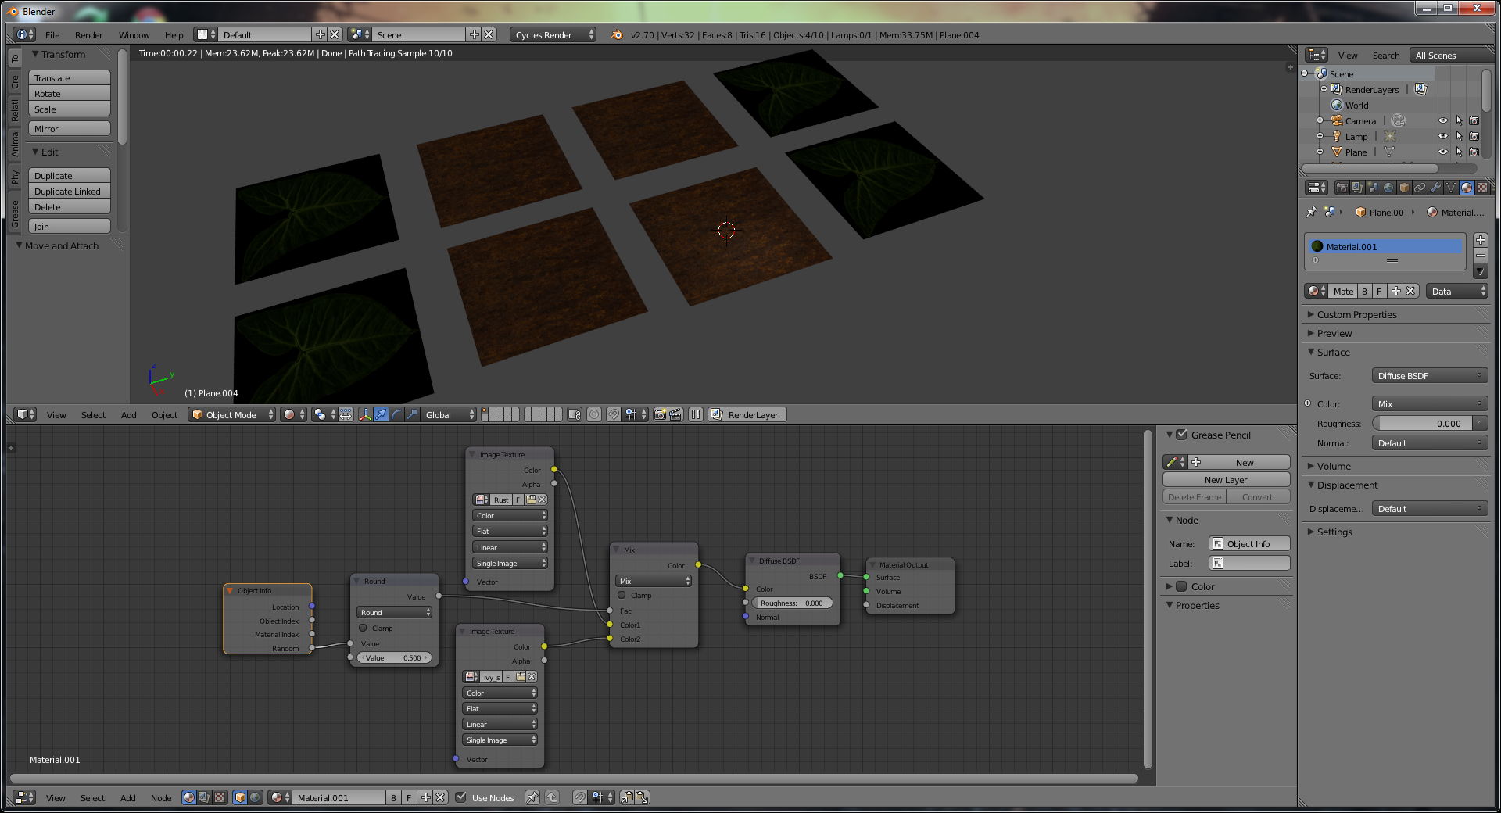

One slight variation of this technique is to replace the Math/Converter/Round with a ColorRamp node set to constant; then as you slide the far stop back and forth you can change the weighting of which texture will be selected.

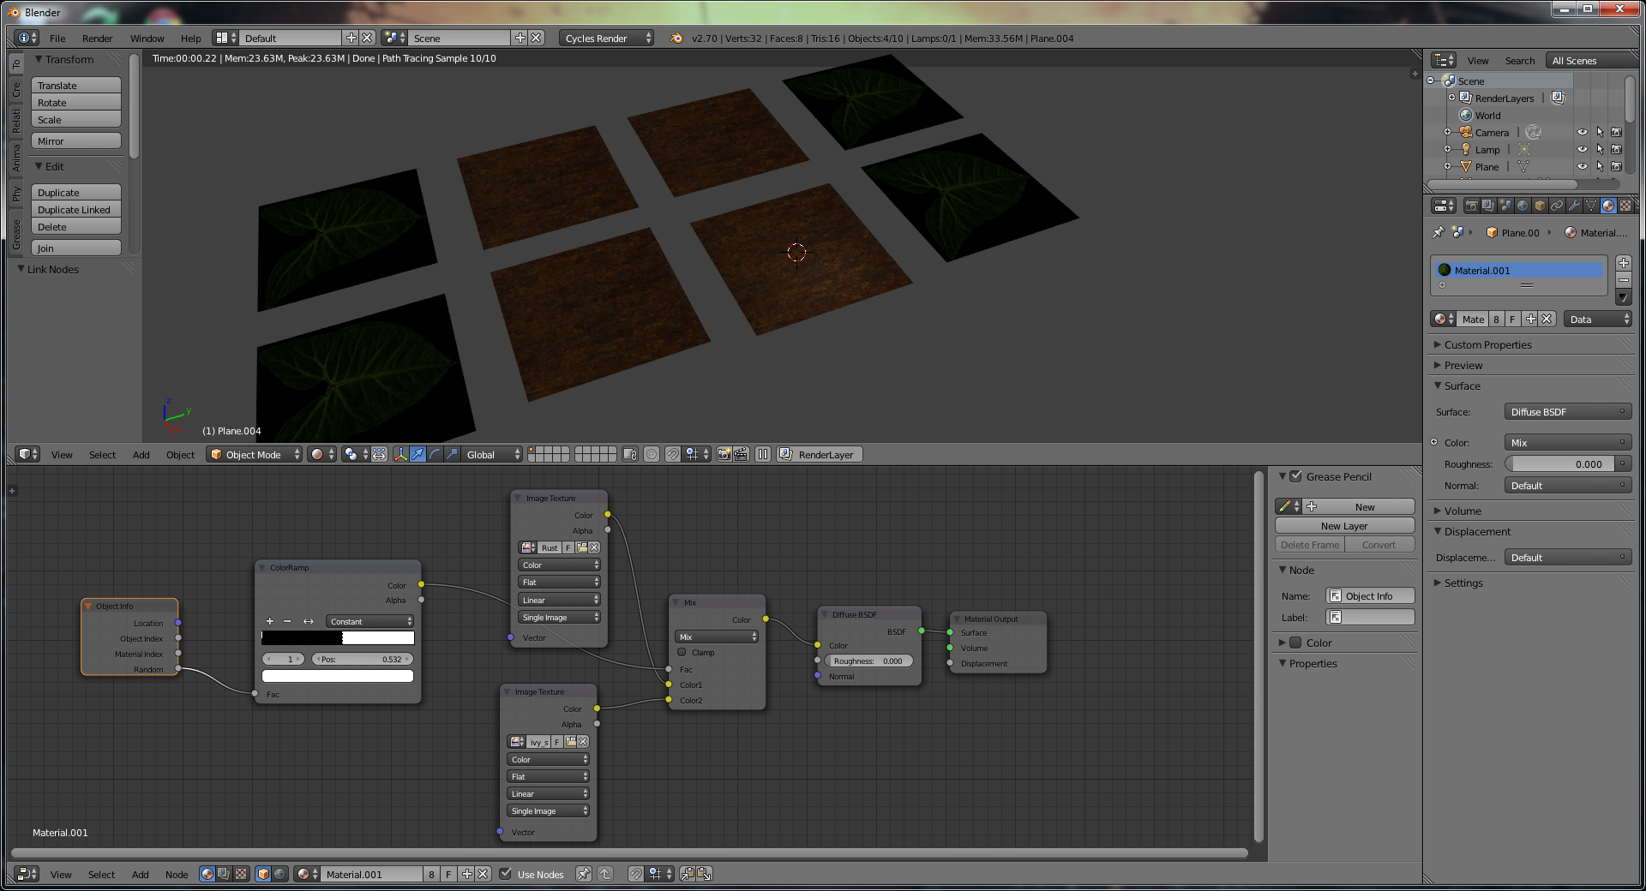

Want a noise texture that scales with the object? Use the object coordinates from the Inputs menu as the input to your noise texture instead of “generated” or “UV”.

# OSL

OSL is pretty boss for creating procedural textures.

The first line has to be #include “stdosl.h”.

P is a global variable that is the point value (in world space) of the point being shaded. Get X and Y by doing: point Pos = P; float x = Pos[0]; float y = Pos[1];

To convert that to object space, do point Local = transform(“object”, Pos);

The OSL spec actually defines 4 shader types (surface, volume, etc), but blender only supports generic shaders (prefaced by “shader”), as the *type* of shader (in Blender) is determined by the output node that the OSL block is hooked up to.

Then you define a function by passing in arguments:

shader node_advancedAdd( float Fac1 = 0.5, closure color Closure1 = 0) {}

Outputs are actually specified as parameters with the word “output” prepended:

output closure color Closure = 0

OSL's surface and volume shaders compute an explicit symbolic description, called a "closure", of the way a surface or volume scatters light, in units of radiance.  These radiance closures may be evaluated in particular directions, sampled to find important directions, or saved for later evaluation and re-evaluation.

### Surface and volume shaders do not loop over lights or shoot rays.

There are no "light loops" or explicitly traced rays in OSL surface shaders. Instead, surface shaders compute a radiance closure describing how the surface scatters light, and a part of the renderer called an "integrator" evaluates the closures for a particular set of light sources and determines in which directions rays should be traced. Effects that would ordinarily require explicit ray tracing, such as reflection and refraction, are simply part of the radiance closure and look like any other BSDF.

Advantages of this approach include that integration and sampling may be batched or re-ordered to increase ray coherence; a "ray budget" can be allocated to optimally sample the BSDF; the closures may be used by for bidirectional ray tracing or Metropolis light transport; and the closures may be rapidly re-evaluated with new lighting without having to re-run the shaders.

OSL does not have a separate kind of shader for light sources. Lights are simply surfaces that are emissive, and all lights are area lights.

OSL shaders are evaluated in "SIMD" fashion, executing shaders on many points at once, but there is no need to burden shader writers with declaring which variables need to be uniform or varying. In OSL, this is done both automatically and dynamically, meaning that a variable can switch back and forth between uniform and varying, on an instruction-by-instruction basis, depending on what is assigned to it.

# UV Edit

A nice easy way to get specific sections of loops is to select the first and last vertices you're interested in, then hit "W" and "Select Vertex Path."

In 2.6, the only unwrapper that "respects" seams is the first one: plain-old unwrap.

A lot of the regular blender tricks still work. Alt+Shift+RMB will select a line of verticies (instead of an edge loop), for instance.

A neat trick to straighten something out: select a line of UVs that's either perfectly vertical or horizontal, then do the Scale->0 trick. Pin the verticies with P, then re-unwap, and the entire UV unwrap will align itself properly.

As of 2.67, you can now scale islands around their individual origins.

If you turn on “live wrap” in the UV editing mode, you can then pin two or more verticies. Moving one of the pin verticies will reflow the UVs in realtime.

# Vertex Painting

Vertex painting is maybe the simplest way of getting color on an object; it waon't show up on your material unless you go into the material's options and select 'vertex color paint'.

In 2.7x(??), there’s a button on the bar in Vertex Paint mode that will use your edit mode selection as a mask for vertex painting.

To make it work in cycles, just attach the "Col" attribute to your diffuse (or whatever) shader:

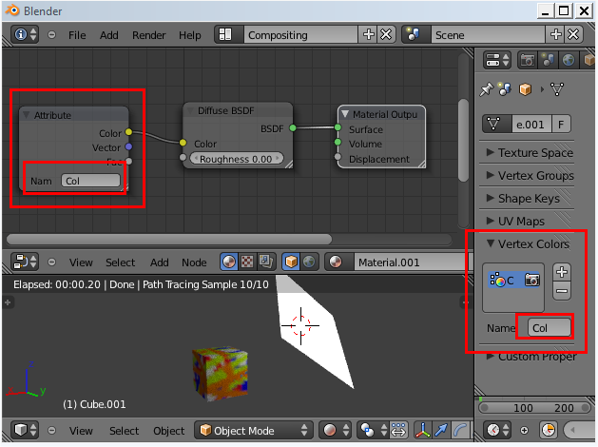

Normally, the vertex paint will bleed into all faces that the vertex touches; in the lefthand tool window, go to options / “All Faces” and turn this off; this will only affect the face at the center of the brush (which is good for assigning one color to a face for things like coloring materials, etc.)

While you can keep the color in one face by being careful not to drift onto other faces, this is sometimes made easier by selecting the face ahead of time in edit mode, then using Shift+Num 7 to align the camera on the face in question.

Face selection masking can help you avoid vertex painting in the wrong area.

1. Select the vertices you want to paint on in edit mode.
2. Change to vertex paint mode.
3. Enable Face Selection making in the 3d header; there will now be a dotted line around the selected faces.
4. Press Shift_K or paint to fill the selection with the selected color.
5. 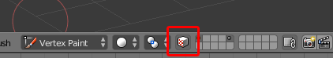

You can then use a material setup life follows to use the vertex paint colors to select materials as well:

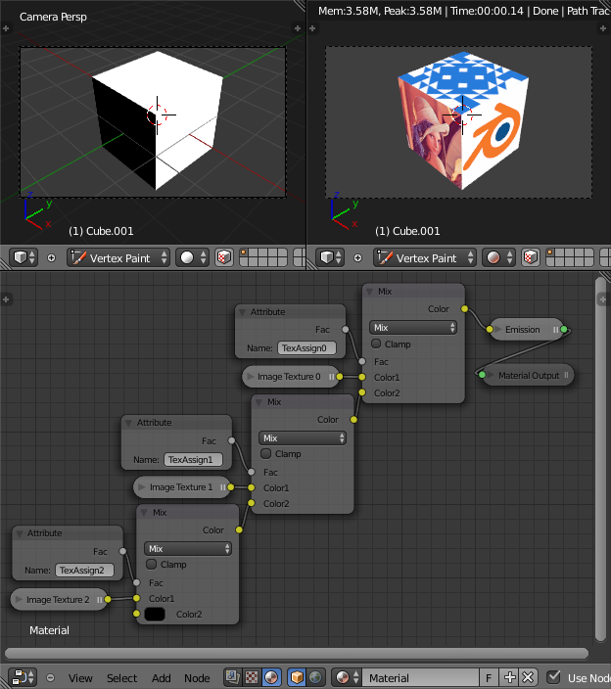

# Texture Painting

F - If you drag after this, it lets you resize the brush

If you need to do some touch-up work, right-click on a part of the model that has the color you want. (similar to the eyedropper in Photoshop.) Saves a lot of time.

To paint in the UV Map, go over to the uv map window, and turn on “image paint” from the image menu. You can then paint in the uv map using the same paintbrush tools as the model.

Ctrl+L (select linked) – will select everything but respects seams, so this is handy for selecting geometry to identify where it “lives” on the UV map.

Sync selection (one of the icons in the UV edit window) lets you see which geometry corresponds to which part of the UV map. Handy for figuring out what islands go with what geometry.

MAKE SURE TO ONLY PAINT TO POWER-OF-TWO TEXTURES! Otherwise blender gets a little slow. See: http://blenderartists.org/forum/showthread.php?257323-What-everybody-needs-to-know-about-Blender-Viewport-performance

Things getting slow when painting with large brushes? Go to "Project Paint" settings in the T/Toolbar menu and turn off "occlude", which overlaps in functionality with Cull directly below (and is much slower, although supposedly more accurate.)

When "Normal" is on, it will draw more intensely on faces facing the camera. Also make sure bleed is on slightly if you're drawing over an area with a seam, as it'll

You can texture paint in cycles, but you have to add the image you're painting onto as a map on the image. Blender internal will magically show you the current image that's in the UV editor.

When you're painting on an object and you'd like to know what's going to end up where, make sure to hit the "overlay" eye enable, which will show you where your paint will go.

The stencil option for texture paint works just like the sculpt version. Random tries to work around tiling problems, but the results are ... ehh. It's best used for touch-ups. View plane doesn't work too well with textures, as it tends to over-repeat.

The “defaults” at the top aren’t special – you can build your own by changing the stroke & curve settings in the tools. Not that some of the defaults (such as the “flat” setting under the curve) aren’t very useful, as they’re not anti-aliased. If you use a flat curve, you’ll get this when you paint:

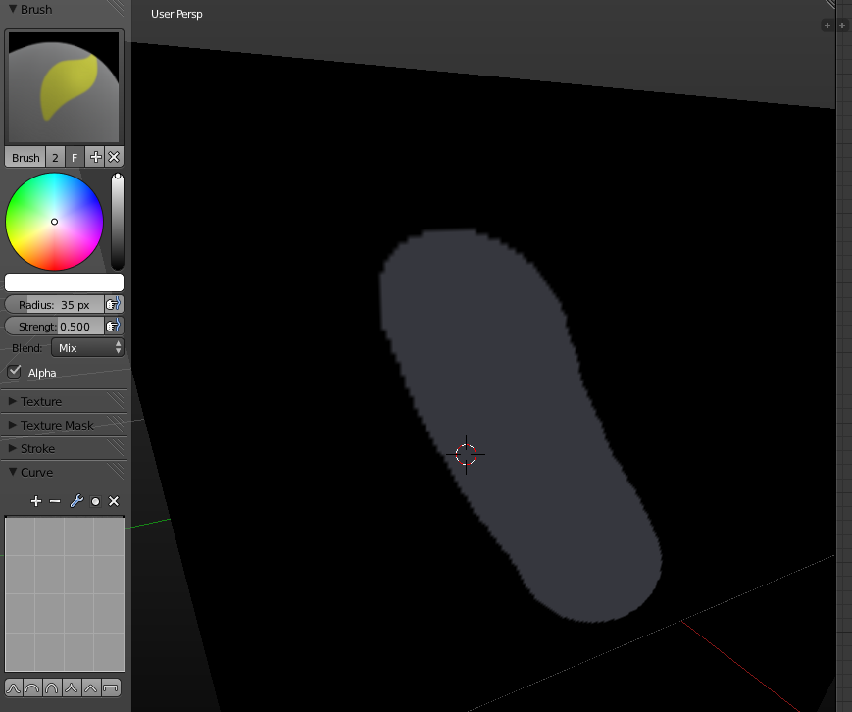

Instead, put a little drop off at the far right end (the outer portion of the stroke) for DIY “antialiasing.”

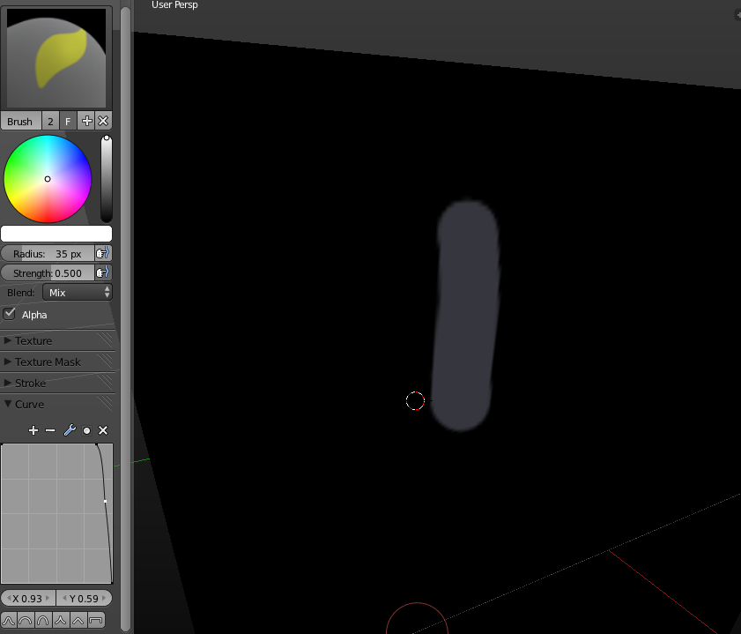

Not perfect, but … better. Also note that from what we’ve seen, he 2014 GSOC changes will make this look better as well.

Also note that there’s no reason to do this yourself. The “Brush Hard” default out of this box does this for you, but it’s good to know in case you need to make your own brush.

You can also edit textures in an external editor. This is sometimes called “reprojection painting”, as a screenshot of the current view will be loaded into your image editor, then re-applied (well, after you hit the apply button in “External Editing”) back onto the image, even if you’ve since rotated to a different orientation, etc. Fancy!

For seamless painting, be sure to set the UV/image editor to paint mode (bottom tab bar), then hit “N” for options and enable “Repeat” under display, then on the “T” tools menu, go to the options tab / Image Paint, “wrap”

For making tileable textures, it’s usually easier to paint straight to the image as opposed to painting on the model itself.

When painting displacement maps, set the background to be gray. This way, any black areas will form a depression and any weight areas will be raised. This beats fiddling with levels later.

When using a texture for a displacement map, you might get crazy, jagged geometry if the source texture is very sharp. Do a guassian blur on it in Photoshop to help alleviate this problem.

# Weight Painting

You can pick bones in weight paint mode, but you have to do it in a (not-entirely) obvious manner. This supposedly only works if the armature is already the parent of the mesh:

First, select the armature and go to pose mode. Next, select the mesh and go to weight paint mode. From here, you can Ctrl+LMB click on the bones to paint weights for that bone’s vertex group. (Note that if we were using the “traditional” blender RMB-based selection, this would be Ctrl+RMB instead.)

# Projection Painting

You need two different UV sets for this to work: one unwrapped normally, and one for each of your angles (left/right/front, etc) Once you have multiple UVs set up, just do a project from view (for front, etc).

From there, align the UVs as necessary for each projection, then go into texture paint mode. In the tools, change the tool from the default (paint) to clone.

Next, go to the options tab to find the “Project Paint” options. Select “clone from UV map”, then paint from each UV map as needed.

# Texture Add-Ons

Texture Paint Layer Manager needs to be added in user prefs. It will add a number of options to the to the properties (N) pane for adding paint layers.

In the tool panel you can then add any type of paint layer (color / alpha / bump / etc) that you want. Behind the scenes it will create maps for each of your channels. You have to go into edit mode and unwrap before any of this works, however.

By default, you can only paint at surfaces 80 degrees or less away from the normal, change that in Project Paint in the texture paint tools bar. Change the 80 to a 90 to paint everything you see in the 3d window.

Again, F lets you resize the brush.

Use a bump map brush with bleed to quash artifacts on seams. The tutorial guy seems to recommend a setting of 5 or 8 for this purpose.

If the file you're working on has a folder called "textures", "save paint layers" will automatically save your created textures there when you click “save paint layers” in the properties box. It will also save them if you've manually saved the texture files to a place on the disk.

Tutorial guy claimed that he had better results with an applied subdiv surf modifier than with just using the modifier on an object.

# Sculpt Mode

PROTIP: Use a (subdivided) base mesh when starting your sculpt, don't use a base cube. You'll run into some limits in how many tri's you can get on screen this way.

PROTIP: Do not sculpt with subsurf on (or subsurf and multires at the same time)

Click – Normal Stroke

Ctrl + Click – Invert

Shift + Click - Smooth

F - Interactive Brush Size

Shift + F - Interactive Brush Strength

Ctrl + D – Dis/enable dynotopo

Shift + D – Change dynotopo detail size

The number keys in brush mode will pick brushes

Brush Shortcuts

C - Clay

Shift+C - Crease Brush

G - Grab

I – Inflate

K – snaKe hooK

L – Layer

M - Mask

P – Pinch

S - Smooth Brush

T - flaTTen

X - Draw

x / y / z - toggle axis symmetry

PgUp / PgDown - Change Multires Level for Viewport (Also Works w/SubdivSurfs)

If you hit a certain level and it starts moving slow, go to the Sculpt menu at the menu.

If you're having a hard time actually getting sculpt to do anything, you're missing verticies. Do the following to find out where your verts are at.

Select the object you're trying to sculpt, then go the Object / Display pane, and turn on wire. From there, go to the subsurf modifier, and turn on “Optimal Display”. Then you'll see where your verts are in sculpt mode.

When you're making a mesh for sculpting, try to make sure all the faces are roughly square: your sculpt will turn out better. This allows you roughly the same amount of "space" to add detail where you need it without getting weird stretching in certain areas.

# Lighting

* **Lamp**: Single point light source. This simple light source can cast sharp shadows, but is best for filling in dark areas without shadows turned on.
* **Sun**: A light with parallel rays that will illuminate the scene with a bright even light. Often a good starting point for outdoor scenes.
* **Spot**: Spot lights produce light in a cone shape, and have some special features. They are the only light source that can be made visible with the 'halo' option, to simulate light in a fog. They are also the only light source that cast fake shadows, called buffer shadows. Unlike raytraced shadows , these buffer shadows are smooth, but not as accurate. They are FAST though, the only real choice for animation.
* **Hemi**: 180° constant light source. Great for use as a fill light, or as a back light.
* **Area**: These are similar to lamps, except that they are rectangular instead of an infinitesimal point. As a result they can cast accurate raytraced soft shadows. These are my lamp of choice for still shots, but they take a lot of time to render.

A spot lamp's halo is just means a visible light cone.

Outdoor scenes often have a yellowish primary sun, plus a secondary light bluish lamp with less energy to fill shadows in with a slightly blue tinge. Also turn specularity off for this lamp so it only affects diffuse.

Tip: Wireheadking suggests never pointing a sun lamp directly at an object.

Tip: just one light in a scene won’t cut it: real scenes have lots of light sources.

Tip: If you're using a lamp to fake environmental reflections, hit "no specular" on it. That way, the "world" won't leave specular highlights on your objects.

To get softer shadows, pick a lamp and increase the samples (in shadow & spot); this will shoot out more rays and result in softer shadows. Changing the size of the light source will also change the shadows (in Cycles); small lights produce sharp shadows, large lights produce soft shadows.

A sun light will cast uniform illumination on objects in a scene no matter how far away they are from the source. Sun lights will also have an output vector (the direction of the rays from the sun). You’ll have to rotate the sun in the scene to get the output in the right direction (the output vector is shown as a dotted line.) Sun lights do not cast shadows in Blender Internal (but they do in Cycles).

It is important to note that since the Sun light is defined by its energy, colour and direction, the actual location of the Sun light itself is not important.

Hemi lights are for simulating constant light from a hemisphere surrounding the scene … such as a uniform sky or cloudy sky. Hemi lights do not cast shadows either.

To achieve quite realistic, were it not for the absence of shadows, outdoor lighting you can use both a Sun light, say of Energy 1.0 and warm yellow/orange tint, and a weaker bluish Hemi light faking the light coming from every point of a clear blue sky.

Spot lights are the only lights that can do shadows in Blender Internal. (There’s a toggle button for this in the light options.)

To check where your lights are pointing, use the Ctrl + Num 0 trick to “see” out of your light. (good for cameras, too!)

One tip that comes up time and time again for lighting: if you want to make your lights feel softer and more natural, duplicate your light source around your “primary” light.

Tip: The “size” setting of the sun lamp refers to the size of the shadows.

Tips from http://www.blenderguru.com/articles/6-tips-for-better-lighting:

Tip 1: Don’t be afraid to change the size of your lights to bring out details. Small lights with high intensities will (or lights with small shadows, if using the internal rendered) bring out details much better. Ex:

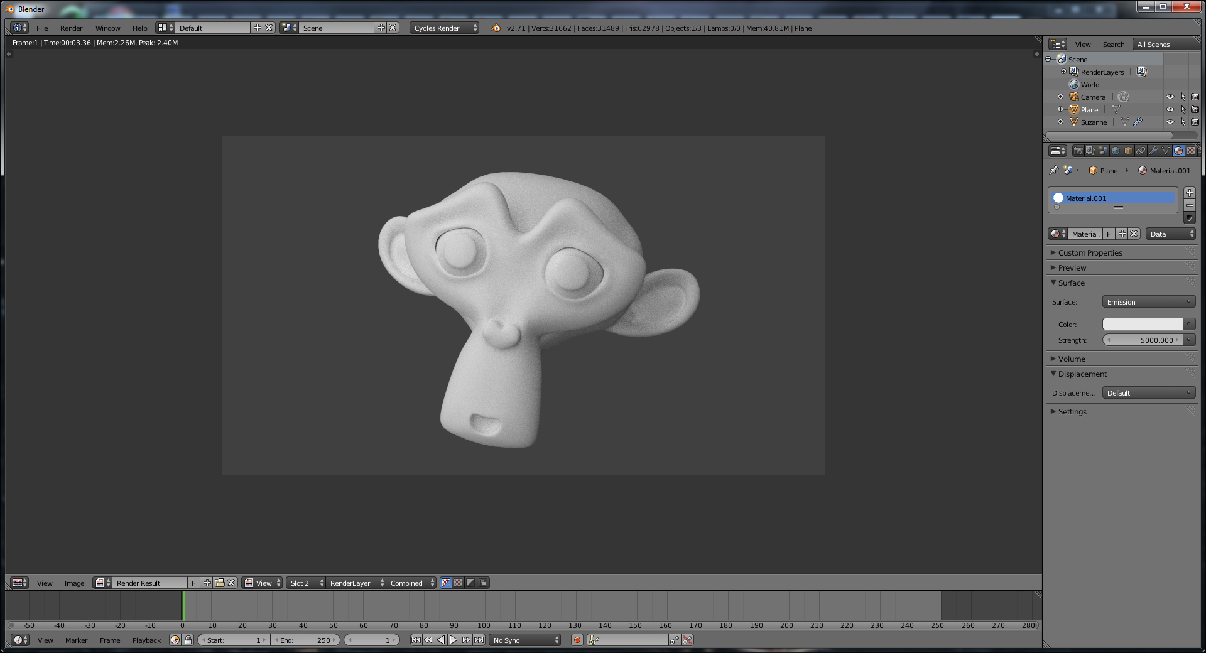

Vs (with a much smaller, more intense light in cycles)

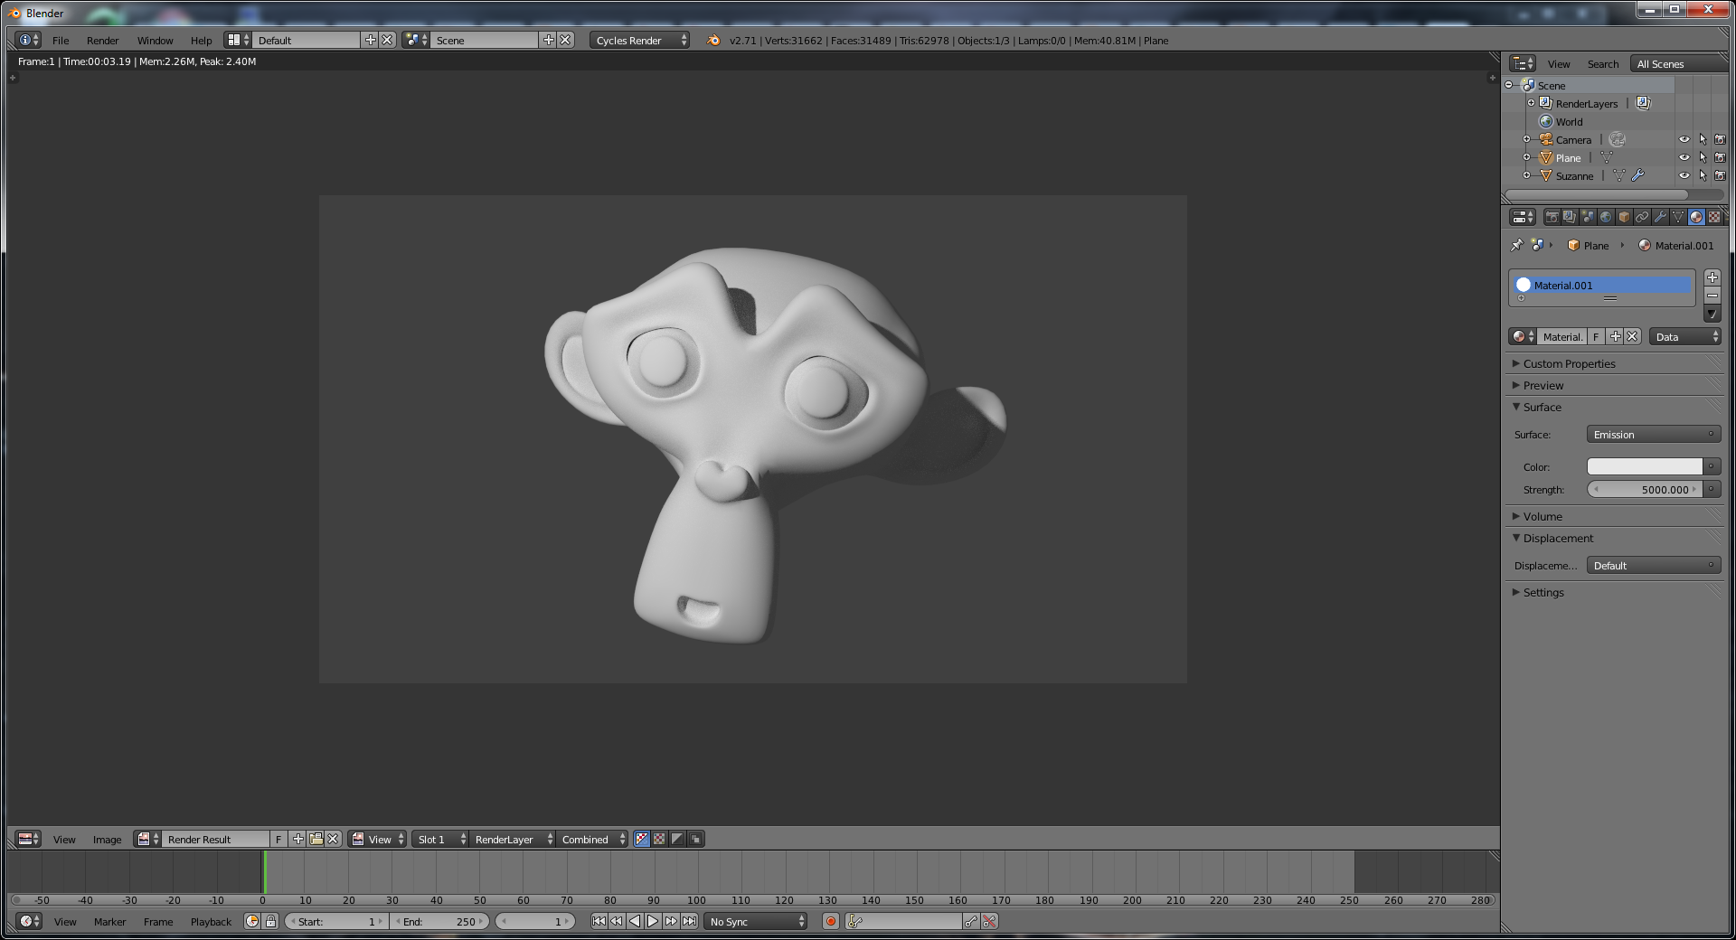

Tip 2: Don’t overlight, as too many lights will kill your shadows (and with it, detail.) Just stick to 3-point lighting

Tip 3: Use colored lights, all white is boring.

Tip 4: Make sure the subject of your scene receives the most light.

Tip 5: Adding a texture to your light can liven up a dull scene.

If you want to add a texture to a light, make sure the texture coordinate is set to “Normal”, not generated. Otherwise you’ll get a solid light.

# Cameras

If you have multiple cameras, Ctrl+Numpad 0 (the shortcut that lets you look through an object) also pick the currently selected camera as the active one for rending.

Rather using fly mode to adjust the camera, you can click on “Lock Camera to View” in the view tab of the right-hand-side / properties pane; normal zooming / panning / etc of the view will adjust the camera as well.

Ctrl + Alt + Num0 - Move camera to match current scene view. (Also known as 'align camera to view.')

G + MMB - In Camera View, zooms in and out; just gold down G to move in the other directions. (You have to left-click to lock in your changes when using MMB; this can be somewhat irritating until remembered.)

Easier than that, though, is just to use fly mode.

On the camera plane, there’s an awesome set of composition guides (including one for the rule of thirds) in the display section.

Shift + F - Camera Fly Mode; Moving left / right / up / down will cause the camera to tilt in the direct. Scrolling the middle mouse wheel will zoom in / out. Numpad +/- will also zoom in/out. Esc / RMB gets you out. If you use MMB instead of LMB, you will slew instead of Pan, but you can use standard keyboard controls for slewing as well. WASD - works as expected. Q - move up Z, E - Move down Z axis.

Teleport: Space will fly you right to the object that’s under the cursor.

Also, Ctrl+T TrackTo is a great trick for making the camera follow an object.

Ctrl + Num0 - Look Through Selected (Good for Cameras)

Ctrl + Alt + Num0 - Move camera to match current scene view. (Also known as 'align camera to view.')

Use MMB click (or any other view key) to exit camera view.

The easiest way to use adjust after an 'align camera to view' is to select the camera from the scenegraph, then use g to pan, and G+MMB to zoom in and out.

2.5 has a sweet depth of field slider that shows a hash tick moving out and back as you change the DOF.

You can adjust the focus of the camera by going to the camera panel, "show limits", then slide the limit. This changes the focus for DOF.

In cycles, depth of field in on the camera’s “Camera” pane.

The “hit E over an object field to get a picker” also works on distance boxes; this is great for DOF settings. Just hit E over the box and use the picker to get a depth from the scene.

# Armatures

Ctrl+Alt+S – Special scale operation for bones (appears to leave them in place, but just thickens/thins the bone instead.)

F - Similar to "create face", creates a bone from the currently select tip to the 3d cursor. If you have a tip and a root of a bone selected, it will create a link between those instead.

Ctrl+LMB - adds a new bone in the 3D view with its origin at the currently selected bone's tip. Basically a shortcut for "extrude"

Extuding bones is a quick way to make them, the CTRL+LMB trick even works here. You can also subdivide bones.

Shift+D duplicates bones.

Shift+E - Special bone "extrude forked"; if you have x-axis mirror enabled, your extude will create two bones linked by the x-axis

Ctrl + M - Mirror (follow by an axis to mirror across)

Alt+M - Merge Bones

Ctrl+Alt+A - Align Bones

Ctrl + Alt + S - Scales the bone (most viz modes) / Scales the envelope (envelope viz)AA

L - select all bones in the chain.

[ and ] - move the selection back and forth along the bone chain

Ctrl [ and ] - extend select. Extends the selection back and forth.

If you add more armatures and would like Blender to automatically generate vertex groups for them, you can go back to Object view and re-parent the object to the armature. Your old groups will remain (and be unmolested), but you’ll get new vertex groups for whatever armatures you’ve added.

Timesaver: in the armature panel, go to Display and turn on X-ray.

The two-second guide: make an armature, then parent your object to it with Ctrl+P.

If you need to jump back to pose position really quick, you can do so in the armature pane. This sometimes makes editing a bit easier.

Disconnected bone groups should be attached to their master bone groups with a child-parent relationship.

Each bone only affects vertices belonging to a vertex group having the same name.

Bones can rotate using either euler angles or quaternions. Eulers are apparently easier to animate (as mere humans can grok what each axis actually corresponds to), but quaternions are "smoother". The tutorialist we saw recommended them for human shoulders and the like. When you connect bones, blender creates a bezier curve and the bones follow it. You have no access to this invisible curve, however.

By default, bones only have one segment. If they have more, they can curve along the length of the bone. The only way you'd ever see this, however, is if you turned on the B-bone display. These would be good for slugs, snakes, or anything that requires more 'deformation.' When you connect bones, blender creates a bezier curve and the bones follow it. You have no access to this invisible curve, however. Smooth bones are an easy way to replace long chains of many small rigid bones posed using IK.

Bones can affect things using envelopes, which simply means a bone affects things within a certain distance. If you scale a bone in envelope visualization, scaling scales the radius of the bone's ends instead. Ctrl+Alt+S in envelope visualization mode scales the envelope.

Octahedrons are good for showing bone roll and size, as they have a square section. Sticks are small, but you have no idea about bone size or angle.

For robot characters, you can lock the rotation to certain axes under each individual bone's "transform locks" section in the bone pane.

The process to edit bone weights:

1) Select Your Armature

2) Switch to pose mode (Ctrl + Tab)

3) Select the mesh to weight

4) Hit (Ctrl+Tab) to go to weight paint mode

Now you'll automatically activate the vertex group of the mesh whenever you select a bone.

If you want to manually apply the bone heat weights to a bone, select the bone, hit W, then pic "apply bone envelopes" or "Apply bone heat weights", depending on the algorithm you want. This works on multiple bones if you select multiple bones in pose mode, then go back to weight paint and do the "specials trick" above.

There is no specific bone roll tool in pose mode, but you can rotate around the bone's main axis by locking on the local "Y": all local space actions are done relative to the bone.

Timersave: in the tools (T) menu, select X-axis mirror, which will save a lot of time when setting up the initial rig, as it always draws bones on top of solid objects.

Timesaver: go into addons, search for “rigify”, and enable it. When you go to add armatures, you have an option for human (meta-rig), which is a pre-made humanoid rig. Handy!

A lot of different tutes seem to use rigify, so we should consider this for ourselves when rigging.

To use rigify, put your cursor at the base of your humanoid model (for a human, this should be between the feet. From there, Shift+A and add an Armature / Human (meta-rig.) If the right is too big, DON'T RESIZE IN OBJECT MODE! Go into edit mode, and scale there (preferably hitting “.” on the keyboard to use the cursor as the scale center.)

From there, just line of the joints over the model. Then, click the armature, shift click the parent, then Ctrl+P, and parent as armature with automatic weights. You can then touch up the vertex groups.

Also: it's a good idea to go to the armature modifier that was placed on the model and select “preserve volume.” It'll help minimize distortion.

Weight painting armatures won't work unless the armature itself is in pose mode! Then you can click the model and weight paint. Just rick click bones to paint. You can actually rotate in weight paint mode to see how things work!

Want to keep the head straight even when the body tilts? Select the head bone, then go to the bone panel, and deselect “inherit rotation.” Another good candidate for this are the upper arm.L/R bones. (This way, arms being down will continue to be down, pointing gestures will stay pointing, etc.)

You can adjust the roll of a bone pretty easily. Select it in pose mode, then tab back to edit mode, and you'll see roll as a parameter in the “N” parameters window.

A good trick to make the entire finger curl or uncurl is to build a Ctrl+Shift+C constraint/copy rotation chain (in local space, of course) that follows the fingertip up to the palm. If you used autorig, you can turn off the Y and Z settings in the constraint box.

You can add a secondary “limit rotation” on X constraint to prevent the finger from curling outwards unnaturally.

The special menu (w) has a “flip names” option, useful when you copy bones or any other item that has L/R symmetry.

If you set “offset” on the copy rotation constraint, then the rotation will be applied on top of whatever manual adjustments you make.

Ctrl + Shift + C – Add constraint (good for copying rotation on palm bones). If you're going to do this with the palm bones, go to the bone constraints panel afterwards and set it to Local instead of world. You can also back the influence off.

If you want to add IK, add it as a constraint on a bone, and give it a target (typically the bone that you'll be moving; note that you'll have to give both your armature object and the bone as parameters.) Note: make sure the target bone isn't a child of the one that you're applying the constraint to, or you'll get a physics loop with wonky results. Just adding one will apply IK from your endpoint to the rest of the armature. Set the chain length to, say, 2 (for legs) if you need to.

Mr. Tutorial Guy created a separate foot bone (but in the same spot as the regular foot bone) as the IK target for the leg. From there, he un-parented the new bone, set the IK chain limit to 2 (so it only controlled the leg, not the whole body), and added a rotation constraint on the real leg bone to match the IK controller (so the leg would remain flat.)

Rigify adds options to your properties (N) menu that automatically has IK built-in. You have have to select a joint, go into properties, and then turn IK on for that joint. Also turn off the forward kinematic rig layers right below. From there, you can grab the controllers (the large rounded polys) to move arms and legs.

A pull target is a bone you can add, say, to get your knees pointed in the right direction. You would add the pole target on a bone with an IK constraint, then adjust the default roll so everything looks right. If you set up a knee with this, make sure to parent it to your foot IK main, so moving the model moves the pole target.

If you want to pose the upper and lower body sepearately, go to the spine bone and de-select inherit rotation.

You can create custom bone shapes to make it easier to pose the model for the animator. In pose mode, you can set a custom shape for a bone. You can then set this to any mesh in your scene. A good technique is to make these larger than your mesh so that animators can pose them without having to leave X-ray on in bone options.

In the pose → weight-paint mode, you're supposed to be able to select a joint and have the vertex group auto-selected for you. As of 2.62 this seems to be broken, but you can ge the same effect by selecting the bone, tabbing out to edit or object mode, then tab back into weight paint.

(Don't forget about auto-IK in the tools menu, which seems to work fine, too.)

After you're done lining things up, turn on the axes display (in object data). Make sure z is pointing up. If not, select the affected armatures, do a Ctrl + N (recaulate Roll in edit mode), then hit “z”, which will cause all the armatures to align on their Z axis. From here, Ctrl+R to re-align the armatures as needed.

Once you're done, space and “rigify”, which will automatically set up your rig for you. From here (in pose mode), select the model, then shift+select once piece of the new rig, then Ctrl+P, and set parent to armature deform with automatic weights.

To make any hair “follow” along, go to the object, find the armature modifier, and move it to the top of the modifier stack. As long as hair comes after, then the hair will follow the armature.

Also: after you've got the armature selected, go to “object data”, then X-ray, and turn that option on. It will let you see the armature underneath the model. This is also where you can change the armature display type if needed.

Armature X-Ray (the thing that leaves the armature visible even without the "z" wireframe mode enabled)

If the armature is applied to a model as a modifier, you can go into weight paint mode and select bones in the armature as well.

In 2.5 if you Shift+A in armature edit mode, you'll automatically add another armature.

You can tell "control" bones not to deform anything under the armature control panel.

You can parent a mesh to an armature to automatically make weight groups; we're not sure if there's a different way of doing this. It looks like you have to do this anyway if you want the mesh to move with the armature.

You actually don't have to manually add an armature in 2.5; if you do the "parent" trick to get auto-bone weights, Blender will automatically add an armature modifier for you. Apparently in 2.4x you had to hit "make real" for this to happen.

If you don't do the auto-weight trick during Ctrl+P, you can just add the armature modifier manually, then go to weight paint mode. As soon as you start painting, blender will create a vertex group for you.

In 2.5 vertex group data is now under "object data". Vertex groups are named the same as the bones they control; you can manually create a vertex group named after a bone, and it will affect the bone as you would expect. Renaming the bone will automatically rename the vertex group. Renaming the vertex group, however, will not have the same effect.

Armatures attach to meshes one of two ways: vertex groups or envelopes. Vertex groups seem to the be preferred way, as they give you more control. When you weight paint, you're actually painting the vertex groups. If

First, add an armature, then extrude it in edit mode to make it go where you want.

If you do Shift+E, you'll extrude using an x-axis mirror, assuming that you have x-axis mirror turned on.

"X-Axis Mirror" is now availalbe under the tools menu in edit mode of 2.5.

If you extrude from the tip, parenting is automatic. If you extrude from the base, you have to parent manually.

If a bone has no parent, then the only way it will ever move is if you move it yourself.

To make the armature affect the model, parent the model to the armature (e.g., select the box first, then the armature, then Ctrl+P). When asked, select "parent to the armature." From there, you can create vertex groups from bone heat, which will set up some sort of default armature map.

Ctrl + Tab with an armature selected takes you into pose mode.

Alt+R (clear rotation - and presumably the others) works just as well in pose mode.

Auto IK (Also in the tools sidebar for 2.5) will pull the armature.

Auto IK works a little different in 2.5. Pick your target bone first, then pick the source(?) bone, then Shift+I, and it will create an IK relationship for you.

Shift+I - create IK relationship, target first, then bone.

If you want to do this using the GUI, use the bone contraints tab, which is now a tab unto itself.

You can 'sever' a IK connection by going into the bone tab, then undoing the "connected" button.

After you're finished drawing armatures, you can usually set them to draw in "stick" mode, so your scene is less cluttered.

Chain len (in bone constraint settings) refers to the number of bones "back up" the chain the solver will move. 0 means no limit.

Knees can't bend backwards. One way of making this work is to add IK constrains to the upper thights. Make the targets unconnected bones that sit far out in front of the actual knees.

Bones are automatically disconnected when duplicated from existing bones.

If you add an armature as the target of a track-to constraint, you can then pick a bone as the actual target. "TO" means the local axis of the object that will be doing the pointing.

You can turn AutoIK on to get a rough pose quickly, then shut if off for detail work (or when working with bones you've manually applied IKs to)

The bottom of the 3d window (in pose mode) has the ability to let you copy & paste the current pose. You can also paste flipped, which is great for walk cycles.

In the armatures panel, you can make the armature jump back to pose position, which is good for working on other details.

### Skeleton Sketching

This lets you draw whole chains of bones at one (it used to be called etch-a-ton).

You have to first create an armature. The hit "n" to bring up the properties menu, and enable "skeleton sketching" (all the way at the bottom.) Now draw and use LMB clicks to mark bones. Use RMB to end your bone trail. If you have quick sketching turned on, the sketches will automatically turn into bones, otherwise use the "convert to bones" button to do that.

The stroke fixed / adaptive / and length settings control how bones are generated for you free (squiggly) sections.

Holding down shift and drawing lets you do gestures:

1) A slash cuts a stroke

2) A V deletes a stroke

3) A C reverses a stroke's direction

Also, apparently these tools are supposed to work with the volume snapping options to ensure that the joints end up getting placed in the middle of the meshes/volumes they're being built to deform. In my tests so far, this does not appear to be working, though your mileage may vary on this (NOTE: I've never actually gotten this volume snapping stuff to actually work correctly, so that may be a part of the problem here...)

# Animation

As of Blender 2.78, we now have bendy bones, which can have curved deformations and rest poses. This makes them great for eyebrows and other things that were only possible before with Shape Keys.

Hit the "record" button in the timeline to automatically add a key every time you change something.

Blender defaults to 250 frames at 25 frames/sec.

To animate objects, use object mode. To animate bones, use pose mode.

Alt + A – Preview (Play) Animation in 3D Window

Space - Stops playback.  
Shift+Left Arrow goes to Start Frame,

Shift+Right Arrow goes to End Frame,

the Up and Down arrows Skip 10 Frames,

the Right and Left arrows skip 1 Frame.

I – Inserts a key at the given frame.

The “IPO Curve Editor” window just means “InterPOlator”.

If you parent something to a path, you have the option to make a "follow path" relationship.

Blender has a simple video sequence editor that will import renders from the hard drive and allow you to sequence them.

If you want to insert a key for something and the option isn't showing up in the main window, trying hitting "i" over the area in the panel buttons. Ex, to animate "alpha" for a material, you have to click "I" over the alpha button, not in the 3D window.

The dope sheet works like regular blender. A selects / desects, B (box select) works, and Shift+D duplicates.

Edit individual actions by picking the "action editor" at the bottom of the dope sheet. You can then pick which animation you want to work on from the bottom of the window.

Contact post is where the leading leg is "in touch" with the ground. It's usually the first pose in a walk cycle.

The NLA is a non-linear animation editor. You need to have an action editor open for anything to come of it.

Note: the NLA editor is near-useless with the right-hand pane. Hit N to bring it up. You add additional tracks to the NLA by choosing them in the action editor, then hitting the "star" button to convert them to NLA actions.

NLA tracks on the bottom override the ones above them.

Shape keys is now in the object data pane. Shape keys only record the shape of the vertices in edit mode, ignoring the effect of any armatures. Whatever shape you have in the shape key panel is the shape that will be edited in edit mode. Shape keys are also animatable using keys. You can get multiple shape keys active at any time, as well.

# Shape Keys

FOR THE LOVE OF GOD DON'T ADD SHAPE KEYS TO AN UNFINISHED MESH!

Note the above: as of Blender 2.78, it doesn’t seem to react as horribly as it used ot when you alter the underlying topology.

But if you have to, there's a way out. Say you join in another mesh; blender will apply your non-basis shape key to the joined verticies using some unfathomable algorithm. What you can do is use the shape key window to select the basis. Select the new vertices, then hit "W" and "Shape Propogate"; this will ensure that geometry stays the same across all shapes.

They're easy: go to object data, and add two keys. The first one will be your basis, and the second is the key you're working on.

If you want to mirror a shape key, there's an easy way to do that: in the shape key drop-down list, do a new shape from mix (with the old shape selected), then hit mirror shape key from the same menu

How do you “apply” a shape key? Delete all the other keys first, then delete the indended key last. It’ll be “applied” to the object.

# Particles

Gotcha: Particles not appearing where you think they should? Make sure you have “use modifier stack” enabled in the particles panel under emission.

Gotcha: Particles showing in viewport, but not in the render? Make sure you don’t have the base object hidden or set to “not render” in the outliner. The particles inherit their parent’s settings. See:

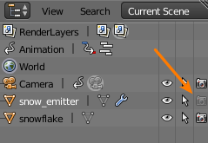

They appear to inherit their material the from emitter object.

Only meshes can emit particles.

You can set the root & tip settings under "strand" to control the thickness of the generated particles (good for hair). The "minimum" value acts as a scaler, but keeps the same ratio between root and tip.

Sta/End - Start and end frames of emission.

Life - Lifetime of particles.

Normal - Force to emit from normal.

Hint: If you use a group as hair particle emitters, the objects will sprout from your parent mesh at the child's object center. Be careful where this center is!

If you use a group as particle emitters, you can select the "use count" button to control the relative frequency of each element.

Random size is relative to the size of the particles, so a .5 will be half of what the "base" size is.

You can set Sta (start) to a negative value if you want to have particles ready by the first frame.

You can make particles "chain" by creating "reactors" that react on the death of original particles for things like fireworks, etc.

To duplicate objects on a plane (such as trees in a field), add a particle system to the plane. Under render, set type to "hair", set emitter from Path to Object, then drop the amount in "emission" above to something more reasonable (you'll probably not be needing 800 trees.) You also need to make the objects bigger, so you can either mess with velocity or physics. In physics, go to size, and change that number to something bigger. You may also have to force the initial rotation so that your trees/flowers/etc are standing up properly.

If you've made a vertex group (or groups) on the plane, you can use them to control where trees "spawn". Go to vertexgroups under the particle system and just pick the name of your group.

Note that the source object for the particles will not be rendered by default.

Children / Interpolated tends to produce better results than simple, as the distribution is more even. It will turn

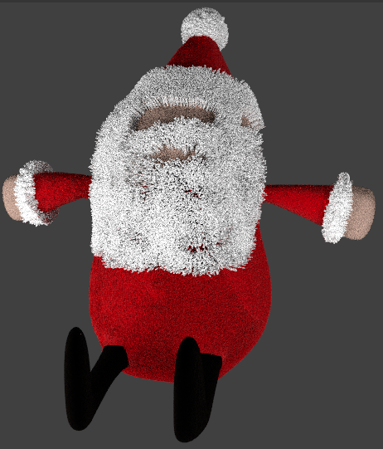

Into:

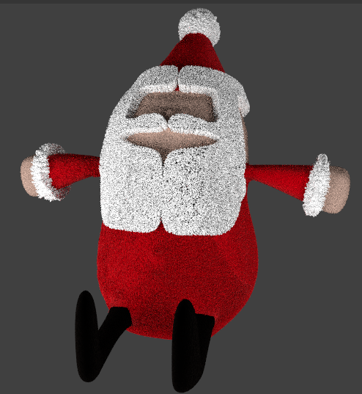

Trying to use groups (such as fake grass clumps?) as hair emitters, but the objects emit at 90 degree angles to what you’re expecting? Under velocity, turn “normal” down to zero, and change tangent to set your length. (I know, makes no sense …)

Using a group for emission (instead of an object) will cause random members of the group to be used instead of the same object.

Troubleshooting:

Check that either the particle system is ABOVE the subsurf, or the hair has “use modifier stack” turned on.

When trying to control the # of hairs emitted using a (density) texture, you’ll have to set the # of particles a lot higher than you’d expect; this is because blender will still create hairs where the texture is black – zero length hairs, and they count towards the total.

Controlling density with a texture is really intended for controlling variable density across a hair-covered surface, not to just define the one tiny area where you want hair.

Instead, use Vertex Groups.

# Hair

Gotcha: If your hair looks great when combed, but looks like an unpredictable mess when rendering, it’s likely because the children are interpolating wrong. Kick up the # of virtual parents on the hair tab until the hair gets back under control.

Gotcha: Bald spots. At least on one model, we noticed that the biggest contributor to the bare spots is the “roughness” settings under Children. When those are set to anything greater than zero, hair starts spawning UNDER the surface of the model (although this might be the point.) Hear sprouting inwards can also be caused by random velocity and Brownian forces (under physics.)

Gotcha: If using interpolated, having “Child Simplification” appears to annihilate most of the hair on the object … sometimes. This is mostly likely a bug in 2.79, see if they fixed it later.

Hair works a lot like the particle system, as they're actually particles that have their entire lifetimes rendered at once.

In 2.6, you won't see the normal and forces controls for particle systems set to "hair" unless you check the "advanced" box.

Cycles now has a ‘strand render’ setting under Particles/Render/Strand Render (underneath none/path/object/group.) In our tests, the results are identical to the other renderer, and is fractionally faster (10.2 secs vs 10.8). It also gives us the “degrees” option to control how many strand segments are generated, but this appeared to do nothing.

You typically want to keep the base # of hairs low; use children to fill in the in-between areas.

Spot Lamps with Buffered Shadows and the Classic-Halfway algorithm supposedly do a good job with strand renders and hair.

If you use the strand renderer, you have an option in the materials panel, under "render pipeline" to change the strand settings, such as start size, end size, shape, etc. Surface diffuse does now show as many highlights in the resulting hair.

You can map textures to particle attributes in materials. They're under the Pattr (Particle Attribute) button.

To edit the hair with hair tools, set the window into particle mode (it’s at the bottom of the 3d window, and typically in Edit Mode or Object Mode), then hit the N key to bring up the tools.

To make some areas NOT emit hair, you have to go to particle mode. First, link your emitter to the vertex group in question by going to the “extras” section of the particle settings. The Selection for the vertex group is not obvious: it’s the last selection box after “neg.” Next, after you’ve linked the hair to a vertex group, you can touch it up by going into weight painting mode.

Don't forget that (well, 2.5+ at least) has a hair modify selection box on the toolbar where you can choose to modify the whole strand, just tips (makes things look puffier), etc.

If you apply a texture to a strand, make sure to go to the texture pane, and select strand / particle as the coordinate type.

A good trick is to add a blender texture with an alpha, so that the hair strand becomes more "transparent" towards the top.

It's usually a good idea to use a 2nd material just for the hair / feathers / etc. Set this using the particles pane / render / material #.

The secrets of doing feathers instead of hair: use the strand render, do the semi-opaque material trick (make this blend texture influence alpha, not color), then set the base of the strand to something (relatively) huge, like 10 (feathers are pretty thick, after all.)

In 2.5 you can control density, length, etc, and setting vertex group weights instead of textures assigned to PVAr.

If you want to set up a nice material for controlling hair:

1. Add a texture, set the type to Blend
2. Under color, enable ramp; create a ramp with two endpoints that are completely translucent (alpha = 0); in the middle create a black point with an alpha of .5.
3. Under influence, remove color and select “alpha” instead
4. Under mapping, go to coordinates and select “strand/particle”

Now your hair will appear “soft.” To finish this up, when you go to add the particle system, go to Render, and select “2” (or whatever # the alpha material resides at) for material.

You're supposed to be able to delete half the particles in particle editing mode, then go to particle / mirror.

If you want to make your strand render hair look better, got to both your base texture and your hair texutre (see the blend trick above.) On the material for both, got to “Shadow” and receive transparent. From there, go to World / Ambient Occlusion, and under “Gather”, set to approximate. Last, on your lamp, set shadow to “Buffer Shadow.” Buffer shadows supposedly give you better shadows on your fur.

If you really want your hair to stand out even further, go into the light for your scene and drop the bias. A bias is added by the light to move the shadow farther away from the object that casts it. A smaller bias means that the shadow moves closer to the object. Somehow this results in the hair “popping” better!(?)

Using hair with cycles (as of 2.66+) is ONLY possible if you go to camera settings and set the render feature set to "experimental". Hair appears to render on GPU just fine, though. Right now hair only renders in object mode, so if you're making changes in particle mode you have to toggle over to get it to work.

Cycles has the following curve primitives:

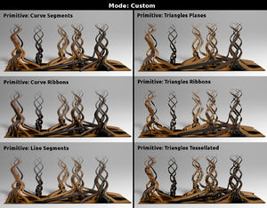

You have the following settings to choose from when rendering hair in cycles:

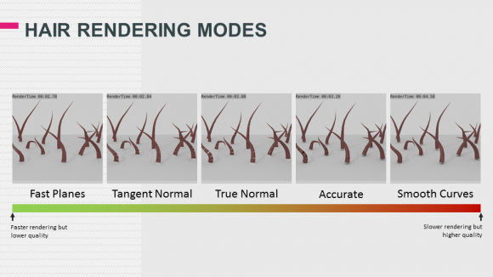

True normal supposedly gives good results, so it's okay to stick with that. We've had difficulty getting Cycles to render hair that's been "combed" (or otherwise modified) using Tangent Normal, but hopefully this'll be fixed soon.

Shape determines how quickly the hair tapers off:

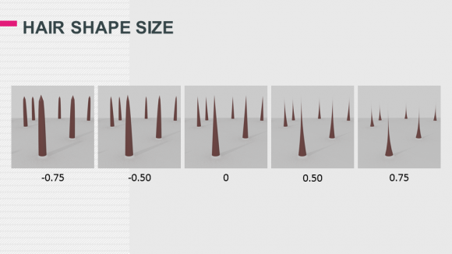

A good setup for hair is as follows. Note that we don't *need* the RGB curve node, the author just used to it tweak his hair slightly to make it more red:

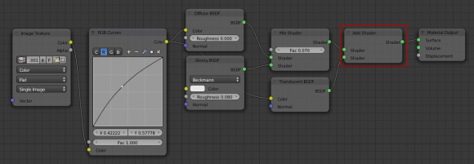

For Fur (instead of human hair), it's great to have it fade out sometimes. Set that up like this. Note that the intercept on the hair info appears to be a 0-1 value that changes with the hair strand length:

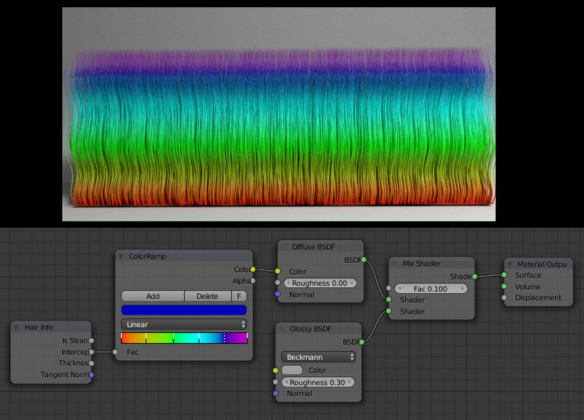

Use the intercept to control how much transparent gets added into your hair shader:

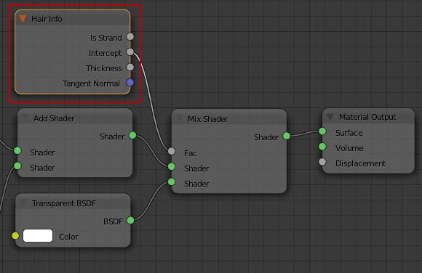

# Rigid Bodies

As of 2.66 you can do quick rigid body sim in the 3d window; select the 3d object you want to add to your simulation, then look in the tools window (T / left hand side), open rigid body tools, and add actives and passives (passives are your walls / floors.) If you change the size of something in edit mode, be sure to alt+a / apply the scale before running the sim, as the results are supposed to turn out better that way.

Then just hit play on the animation toolbar and watch the magic.

# Physics

If you want physics to affect your particles, you have to go to the modifiers on the object, then convert the particles to real objects. Note that if you want to create a target group for softbody physics, then you'll have to do this BEOFRE converting the grass to real particles.

It's a good habit to jump to frame zero after adding soft-body physics. It supposedly prevents blender from trying to cache frame 1 while you're working.

The "default strength" is the strength of all the blue parts if you're using vertex groups for softbody. Hit "free all bakes" to remove previously calculated physics, and then "bake all dynamics" to calculate the dynamics again.

You can enable a simulation inside a mesh in the physics screen. On the physics tabs, go to Fluid, then use domain to constrain the physics to your object.

Softbodies need a vertex group to act on. A weight of 1 means - oddly enough - that no verticies will deform during a softbody calculation.You can paint the weights of a vertex group in weight paint mode; blue is zero, red is one.

Once you have the weights on your mesh, go to F7/Physics, then enable softbody. Hit "use goal" and select your vertex group. If you want the softbody to collide with anything, you have to enable "collision" also in the physics buttons; turning on collision is enough to get this to work; no tweaking required) on the collidee.

You can have the soft body collide with itself if you pick the collision tab under 'soft body'. You normally create forces to act on soft bodies by adding an empty, then attaching a force to it in the physics buttons.

Tip: If you have a circular piece of cloth that you simulate with cloth physics, by default the cloth will come to rest with “ruffles” along its edges, which is great if you’re trying to make something like a jellyfish.

# Fluids

For 2.65: You need at least two things for fluid sim:

1) A domain. This defines the extent of the sim. During the sim playback, the domain gets replaced by the fluid being simulated. You have to hit "bake" on the sim, then let blender calculate the fluid volume each frame.

2) A fluid source: can either be a blog of fluid, or an "input" source.

You can also define fluid obstacles. Set these up as Fluid obstacles, not collision obstacles.

NOTE: Don't try to collide with a plane. You have to set the collision settings to "shell" instead of volume if you want to try this, although our results were squirrely. More users on blender mailing lists suggest using an object than has volume. Also make sure the normals are pointing the right direction; fluid collision will also fail if the normals point the wrong way.

Under fluid/domain, make sure the req. bake memory (the amount that will be sued) never exceeds what you have in your system.

Once you're set up, you can tell blender to "bake"; bake can be found on the domain. Then playback, render, etc.

Protip: Keep your domain as small as possible to speed up your simulation.

Leaving fluid threads at zero appears to guess how many cores you have.

# Smoke

As of Blender 2.77, the smoke cache has a new file format option called “OpenVDB.” Apparently this takes about 1/10th the space on disk when storing smoke cache data.

If you’re rending smoke in cycles and it appears black, go into the render tab and kick “Volume” bounces under Light Paths up to 1 or 2.

When selecting the flow type, you can pick from, fire, smoke, or fire+smoke, which is odd because Fire already generates some smoke. Jonathan Price always picks just “fire’ for this reason. Jonathan seems to prefer Wavelet over FFT as the noise basis with a strength of 5(ish).

When you bake the physics, be sure to give you cache a name (as blender tends to lose it otherwise.)

In the “Smoke Flames” panel section, the Reaction Speed ACTUALLY controls how much of the particle system will be fire and how much will be flames. The lower you go, the greater percentage will be flames vs smoke. The higher you go, the higher the flames will go. Smoke controls how much smoke you get, so you can also control this independently.

Also, kick the flame vorticity up to 4 (the one under Smoke/Behavior, not Smoke Flames / Reaction).

Adaptive domain should almost always be on. Smoke High Resolutions should be on for renders, at either 1 or 2 divisions (with the usual speed caveats as you go up.)

Kick up the divisions in the domain resolution to make the smoke look better. The tradeoff is the physics calculations go slower. Leave it at 32 when playing around, and maybe 128/256 for a render.

Note that if you set the smoke/flame sim up using quick smoke, you won’t have any input for the flame data, so when you render, you’ll just get … smoke. Going into the node setup, you’ll have to add an attribute for “flame”. Curiously, there’s a preexisting “add shader” input, as they appear to have expected us to add flame this way. Note the abrupt transition between dark orange and black; this is to give the resultant flames a crisp boundary. The factor output -> intput to emission strength is to make the flames brighter where the “flame” value is higher. The multiply node helps emphasize this.

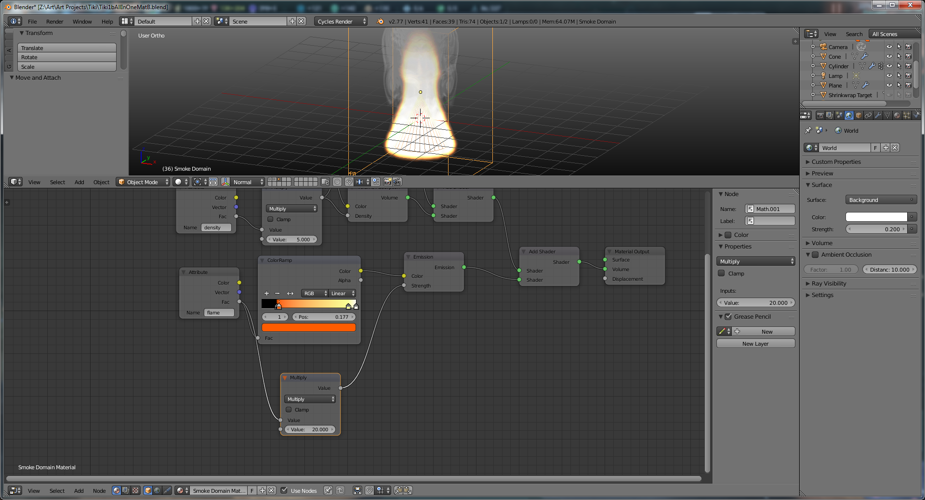

If you want to create particle systems that follow the smoke (ex: for embers that follow smoke flow upwards) you need to add a “smoke flow” force at the base of the smoke.

It doesn’t appear to matter where you add the smoke flow in the scene, but you DO have to go to the physics settings and set the “Domain Object” under Force Fields to the smoke domain. You’ll also have to kick the strength up to something in the 20s or 30s, otherwise there won’t be enough force to get the particles to do anything.

You attach the new particle system to the emitter (typically.) Set the emitter type to particle (which you then create somewhere else – use a low-poly spehere.)

When making a material for the embers, you can include a “particle info” node, so that you can make the embers brighter if they’re moving faster (as they would be in real life.)

You can use the dot product in the vector converter node setup to average your velocity:

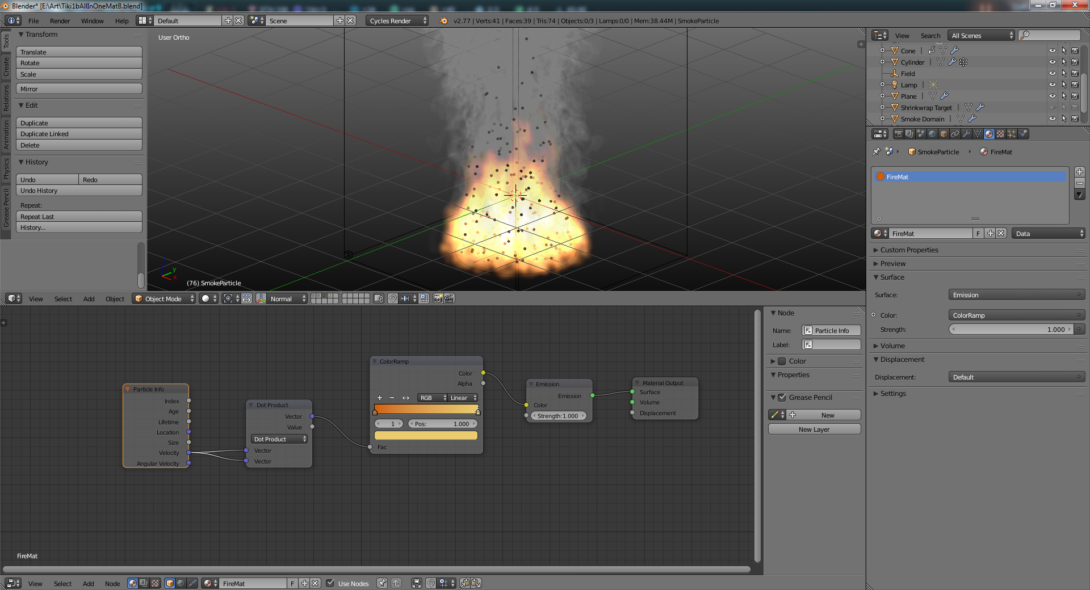

If you see banding artifacts, go to volume sampling, and change heterogenous step size to something smaller.

Now that cycles does motion blur, it’s a good idea to turn it on for the embers.

If you want the fire to look a little better, add a cloud noise texture to the flames. You can then animate the texture to make it look a lot better. This is added under “smoke flow advanced.”

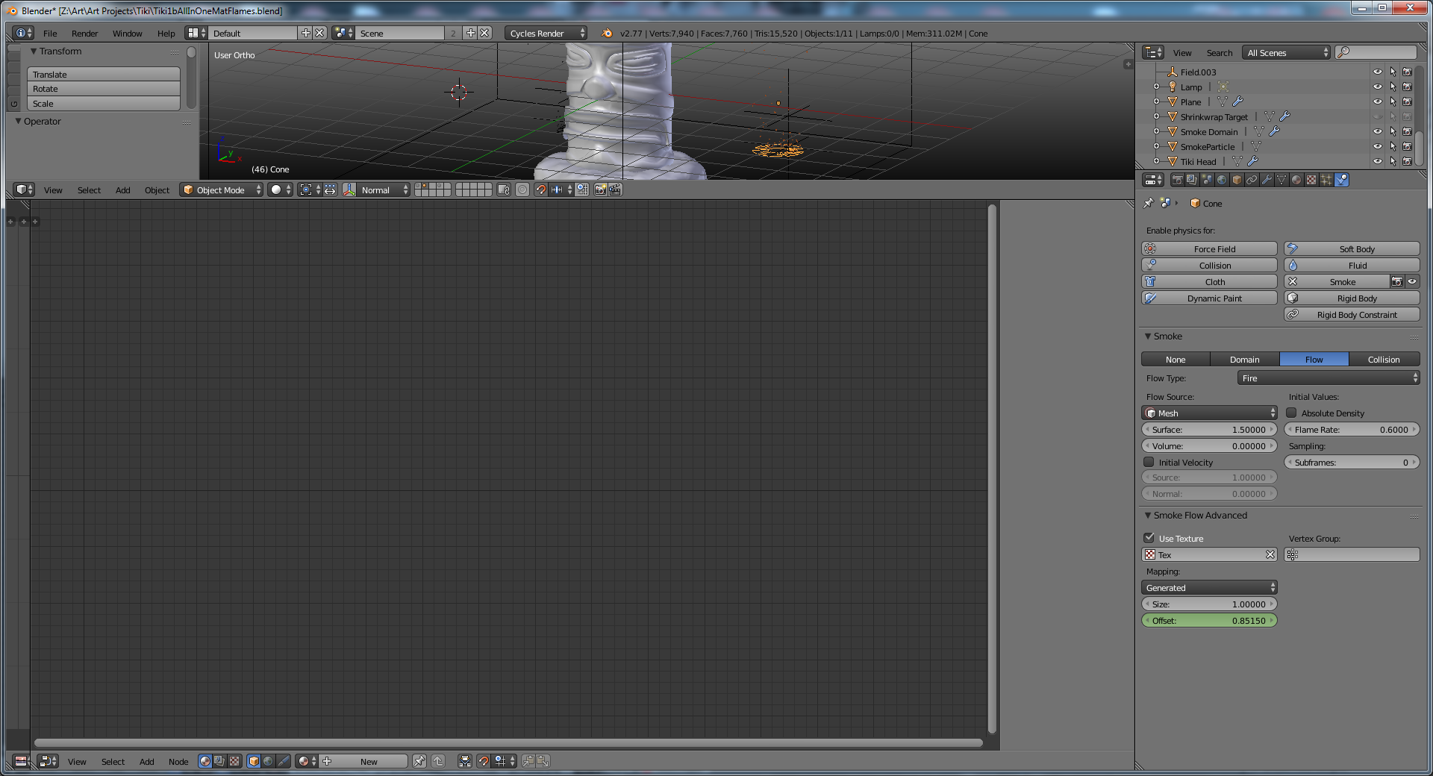

Setting up smoke is easy: it's very similar to fluids in that you have a domain and a flow object. If you want fire and smoke, you have to set that up on your flow object.

The material setup is, frankly, absurd:

You have to add a "Volume" material to your domain (just switch the type to Volume at the top of the material panel), and drop the density to 0.00. You Also have to kick up the Density Scale and Emission Scale to at least something like 5 to get good, visible smoke. Then set the "integration" parameters for the domain material (all the way at the bottom) to a much smaller step size (.02) otherwise you'll get banding during renders.

Next, create a new texture for the domain, and set it to "Voxel Data". Set the domain object to the domain object, then set the influce to density and reflection color.

If you want flame, add another voxel data taxture, set desnity emission and emission color as the influences, and add a ramp color like so:

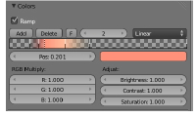

Then you'll get smoke.

As of 2.65, you can set the smoke color for individual flows. You set the smoke color on the flow object; then for the domain voxel texture set: emitter color and/or reflection color influence to 1.0; you can then also set this to control the individual emission and reflection densities as well. You have to re-bake every time you change the smoke color, though. :(

Particle-based smoke appears to be a lot more flexible (set this on the flow object); to make the particles be affected by a force emitter, you'll have to turn the emitter up HIGH (as it 40 or 50.) You'll see nothing if you leave the field strength at 1.

As soon as you apply the smoke domain setting to an object, it goes into wireframe mode for you (even if you're currently in textured mode or something similar.)

Smoke will simulate without baking if you go to frame zero and do an Alt+A to start animation. If you skip ahead to a different frame and do an Alt+A from there, Blender doesn't bother simulating / rendering the smoke. Even then, it sometimes doesn't work. It appears that you can force it to re-start its internal smoke calculations by moving to frame 0, dragging the current frame to the right slightly (say, frame 2) ... at which point Blender will start rendering smoke again. Then jump back to frame zero and hit Alt+A to see Blender render the smoke.

Don't set the mix type on the domain material to "multiply" as the one blender cookie tutorial suggested: then the smoke doesn't render at all. Leave it on "mix"

Cycles Smoke: A good smoke material is just a volume scatter and volume absorption added together, then hook that output to the volume input of the final material block. Then you also need at add an attribute input with the name set to “density”, and plug that into the volume absorption density node. Use the input “flame” to an emission node, then plug that into the volume output if your smoke sim has a flame component.

Note: if you don’t see smoke:

* 1. Check to make sure you have volume scatter hooked up. Absoprtion doesn’t seem to do much sometimes.
  2. Have a material on the smoke domain with the attribute “density” feeding into the scatter’s density node.

If you’re trying to do smoke, and you see weird black “outlines” on your semitransparent shapes, then blender is hitting up against the maximum number of transparent objects that it’ll pass light through. You can fix it by kicking up the Transparency Maximum Setting in Light Paths under render:

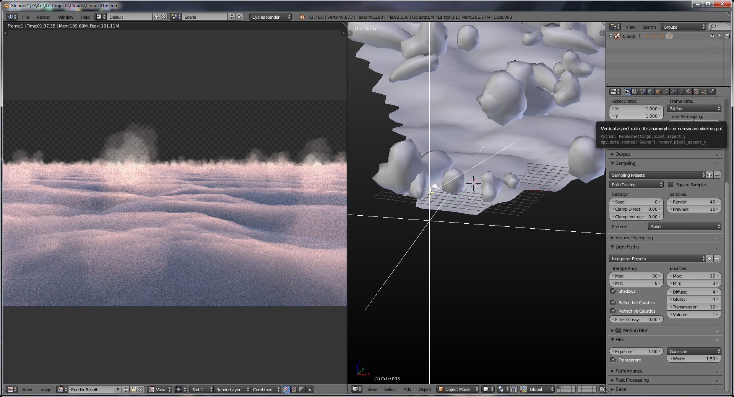

Compare the before and after of this cloud scene. The before has transparency max set to 8, while the after has the max set to 30.

Before

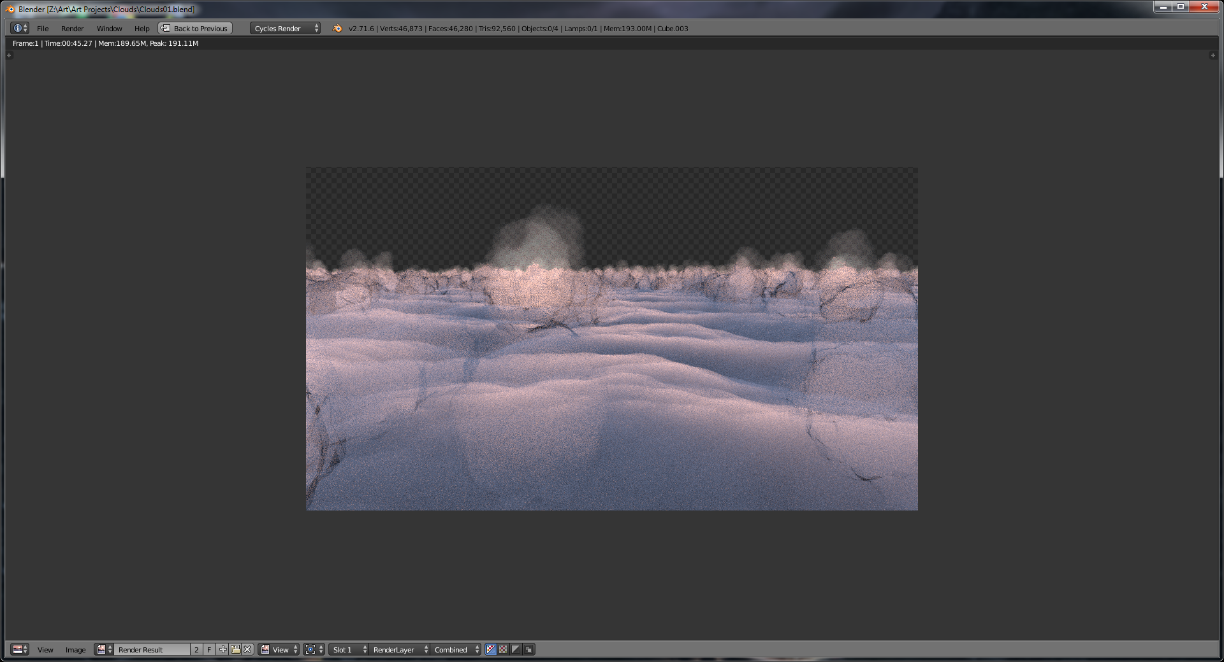

After

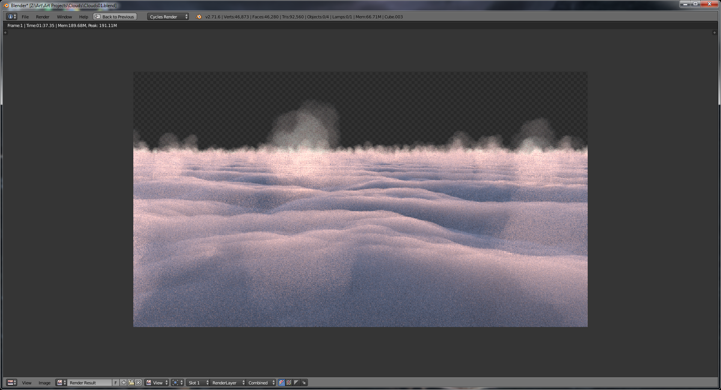

### Clouds

For realism, unfortunately, you need to create a scene that go out FAR towards the horizons (kick your clipping end up to 400m or so.)

The secret to a good cloud texture? Plug a noise texture into the density node of cloud material. Also, using the geometry position instead of the generated coordinates for the vector input of the noise tex makes for a better looking cloud. Combining two noise textures (at slightly different scales) make it look even better.

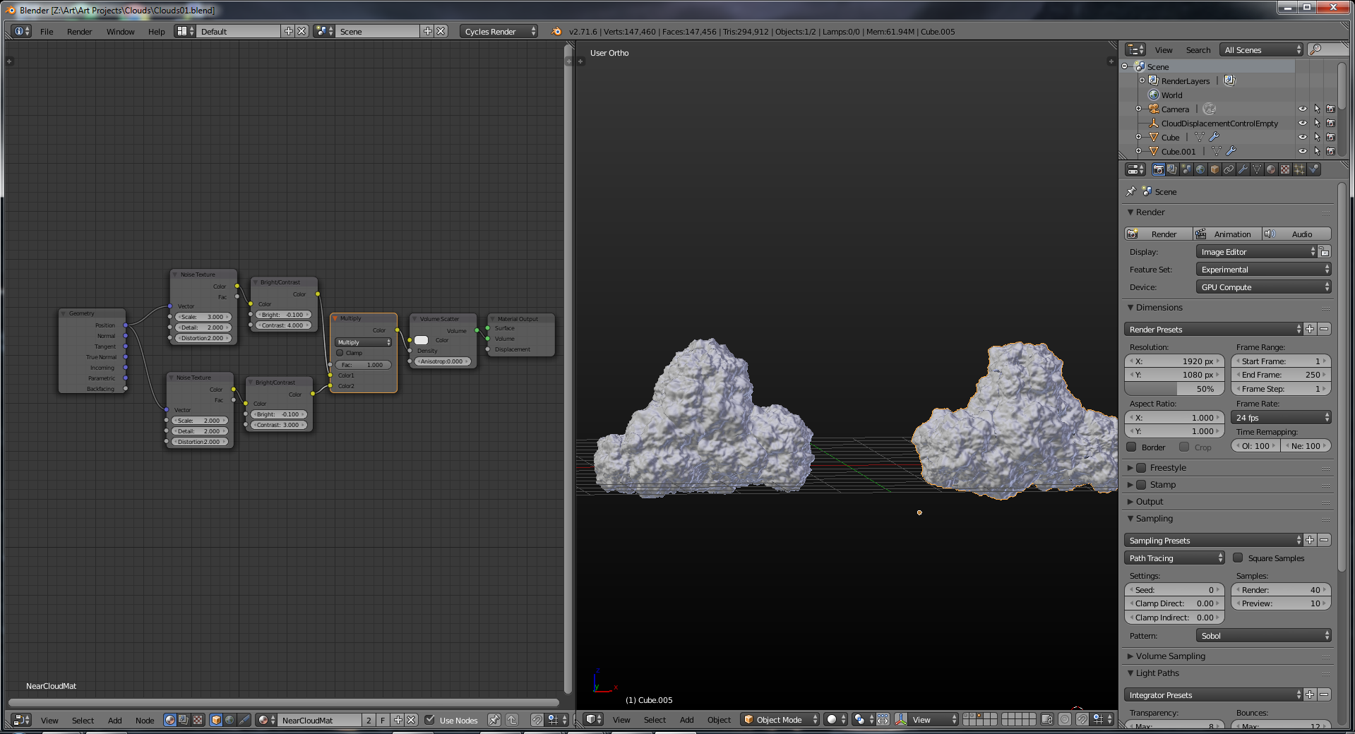

# Cloth

When doing a cloth sim (although this applies to all other physics materials), you want to make you object subdivided so that the faces are roughly square. Rectangular (or other) faces will result in odd-looking deformations.

Per Andrew Price (at least at ver 2.7, anyways), having more vertices means that the cloth under simulation will act as if it has more mass.

If your cloth sim acts odd (say, the cloth sticks together and pokes through itself during collision), you can fix this by turning up the Steps under the “Quality” setting of the Cloth pane.

You’ll need million of hairs to make fuzzy cloth look real.

# Hooks

Hooks give access at object level to the underlying geometry of meshes, curves, surfaces or lattices. A hook is an object feature and it is like a parent to an object, but for vertices.

They're mostly used for vertex animation, but can be used to force verticies to move to locations for modeling as well.

Ctrl+H - Add a hook.

The hook appears in the modifier stack afterwards. You can press "apply" to permanently apply the hook mojo to the verticies.

# Import / Append

If you append an object it’ll bring its materials with it.

If you want to append an entire object hierarchy, there’s no easy way to do that. Instead, open the source file, use “select hierarchy” on the parent, then Ctrl + C. Open the target file, then simply Ctrl+V.

# Environment

Make sure there’s something to reflect! It’s sometimes hard to tell what a material is supposed to be if there’s nothing around it.

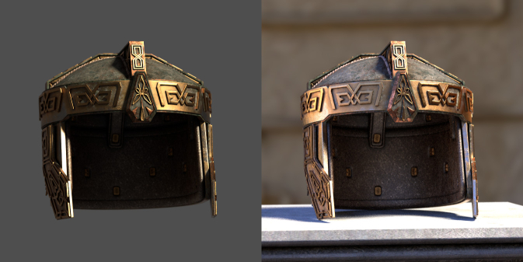

Want to render a huge scene without killing your CPU?

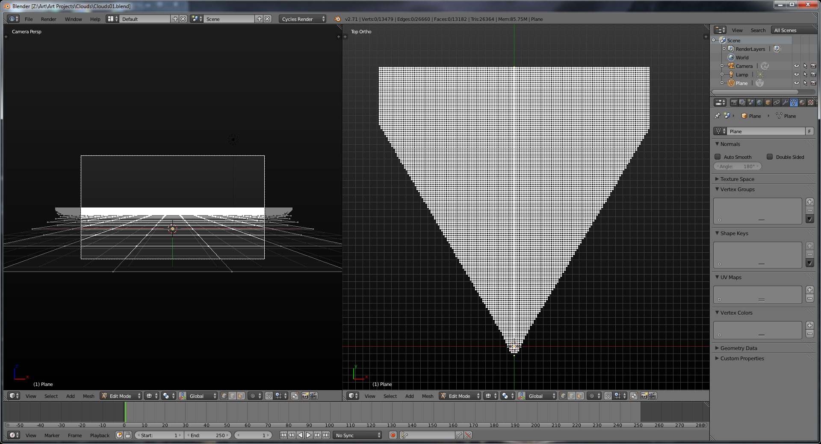

A great way to get a realistic sky is to go to the world editior, hit “use nodes”, and then select sky texture for the world surface; it’s pretty much a pre-made horizion, and seems to work great (at least w/cycles.) You can also drag the sphere in the node editor to change your day/night settings (complete with reds for dusk, etc)

Kick the “turbidity” up, which will simulate more atmospheric particles / dispersion, etc (great for sunsets.)

You might get a lot of fireflies if you do this, so under world hit “multiple importance sampling”, which should help reduce that somewhat.

Blend - The background color is blended from horizon to zenith. If only this button is pressed, the gradient runs from the bottom to the top of the rendered image regardless of the camera orientation.

Real - If this button is also pressed the blending is dependent on the camera orientation. The horizon color is exactly at the horizon (on the x-y plane), and the zenith color is used for points vertically above and below the camera.

Paper - If this button is pressed the gradient occurs on the zenith-horizon-zenith colors. Thus, there are two transitions on the image, which reflect the camera rotation but which keep the horizon color to the center and the zenith color to the extremes.

You can also map textures to the background via the texture panels to the right.

If you want to assign different materials to an object, you pick the material number in the Link and Materials portion of the Mesh Buttons. Select faces/ vertices to assign a material to, then hit “New”.

As of 2.72, Blender can do fog in cycles. Set the feature set to “experimental”, then go to world, and change the “volume” settings. You may have to hit “use nodes” on the surface material before this will kick in, however. Pick “volume scatter” for fog. Make sure the desnity is set to something around .1, or things become invisible quickly. Note that if you’re doing this for the environment, enable “homogenous volume”, as this will speed up your rendering significantly. Also set the color to pure white, as it defaults to blender’s 90% of white / gray. The current implementation has a lot of fireflies, so use clamp to manage those. Just clamp indirect lighting to 3 or so. Right now the volume sampling settings are not working. You can switch from Equi-angular (best for outdoor, per Blender Cookie) to Distance (best for indoor.)

Environment materials (as of 2.72) don’t work with the Sun Lamp just yet, so use a spot / point light, and do the Light Falloff node trick mentioned in the cycles part of this document.

One other tip: if you want your spot lighting to be exaggerated when using volumes, you can lower the volume light bounces from 1 to 0 in “Light Paths”. Without this, each light that comes in though a window will bounce and cause the lighting to be more equal in your scene (although this is more physically accurate … do whatever is best for your scene.) . See the first (default settings) vs the second (volume bounce 0):

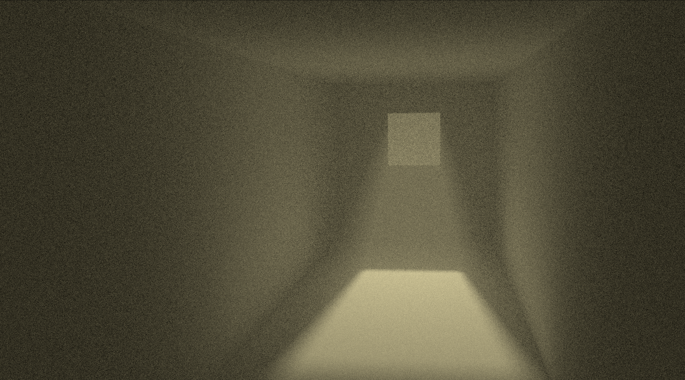

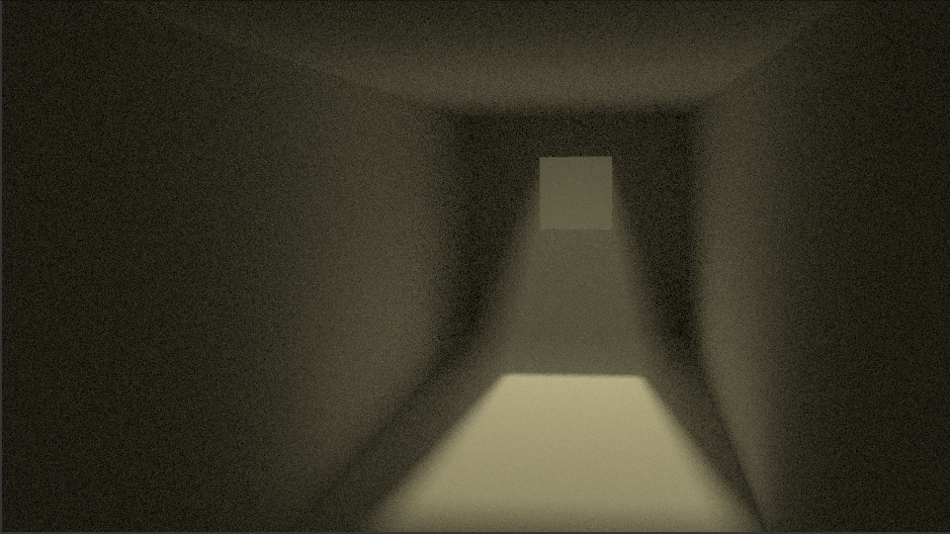

Want the *effect* of having a sky color / texture, but want the sky to be blank (to make post-processing easier?) Under the render tab, go to “film” and turn on transparent.

A nice trick Gleb recommended is to add an extra fill light (perhaps even textured) that has a color opposite to the dominant light color to add a little contrast. Worked pretty well for our robot scene.

# Rendering

To use GPU rendering, go to user prefs, compute device, CUDA, then select the graphics card. Then under the render section on the render tab (far left, looks like a camera), set render again to "GPU."

In Render / Integrator, set Preview samples to 0 so we don't overwork the card.

Restrict Render sets an item in the scene to NOT render, which can also be accomplished in the outliner.

As of Blender 2.78, you can preview the effect of depth of field in the viewport, but only if you’re looking through the camera in question. The traditional “draw bound, switch to rendered view” trick doesn’t seem to work.

For Cycles SSS:

Turn on "no caustics" under integrator on the render pane.

In the world settings, you can go to envrionment lighting and put on a global lighting setting; this really helps with toon renders when you want to get rid of black spots.

Blender 2.5+ doesn't have Backbuf, so to add an image background do the following:

* world - texture - add new - type: image
* load the image - map to view - influence horizon
* in world panel, choose paper sky
* in render panel, set render size = size of image

Turning on "ambient occlusion" in rendering is sometimes called a "dirt shader". It fakes darkness in corners and creases where light is normally diffused by dirt and dust. The option is actually located in the "world buttons" under material/F5.

AO removes some of the "harshness" from shadows. In 2.5, it's located under the world tab.

Ambient Occlusion is the most basic (yet really powerful) way of faking indirect illumination. It uses the distance between objects to brighten or darken the scene (the longer the distance from surrounding faces the more an object is illuminated).  
This means it doesn't depend on the lights setup of the scene at all and as such wont give realistic results by itself

Press F3 to bring up the save dialog for your rendered image, which is not normally saved by default.

J - Inside the render window, flips to the previous render. Works like a buffer; you apparently have to use J to flip, then re-render (unless there's a better way of doing this.)

F11 - Show/Hide Render Window

F12 – Render

OSA – Anti-Aliasing

You can hit F3, or go to File > Save Image to save one of your renders.

Edge/Edge settings turns on the toon shader.

Have a cycles light emitter that you don’t want to be seen by the camera? Go to the object tab for the light, open the Ray Visibility subset (at the bottom), then turn of “camera”

Another trick for getting rid of fireflies, especially if you’re using cycles volumes:

Under sampling (in the render panel), set “Path Tracing” to “Branched Path Tracing”. You can change the sample types individually (e.g, volume vs diffuse vs glossy, etc). So if you have a lot of gloss in your scene, you can kick that up separately.

It works but taking all lights into account for shading instead of just one; this is slower, but will reduce noise.

Want to make your object appear on a blank/alpha background? Go to the render node, and make sure the settings is to to RGBA under “Output.” Then go down to film, and select “transparent.”

One way to fake a freestyle-like outline on everything is to take your mode, shrink/fatten it so that it’s a bit larger than the original, then give it an all-black texture and flip the normals. This appears to only work with B.I., though.

# Cycles

1. As of 2.78, you can use Shading > Material in a Cycles Viewport, and cycles will actually let you preview the textures and bump mapping now like we used to do with internal.

As of 2.78, Cycles has “microdisplacement”, which is a really efficient way of doing True displacement that also reduces the subdivisions for objects farther away from the camera. To use it, you need to:

1. Enable experimental features in render.
2. For your material under settings, set displacement to True
3. Add a subdivision modifier and set the # of subdivisions to “adaptive.” The smaller the number, the more the subdivisions. (A 5 means that every 5 pixels will result in a subdivision, whereas a 1 means every pixel gets a subdivision.)
4. **It’s two separate features that work together:**
5. Adaptive Subdivision – Automatically subdivides objects based on the amount of screen space they take up Micropolygon displacement – Uses the adaptive subdivision to displace the geometry at the time of rendering. This results in more detailed renders, with memory reductions of up to 88%, and decreased rendertimes of up to 75%. If you make environments, or want to achieve photorealistic results, this is HUGE.

It works on geometry, not objects. The same object will have less subdivision in the background than the foreground.

Note that this appears to be scale-sensitive, so make sure to apply your scale if you get funny results. The delta between the render and preview subdivision rates is on the render tab under “geometry.”

As of 2.78 it doesn’t smooth displacements between materials or work well with particles. It also has weird results when set to “bump” mode or “bump + true”.

In order to get Cycles’ “noise” to look different every frame, you used to have to animate the seed value in sampling. Not anymore! Just clicking the clock next to the seed will change the seed every frame:

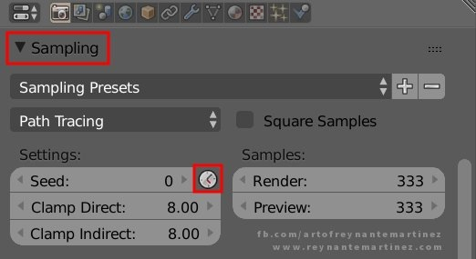

You can copy colors in the editor by hitting Ctrl+C with your mouse over the big color swatches, then Ctrl+Ving to do the same in a target. This kind of swatch:

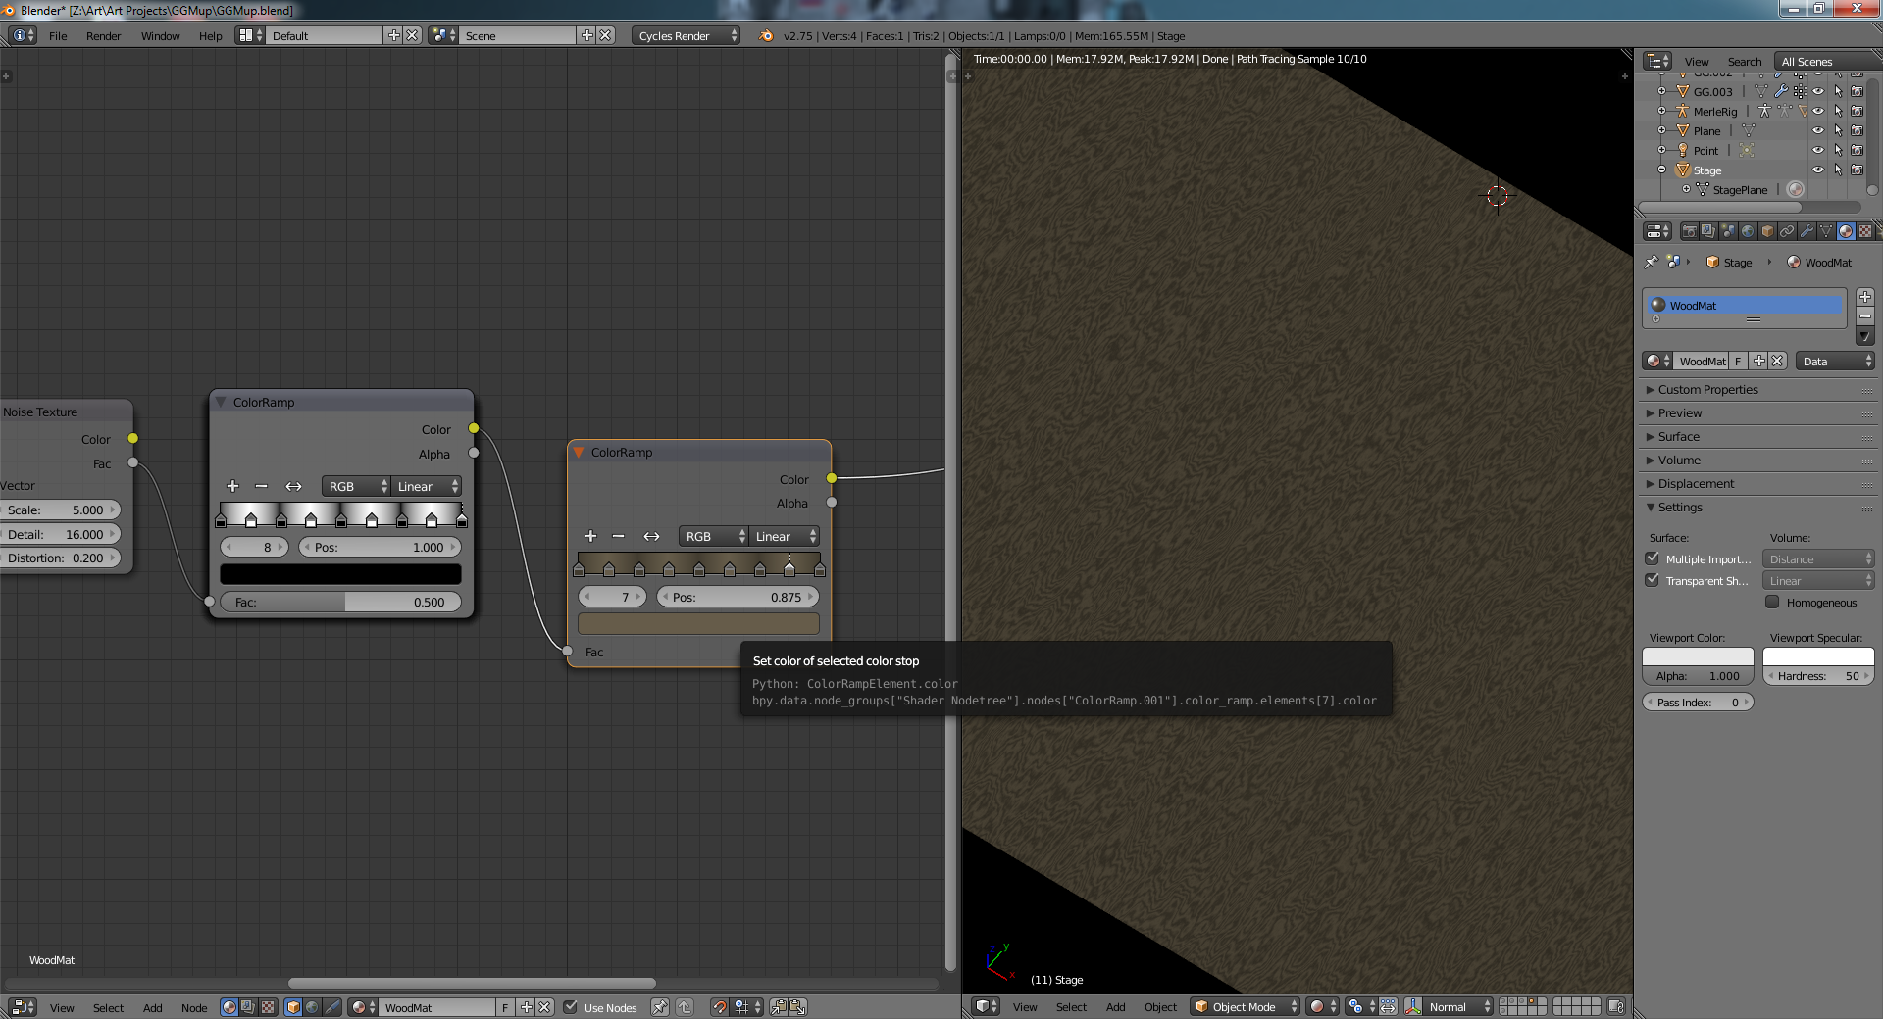

Cycles is the new, non-sucky (does lighting better AND is GPU accelerated) renderer for Blender. You need a special build as of 2.6, but it was integrated into the trunk right after the 2.6 release. Enable it from the plugins/render menu, then choose "cycles" from the menu at the top. From there, you can also set viewport shading to "rendered" and let your GPU render for you.

If you want ANY specular, then you have to mix a glossy material with a diffuse one, as diffuse materials don't have ANY specularity.

For some reason (at least as of blender 2.63) Cycles doesn't update the rendered view if you move your UV coordinates around. Tab in and out of edit mode to force the render to reflect your new UVs.

Add a bump map to a cycles material? You need to get something into the displacement node of the render output. You could use the image texture itself, but that would give you TOO much bump, so you typically run the image through a mix node (set to multiply) so you can control the bump level. Also note that you add the color to the bottom of the mix node so you can control the mix with the "fac" parameter. See the following image:

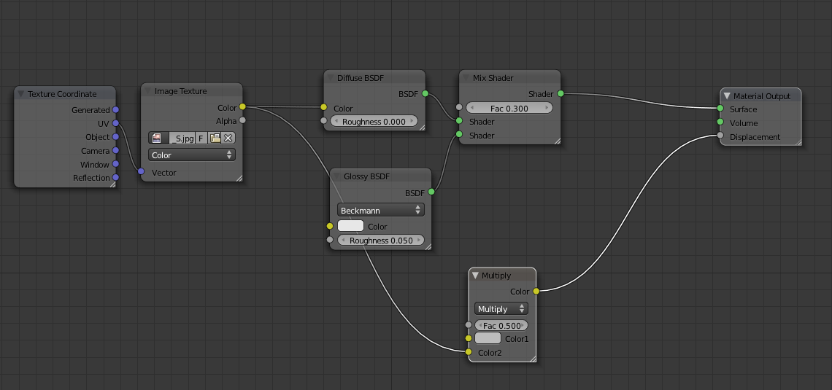

As of 2.63, blender wil add cycles displacement maps to the material disp input using the alpha output instead of color. If it looks like nothing change when you added your disp. map, reroute the output of the displacement node from alpha to color.

If you set the viewport to "rendered", it might start to bog down on a complex scene. Go to the render tab, set the integrator to "direct light", then set the max bounces to 1. This will give you lickety-split updates. Set preview samples to 5 instead of 10 for extra speed. When you're ready to render, go back to "full global illumination."

Cycles has an Anisotropic shader, which is good for radial reflections on brushed metal. You have to turn the rougness up (the default is zero), otherwise it basically acts as a glossy shader.

Cycles does do SSS on the GPU (as of 2.68.)

You can't an image texture as a displacement except through the node editor. It's a bug in the pre-2.6.1 blender.

As of 2.6x, Cycles finally supports Normal maps instead of just bump maps. Attach an image texture to a normal map node, then attach the normal map to the "normal" input of your diffuse / glossy / etc shader for best results.

On your Image Texture for the normal map, set the RGB multi-hued images to "non-color data"

Go to the world setup for cycles, then hit "use nodes", from here add a Sky Texture, which gives you a kickass orb to set the position of the sun relative to the model. It also changes the light color, so the setting sun is more red/yellow that mid-day.

Cycles does depth of field natively; just go to the camera settings and give it a focal point.

As of 2.76, Cycles lets you enable “camera cull” (which also has to be enabled on each object that you want to cull.) The objects in question will no longer contribute to reflections in the scene, which can help with performance (say you have established background scenes and only want to render part of it.)

If you want to use multiple UV maps, you have to specify the UV map in an attribute input, otherwise the faces that get the 2nd set of coordinates will still use the primary UVs for rendering. An example of using a set of UVs called "Slice":

As of 2.76, Cycles also does point density (has to be done on CPU, ATM). Plug, say, an emission shader into the volume output, and you’ll get a cloud where your object is. You can control this with a point density texture (under textures.) Feed that into the strength input of your shader, and it’ll let you control coordinates, whether or not the density is generated from veticies, etc.

As of 2.68, Cycles has a mist pass which you can use as to mix in the compositor. You have to turn the mist pass on in the cycles world properties panel first, though. This simple node setup will do the trick:

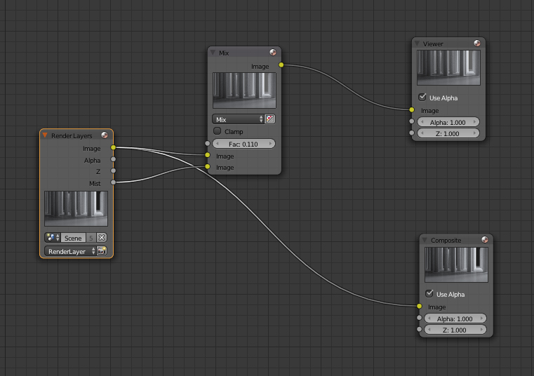

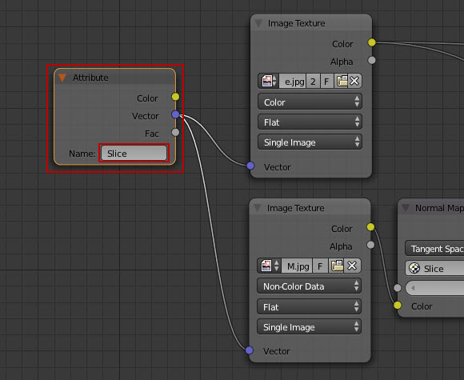

I started using texture paint mode several years back, and always with the Internal render materials. I started using Cycles more and more as we work on the content for Theory Animation's output. I still wanted to adapt the same workflows over to Cycles materials, but I hit a few snags. I also found some tips worth sharing for those searching for similar solutions.  
If you want to use the Z-output of the cycles render node, you'll never see anything unless you add a vector map node or a normalize node. For vector map, you usually have to go negative, then set the scale to 0.01 (or similar.)

A good way to get fog is to the normalized / mapped Z-output above as the "FAC" input to a mix node with the 2nd node set to an RGB gray color.

You can't texture paint with cycles without saving the image to disk first: so paint, then save to disk and plug the node it in as you would with a normal image map.

Firstly, I didn't know how to get the image to let me display after painting, checking in render view. This was an easy fix - as long as the image node is attached to the diffuse node and has a uv texture coordinate node affixed, then all you have to do is save where you are with the painting with 'save image as' and then you can preview in the render view. This also allows to easily iterate the image changes for use later with varying degrees of dirt, etc.  
  
Second: I got frustrated with not being able to access the brush textures I had made once I had set up my cycles material for my object - seems that if you load up the images as textures in the brush textures you are okay, but once you have connected that image node to your diffuse for painting, the tab to get to the brush textures is gone. Fix: make a copy of your scene, and then switch back to Blender Internal - you can then add all the texture brushes you want, and use this scene to edit the parameters when necessary, even after painting with the Cycles scene.  
  
BProjection paint - a very cool addon that I had tested with the Internal renderer, I had no idea how to use it with Cycles output. Seems that the fix for this is almost the very sme as the first problem I had, only a slight difference. My object being painted needs to have the saved blank texture on it set to uv and connected to the diffuse, but when generating the BProjection plane, that material also needs to be set to use nodes in Cycles, and add an image node with a texture coordinate node set to 'generated'. You can then name your source image for cloning there, and then manipulate the position and scale of the projection plane in the N panel settings. I also found it easy to swap projection plane images right there in the node, making it easy to get multiple textures blended depending on brush settings.  
  
Paint Layers - I haven't totally figured out how to utilize this with Cycles, but when generating layers at least it does generate the images with the names on them - I would like to see this maybe set up for adding nodetrees as well for the Cycles materials, but I might have to have a go at imagining them up and providing examples to people that actually code.  
  
I hope this helps someone here, and if anyone has any pointers to share I hope I see them here!!

HDR probes (essentially a 360 background image that can be used for lighting) is set by going to the world tab surface section, deleting what's there already / hitting “use nodes”, adding a new "environment texture", then loading your.hdr image. You'll be able to see the background in rendered viewport mode, but only if you're in perspective, not ortho. You also can see it looking through the camera.

NOTE: if you're wondering why this isn't working, check to make sure you used "Environment Texture", not "Image Texture".

Note: if you want to control the rotation of the background probe, stick a mapping node between the input texture coordinates and the environmental texture node. Then just change the Z rotation and watch the world spin!

Want to adjust the texture scaling? Use the texture coordinates input!

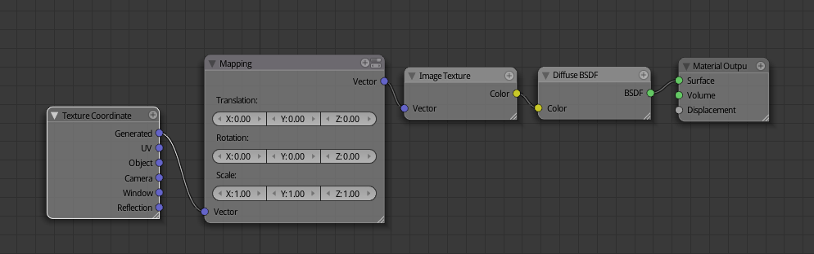

Under the “world”/planet icon, there’s an option for sky color, which is (by default) set to gray. Set this to black to emit no light from the “sky” and make the colors from your lights more vibrant.

There’s a couple ways to get rid of fireflies when doing cycles rendering. Using “clamp” under Sampling / Settings limits the contribution of each individual pixel. Turn this down to eliminate sharp “points”, but you’re also limiting the contribution of any individual light to this value. If you set this to “2”, and you have a light source at 20, you’ve effectively neutered the light down to “2” as well.

Under Light paths, you can use the “no caustics” option, which also reduces fireflies, but – as the name says – removes any caustics from your scene, so use with caution, as it reduces your overall amount of light.

Filter glossy (also in the light paths settings) blurs sharp reflections slightly to help reduce fireflies.

Cycles: Volume Scatter is used for smoke, mist, etc, while Volume Absorption absorbs the light, such as in colored glass.

Not seeing any color for your volumetric material? Make sure you have the density high enough. When we did the beer tutorial, a value of 1 wasn’t even noticeable, while 65 worked fine.

In Camera, got down to “Light Paths” and set that to “Full Global Illumation” before we do the final render.

For emissive materials, you can change the way light falls off by adding a Color/Light Falloff node as the input to the emission material’s strength. This helps to simulate, say, a sun lamp (which has constant light) when you’re using an environment volume (where the sun lamp doesn’t work properly yet).

As of 2.71, Cycles has an experimental “Displacement” setting under the mesh data:

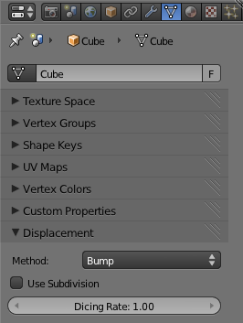

This will let you select between using the input to the displace node for bump mapping, geometry displacement, or both!

# Compositing

1. Super Helpful: If you Ctrl+Shift+Left Click on a node, it’ll automatically add a viewer to that node.
2. Hit Ctrl + <- for an easy jump to the compositor. Shift+Space will toggle the node layout full screen if you need it. (Or control down/up)

You can group a series of inputs with Ctrl + G, then hit TAB to jump into the group.

If you select "backdrop", you can then do a shift+A, output/viewer. The backdrop will show whatever the viewer does.

If you want depth of field to work, you have to add a filter/defocus. Hit "use Z buffer" on the filter. From there, can route the output to the viewer or the render result. Lower Fstop if you want a stranger DOF (you likely won't see any with the default setting of 128)

Defocus can give you jaggies unless you set the threshold in the "defocus" node to 0 instead of 1. (NOTE: FIGURE OUT WHY. WE HATE MAGIC NUMBERS!)

You can create depth-based falloff by running the z output of the render to a map value function. Take the "normal" output and put into as the input to a filter node set to screen, and set the output of the map value node to "fac". As you adjust the offset and size of the map value, you'll change the distance falloff of the resulting image.

A lens distortion of .03 is a nice touch sometimes. Be sure to select "fit" so you don't get weird missing spots at the edges.

A nice touch is to add a color correction node, set the hightlights to one color, then set the midtones or the shadows to its complementary color.

Here's how to do fog in cycles with the compositor; just the a mapped version of the z depth as the fac input to add additive node that adds a darkish gray.

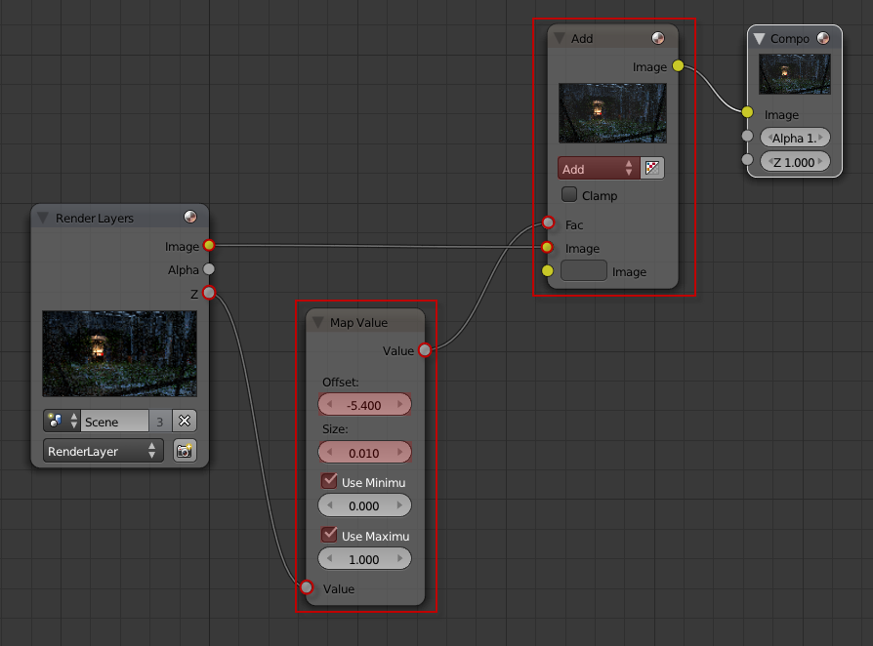

Want to apply a compositing effect just to an object? Give that object a pass index in the object data (square cube) tab, under relations. Then, in the render layers tab, under “passes” turn on Object Index, otherwise you won’t get the IndexOb output that you need.

If you add a viewer and background in the compositor, you can change the size of the background preview with V and Alt+V.

# Post-Processing

Under the scene tab, there’s an entry for color management, with one of the items being Render: View, which you can that change to “Film”, which causes the scene to have very deep blacks. This is (apparently) frequently used for artsy scenes. You can adjust for the darkness by playing with exposure / gamma.

Right underneath that, you can tweak the curves of the output image.

If you enable the mist pass in render layers, you can do some neat tricks with mist in the compositor. Just add the mist pass to the source image. A color ramp will serve to control the fade-in distance of the mist, and the add node (look for “mix”, then set it to add) will control the strength.

A glare node in the compositor will add an element of bloom to the image (again, useful for abstracts.) Lens distortion is also a good choice for abstracts.

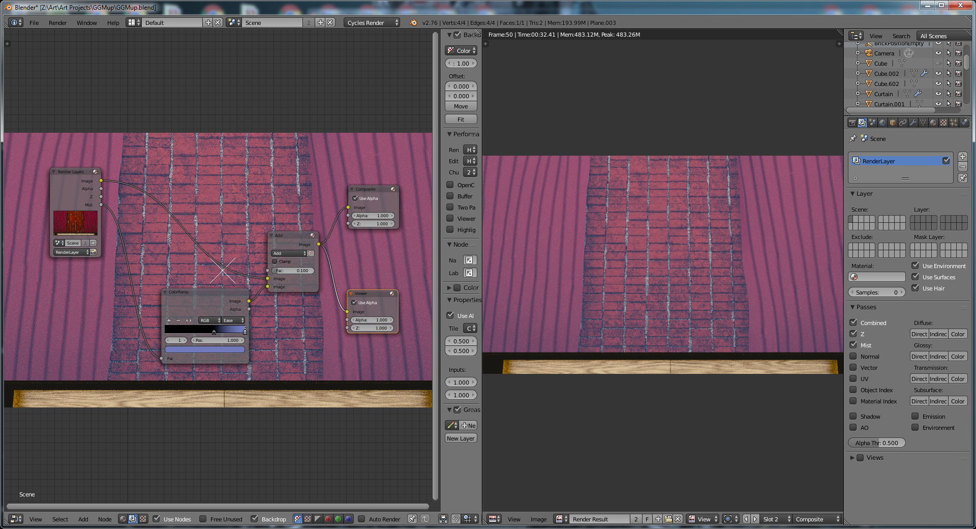

If open your image in Photoshop, copy the image to a new layer, do a soft Gaussian blur, then use “curves” to make the lower end a bit lighter, you can then change the blending mode to “soft light”, which will make the details pop (per Gleb Alexandrov, although we’re not sure how just manually increasing the contrast / saturation would be different.)

Also, make a small set of brush strokes (or two) with a really large soft brush on a new layer over the center of the image. Then set the blending mode to overlay, and it’ll highlight the focal point of your image. You can also do the reverse and darken the corners of your image.

You can also add (with a linear dodge blending mode) dust & scratches over your layer. Same goes for film grain.

Also, add some dust to the image by taking some stock photos or textures and doing an overlay.

Adding a “curves” adjustment layer will let you “kick up” the levels closer to the left, which will enhance the colors/detail in the shadow.

A photoshop color lookup layer is great for letting you play with different variations of color curves.

Gleb’s tricks for post-processing:

1. Add a depth of field.
2. Set the scene view (under Scene / Color Management) to Film.
3. Lens Distortion

Clown Passes:

This is also known as an “object ID” pass; the goal is to create an image with a different color per object, which you can then import into Photoshop and use as a selection mask for individual objects. Ex:



The easiest way to do this is to go to the Scene Tab; under the layers you’ll see a material override; Create a new material that’s simply a cycles emission shader with a strength of 1, then use the cycles Object Info node to create a random, per-object color:



# Baking

Baking, in general, is the act of pre-computing something in order to speed up some other process later down the line. Rendering from scratch takes a lot of time depending on the options you choose. Therefore, Blender allows you to "bake" some parts of the render ahead of time, for select objects. Then, when you press Render, the entire scene is rendered much faster, since the colors of those objects do not have to be recomputed

Render baking creates 2D bitmap images of a mesh object's rendered surface. These images can be re-mapped onto the object using the object's UV coordinates. Baking is done for each individual mesh, and can only be done if that mesh has been UV-unwrapped. While it takes time to set up and perform, it saves render time. If you are rendering a long animation, the time spent baking can be much less than time spent rendering out each frame of a long animation.

Note: It's also good for retopo + sculpt, where you can grab the normals from a high-resolution mesh and use them as a normal map on a lower-poly version of your model.

You have to make sure the object is UV unwrapped; you then bake whatever you want to a new image, and apply that new image to the object as a texture (normal map for instance.) For this to work properly, you HAVE to go into image sampling on the texture, and set "Normal Map." Otherwise, Blender thinks it's a simple bump map without normal information. Seams will be EXTREMELY visible without this step.

As of 2.63, it seems that the most common ways to make a sculpt's normal map to an image is to either use:

Bake to active, where you have two copies of a mesh, the original, and the (presumably) retopo'ed one.

Bake from multires, where baking happens from the highest multiresolution level to the viewport level.

Baking from selected to active seems to be the "new best" way to do things in 2.66+. Normal baking is HORRIBLY persnickety:

1) You have to make sure that your selected and active objects are all on layers that are active, and you don't have them set to be invisible for either render or drawing.

2) The low-poly mesh has to be unwrapped. After you unwrap it, you HAVE to create a new image (so that your unwrapped UVs are on a blank, black texture.) If your UVs are on the default gray "nothing" the bake will fail.

From there, select the high-poly version, then the low-poly version. Go the render tab / bake, hit bake mode "normals", and make sure "Selected to Active" is on. If you bake now, you should see our texture map.

To use in with the blender internal redered, make sure "Normal Map" is selected under Image Sampling is selected, then do the obvious (turn off color in influence, and activate "normal" instead.

This page has a good overview as well:

http://cgcookie.com/blender/2010/06/30/normal_maps_blender_2_5/

# Drivers

Drivers make use of python, and Blender will refuse to run the drivers at first. You have to go to User Preferences/File and change the auto-run python scripts checkbox.

This is a quick way to add drivers with a scripted expression. First click the property you want to add a driver to, then add a hash # and a scripted expression.

Blender updated the #frame driver on every render. It appears to be the only auto-updated driver, however. For instance, you could type this into the render’s seed value box (although cycles now has an option to auto-update the seed for you, so this is unnecessary.)

You can also use this to make something bounce around. Entering #sin(frame) for instance.

You’ve probably seen many folk typing *#frame* into the Seed property for cycles renders, but it’s capable of a whole lot more than that. The simple example above uses the same ‘frame’ property, but multiplied by 0.2 to make a slow rotation* of an Empty that the camera is parented to. Instant turntable!

Since it uses python, almost anything is possible. Using *#bpy.data.objects[‘objectname’]* would give you access to any properties an object or its data has.

One slight disadvantage is that these expressions are only evaluated during animation, not in realtime like your usual transformation drivers.

# Custom Properties

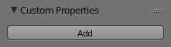

*Custom Properties Panel.*

Custom properties are a way to store your own meta-data in Blender’s data-blocks which can be used for rigging (where bones and objects can have custom properties driving other properties), and Python scripts, where it’s common to define new settings not available in Blender.

Only certain data supports custom properties:

* All [data-blocks types](https://www.blender.org/manual/data_system/data_blocks.html#data-system-datablock-types).
* Bones and Pose-Bones.
* Sequence strips.

To add a custom property, find the Custom Properties panel, found at the bottom of most [Properties Editor](https://www.blender.org/manual/editors/properties_editor.html), and hit Add.

# Scripting

Want to see the behind-the-scenes python commands? Drag down on the topmost menu bar's bottom divider to display the normally-hidden "info bar"; it'll show you what python commands you're running as you execute them.

Whatever script you run will always affect the active object (not all selected objects - just the active one.)

Blender scripts all start with

import bpy

Turn syntax highlighting on with the 3rd button in editor's menu bar.

bpy.context.selected_objects - all objects that are selected

bpy.context.scene.objects.active = XXX - sets the active object to *X*

# Scripts

1. A handy add-on is the "import images as planes" script in add-ons. From there, you can go to File/Import and you can import an image as a plane.
2. Ctrl-C over tools & menu-items to copy the Python command.

# Game Engine

To make something react against other objects (say, w/physics), use the pacman icon and call it an 'actor'

P – Start the blender game engine.

# Workflow

Want to hide all the high-impact items in your scene? Rather than set restrict view on the items individually, move them all to a layer and simply shut that *layer* off and on.

# Our Settings

A helpful default is to go to "Edit Methods", and tell "add new objects" to go to "aligned to view." This will make all new objects face you in whatever view you're in. This is REALLY handy for adding new curves, which always otherwise seem to spawn 90 degrees out of view.

Be sure to turn on splash screen tips whenever we do a new install: It’s in the testing add-ons ATM:

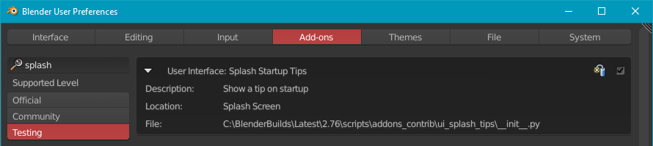

According to Andrew Price's usability research, black wireframes on dark grey backgrounds violate usability contrast settings. Set the wireframe colors to a gray of .6 or .8 to rectify.

Another usability fix is to kick the DPI under system up from 72 to about 100. (We went with ~90)

One setting we really like: as of 2.66 up, click on "region overlap" in settings / system, as it causes the 3d view to get shifted around less when opening the tool / properties panels, and gives them slight transparency.

# Add-Ons

Our preferred addons:

Import Image as Plane

Node Wrangler

F2

Layer Management (Lets you name layers) – will show up in the properties shelf

Import Image as Plane – Really handy for when you’d just be importing a plane as a background, as it takes care of the grunt work. Two gotchas: if you’re using this as an environment background, make sure to set the settings to “emission” on the import dialog. Second, the default material has the “strength” of the emitter set to “is camera ray”, which means the image won’t be reflected on any glossy materials, etc. Just sever this link and set the strength manually.

Scorpion81 has an enhanced fracture modifier which uses a LOT less memory, but got rejected from inclusion in mainline for some reason. You need a special build for this ATM.

Note that you can’t run fracture on models with non-manifold geometry. Go to edit mode / select menu / non-manifold and fix however you need to.

From there, set up your fracture, and hit “execute” fracture in the physics panel. Note that you’ll need something to collide with, so just add a flat plant and make sure it’s set to be a passive rigid body.

Another alternative is “cell fracture” which comes built-in to blender (although you do have to add it from the properties menu. Cell fracture (by default) will put all the pieces on the next layer. It also likes having a lot of topology, so adding a subsurf, then applying, is not a bad technique.

## F2

Pretty simple … after you have a face that you’ve created on (what’s going to be) a new loop, select the edge at the end, then hit “F” and the F2 addon will continue the loop for you!

## Node Wrangler

Adds a WHOLE bunch of extra operations to the node editor, such as: merge selected nodes (with mix, add, etc)

To bring up the menu, use Ctrl+Space

Lazy connect allows you to connect nodes when really zoomed out (without having to worry about hitting the node bubbles exactly.)

Ctrl+RMB Drag – lazy link creates linkes between unconnected nodes.

Ctrl+Shift+RMB – lazy link with menu, so you can pick what you want to connect.

Alt+RMB Drag from one node to another, and node wrangler will automatically create a mix for those node outputs.

O or Ctrl+Shift+Click – View the output for that node.

Alt+S – Swap connections

Shift+P – Frame Selected (Then use F6 to set the color and label.)

Shift+S – Switch Node Type while keeping connections.

Shift+C – Copy node settings (color, curves) from the active to the other selected nodes.

Ctrl+T – Adds the an image texture, mapping, and texcoord set (as you frequently add those three together.)

/ - Add reroute nodes to all outputs

As merging is very common, you can use the following shortcuts with selections:

**Mix:** Ctrl+0  
**Add:** Ctrl++  
**Subtract: Ctrl - Underscore** Ctrl+-  
**Multiply:** Ctrl+*

### Batch Change Blend Type / Math Operation

Change the blend type of all selected mix nodes and math nodes using:

**Mix:** Alt+0  
**Add:** Alt++  
**Subtract:** Alt+-  
**Multiply:** Alt+*  
**Divide:** Alt+/  
**Greater Than:** Alt+>  
**Less Than:** Alt+<  
**Cycle Up:** Alt+↑  
**Cycle Down:** Alt+↓

|  |  |  |
| --- | --- | --- |
| Connect to Output Node | O | Link the selected node to the Output node (Composite or Material/World/Lamp Output node). |
| Change Mix Factor | Alt + Left/Right | Increase or decrease the Fac of selected Mix nodes (0.1, Alt + Shift 0.01, Ctrl + Alt + Shift 1.0). |
| Delete Unused Nodes | Alt + X | Delete all nodes whose outputs have no connections (excludes final output nodes such as Composite, Viewer and Material Output). |
| Reset Backdrop | Z | Move the backdrop image back to the center with 1.0 zoom. |
| Vertex Color Node | Add > Input | Add an Attribute node with the Vertex Color name already filled in. |
| Reload Images | Alt + R | Update all images in the node tree. |
| Copy Label | Shift + C | Copy the label from the active node to selected nodes, or from linked inputs/outputs |
| Clear Label | Alt + L | Revert the label to an empty string, telling Blender to display the node type instead. |
| Modify Label | Alt + Shift + L | Add a prefix or suffix to selected nodes' labels, or replace certain text with something else. |
| Align Nodes | Shift + = | Align nodes either vertically or horizontally, with even spacing between them. |
| Select Frame/Children | [ / ] | Select the parent (the frame containing the selected nodes) or the children (all nodes inside the selected frame nodes). |
| Detach Outputs | Alt + Shift + D | Grab a node while disconnecting its outputs. Similar to Alt + D, but keeps inputs connected. |
| Add Image Sequence | Add > Input | Select a single image from the file browser and an Image node will be added with the sequence length already filled in. |
| Add Multiple Images | Add > Input | Select multiple images in the file browser to add an Image node for each in one go. |

# Modeling Techniques

## Scale

If you enable rigify and add a human to your scene, you’ll get a rig at standard human height (~1.935 meters), which can aid as a composition guide.

## Abstract

There’s a build modifier that will progressively add faces to an object over the course of an animation. If you click ‘randomize’, the faces will be populated at random, which give a nice abstract effect.

## Cables & Wires

If you use BevObs to make a cable, select the curve that defines the cable's length, then add the cross-sectional profile to BevOb field.

Using "r" or rotate on endpoint will cause your cable to "hang" a different way.

If you select the "3D" modifier for a curve, you can use the "tilt" tool on it, which makes it easy to get wires to twist. Select a point on the curve, and hit Ctrl+T (used to be just T, but his brings up the toolbox in 2.5); this will let you tilt/rotate the normals on your curve, causing them to twist up for you.

## Feathers

Use the same tricks you would for hair (set the base to be something thick, like 10, then use material with a blend texture for alpha that becomes more translucent as it goes on.) Go to the particles and set clump to 100%, which will form "feathers" out of the hair.

## Ice

Ice IOR is 1.3-ish. You basically create a cube, use sculpt to "melt" it a bit, then add a material that's completely transparent but with small, hard specular reflections. Add raytracing, and viola! Don't forget to set the number of bounces to about 10 or 12 for this.

Also: to get the little bubbles inside, you can add a plane, add a hair particle system, then set the hair object to a be small sphere with the same material as the ice cube. You can then adjust the plane to make the spheres spawn where you want.

## Pillows

You can make pillows (with edge scrunching) with a little help from the cloth simulator. Create a pillow, then center it at 0,0,0, and add a cloth physics sim to it. Pick “cotton” from the presets, as this seems to work well. Step two involves adding a Point Force field at the same spot as the pillow. Kick the strength of the force field up to 200, and reduce the “gravity” cloth field weight to zero. Simulate, and … viola:

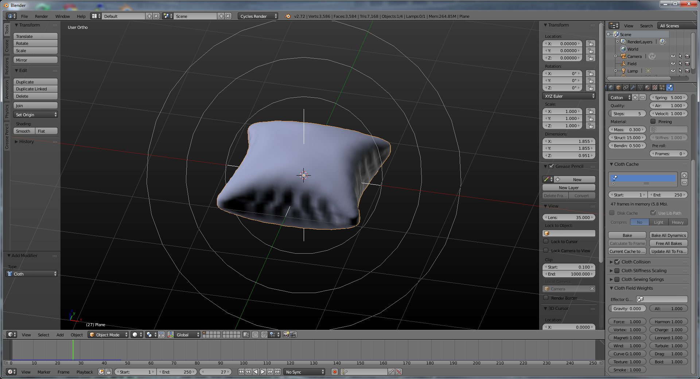

## Regular Polygons

Blender used to have an add-on called “regular solids”, but it appears to be gone as of 2.77. You can still make penta-/hexa-/whatever-a gons by creating a cone with the # of sides that you’re interested in.

## Rotating Camera

The easiest way to do this is to parent a camera to an empty that’s coincident with the target, then animate the rotation of the empty. Otherwise you have to mess with #sin & #cos(frame) drivers, and that’s tedious.

## Snow

To make your snow / ice extra glinty, you can add a light that JUST emits diffuse (i.e., turn off specular.)

From there, add a cloud texture to your snow; make the noise size 0, the depth 5, the brightness 0, and the contrast 5. From there, assign it to affect specularity. This will give you "glints." Note that you should turn the default specularity all the way down so you only get your glints. Drop the hardness on the "base" material if you need more glint (a hardness of 2 will put glints everywhere, but they'll be bright as hell. Combat this by going into your cloud texture and dropping the influence down to .1 from the default 1)

If you want to make imprints into the snow, the easiest way to do it is to create a displacement modifier, and have it "pop" the snow up for you around whatever you need to make (tire tracks, etc.)

## Terrain & Outdoor Scenes

There's no point in rendering off-camera geometry. Jonathan Price recommends sizing up your ground plane while looking through the camera (Ctrl+Numpad 0) so that it's only as big as your camera needs. Your ground plane will look like a trapezoid when you're done.

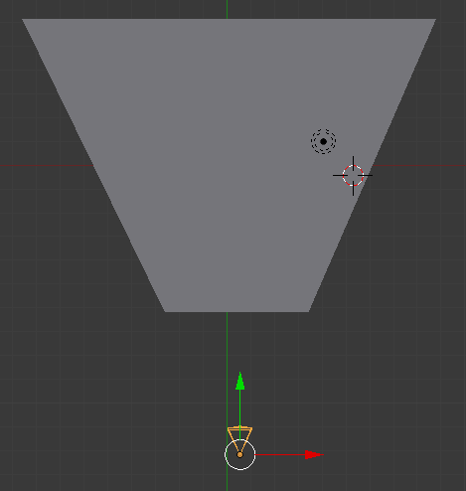

Also, creating a plane then subdividing with fractal (in options / F6) is a lot more efficient than doing the old proportional edit G Z w/Random trick or using a displacement modifier with a noise texture.

Outdoor Scenes

A typical setup seems to be setting up a sun lamp with high energy and a yellow light for outdoor scenes, as well as a blue sun lamp with lower energy for the bluish tint that real-life shadows take on.

Ground

You can "cheat" on making quick ground by adding a plane, subdividing a few times, then adding a displacement modifier. Use a cloud texture for the modifier and viola, instant terrain.

Grass

One tutorial guy still used hair for grass, even in 2.6.

Set translucency in the grass to something pretty high (around .8), this will make all the light coming in the back pass through the front, which is a great way to cheat and not have to use SSS.

You can't really use ambient occlusion on grass, as your computer will have a coronary. You can fake it out by setting an color texture with a black base. Other nice tweaks include browning the tips slightly.

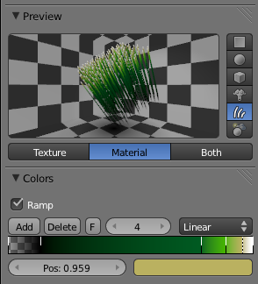

## Trees

Go to Plugins / Add Curve / Sapling. From there, you can go to Shift+A/add curve, and you'll get an option for "add tree." Hit bevel in the tools panel to make the tree "fill in."

# Material Techniques

Toon Shading (falloff-style). To get something like this:

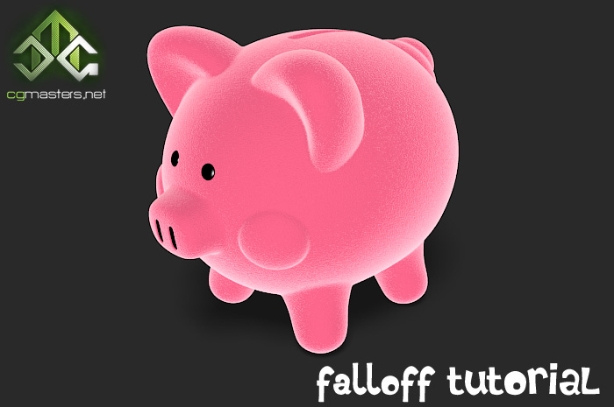

... is actually pretty easy. Look here <http://www.cgmasters.net/free-tutorials/falloff/> for a full tute, but basically:

1. Click "ramp" on your shader, and set the input type to "normal" (since we're making the normals a different color.)
2. Make the farthest left-most color full-white, no A=1.0 (no transp)
3. Move the second stop to about 0.7, and change it to fully transparent with a color to match your character.

Metal has "colored" specularity based on the color of the metal. Plastic has "whiter" highlights (while still colored slightly).

Here's the node setup for getting the same with Cycles; the trick is the "facing" output of the layer weight, which goes from 0 to 1 depending on whether the surface in question is facing the viewer to "facing" it at a grazing angle. At .2, you get about the same about of edge shading as the blender internal render.

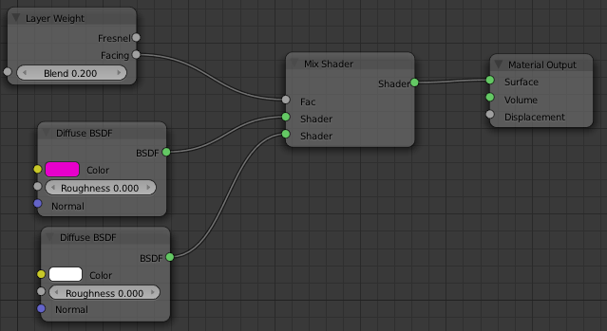

## Antique Bronze

To get something that looks like this:

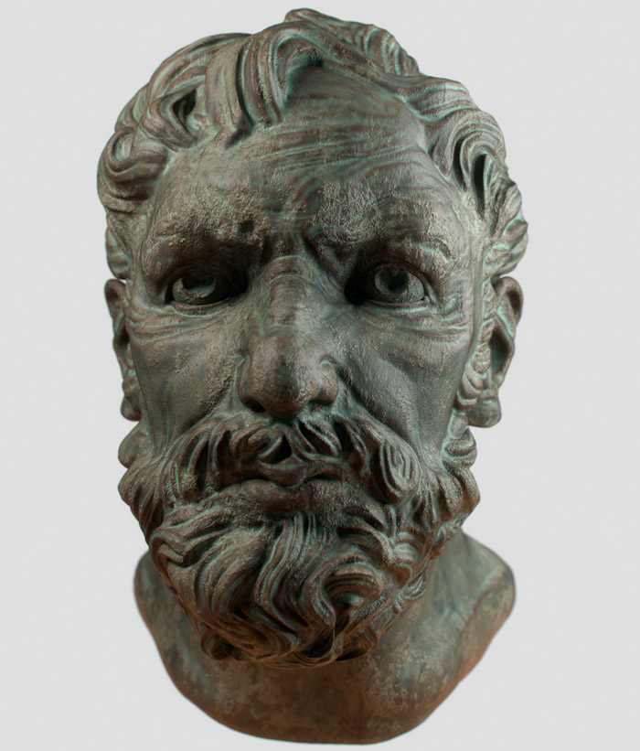

Use this setup: (see http://blenderartists.org/forum/showthread.php?216866-Cycles-tests-the-new-blender-CPU-GPU-renderer-of-awesomeness/page203)

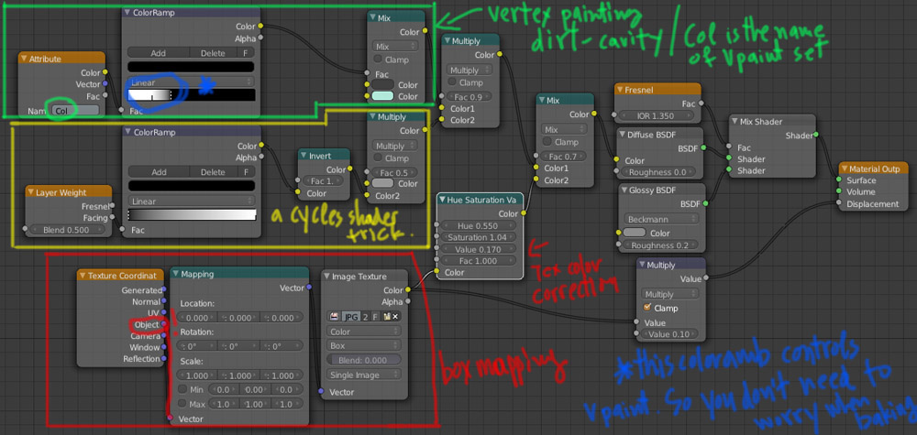

From the creator: For texture, any rusty metal texture can serve well, especially warm tones. Green oxides will eliminate this warmth.

## Metals:

Metals are mostly reflective with virtually no diffuse (most games will cheat and just drop diffuse entirely.)

Metals will color their reflections and still have Fresnel, but also have an edge tint. This is due to having a different Fresnel curves for different wavelengths.

## Flecks:

Need something with flecks, such as car paint or snow? Add a Voronoi texture, set it to “cells”, and turn the scale waaaaay up. Insta-flecks!

Another trick that can be used here: once you have your Voronoi texture, take the color output and feed it into a normal map, then feed that normal map into the “normal” input of your glossy shader.

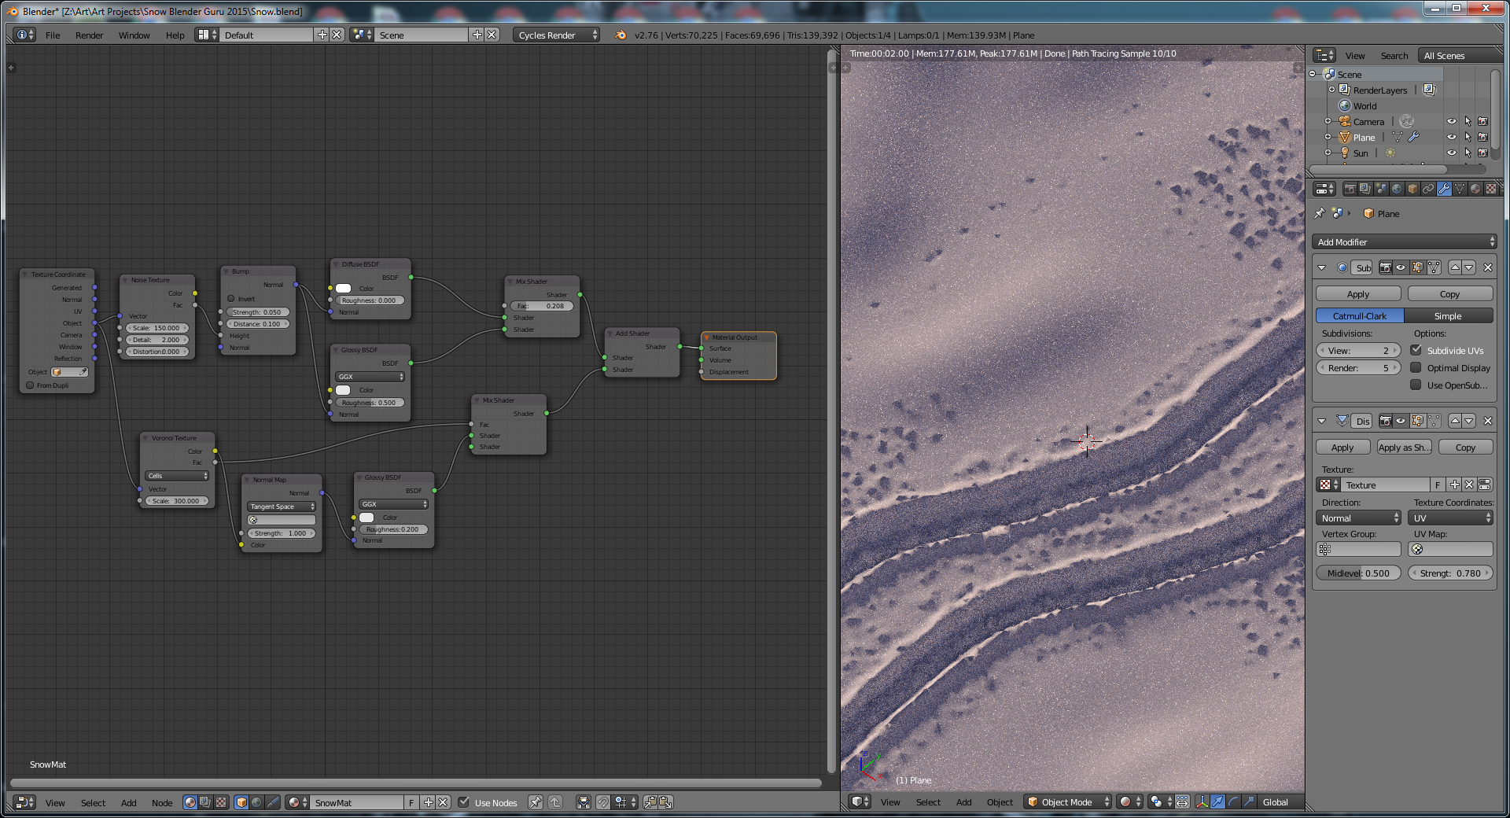

The multi-color nature of the Voronoi output *looks* a lot like a normal map, which is why it works; and when it does, it causes only certain cells to face the camera (hence: flecks!)